 

CSCI321 – Project

Project Topic: Recommender System based on collaborative filtering

Topic Code: CSIT-23-S1-14

Project Requirements

## 

## Project Team

| Group: FYP-23-S1-14 | | |
| --- | --- | --- |
| Student ID: | Name: | Email: |
| 7222828 | Loo Joon Wee | [jwloo002@mymail.sim.edu.sg](mailto:jwloo002@mymail.sim.edu.sg) |
| 7372772 | Low Rui Hao | [rhlrlow001@mymail.sim.edu.sg](mailto:rhlrlow001@mymail.sim.edu.sg) |
| 7436208 | Muhamad Amir Akmal BMS | [mohammad103@mymail.sim.edu.sg](mailto:mohammad103@mymail.sim.edu.sg) |
| 7224527 | Tham Jia Xuan Travis | [jxttham001@mymail.sim.edu.sg](mailto:jxttham001@mymail.sim.edu.sg) |
| 7222439 | Wee Zee En Leonard | [zelwee001@mymail.sim.edu.sg](mailto:zelwee001@mymail.sim.edu.sg) |
| Supervisor: | Mr Terence Chew | [tchew@uow.edu.au](mailto:tchew@uow.edu.au) |
| Accessor: | Dr Prem | [premrajan_p@yahoo.com](mailto:premrajan_p@yahoo.com) |

## 

## Document Control

Title: Project Requirements

| Owner | Current Version | Last Change on | | Approved By |
| --- | --- | --- | --- | --- |
| Date | Time |
| FYP-23-S1-14 | 1.1 | 30/1/2022 | 2.00pm | All |
| FYP-23-S1-14 | 1.2 | 5/2/2023 | 10.30pm | All |
| FYP-23-S1-14 | 1.3 | 10/02/23 | 10pm | All |

### 

### Record of versions:

| Revision Date | Description | Section Affected | Changes Made By | Version after Revision |
| --- | --- | --- | --- | --- |
| 30/1/2023 | Starting of outline and inputting of content | Document Control, Introduction | Joon Wee | 1.0 |
| 5/2/2023 | Finishing of introduction, inputting content for glossary and some overall description.  Adding functional, non functional and interface requirements | Introduction, Glossary, Overall Description,  Functional, Non-functional, Interface Requirements | Joon Wee, Amir | 1.1 |
| 10/02/23 | Edit introduction purpose  Adding Business model  Edit and finish up functional, non-functional and interface requirements | Introduction, Business Model  Functional, Non-functional, Interface Requirements | Joon Wee  Amir | 1.2 |
| 14/02/23 | Refining business model  Refining overall description | Business Model  Overall Description | Amir | 1.3 |
| 19/02/23 | Start working on creating and updating researches and comparisons for web crawl and collaborative filtering algorithm | Researches and Comparisons | Joon Wee | 1.4 |
| 26/02/23 | Start working on adding Programming languages and database comparison  Add and update meeting minutes | Researches and Comparisons  Meeting Minutes | Joon Wee | 1.5 |
| 12/03/23 | Start working on adding individual pros and cons of choosing a specific language and database.  Start working on adding researches and comparisons for hosting platforms  Add and update meeting minutes | Researches and Comparisons  Meeting Minutes | Joon Wee | 1.6 |
| 20/03/23 | Add and update wireframes  Add and update meeting minutes | Wireframe  Meeting Minutes | Joon Wee | 1.7 |
| 24/03/23 | Updating wireframes  Update version control  Refine whole report  Add and update meeting minutes  Added and updated Sequence diagrams | Document Control  Researches and Comparison  Requirements  Wireframe  Meeting Minutes  Sequence DIagrams | Joon Wee  Amir | 1.8 |
| 25/03/23 | Updated Sequence diagrams  Updated Use case  Adding of gannt chart for WBS | Sequence diagrams  Use Case (functional Requirement table)  Gannt Chart | Amir  Joon Wee | 1.9 |
| 8/04/23 | Updated feature mind map  Added meeting minute 11 | Requirements  Meeting minutes | Joon Wee | 2.0 |
| 18/04/23 | Added meeting minute 12  Updated wireframes | Meeting minutes  Wireframe | Joon Wee | 2.1 |
| 2/05/23 | Added meeting minute 13 | Meeting minutes | Joon Wee | 2.2 |
| 16/05/23 | Added meeting minute 14  Updated use case diagrams and sequence diagrams | Meeting minutes  use case diagrams  Sequence diagrams | Joon Wee  Amir | 2.3 |
| 18/05/23 | Updated Sequence diagrams | Sequence Diagrams | Amir | 2.4 |
| 19/05/23 | Added and updated (reordering) User stories | Functional Requirements | Amir | 2.5 |
| 20/05/23 | Added and updated (reordering) Use case Diagrams and Use case descriptions | Use case diagrams  Use case Descriptions | Amir | 2.6 |
| 20/05/23 | Updating of WBS Gantt Chart  Finalising and reviewing of document | WBS Gantt Chart  All sections | Joon Wee | 2.7 |
| 23/05/23 | Combining of technical report into this report | Design Specification  Testing Documentation | Joon Wee | 2.8 |

## Table of Contents

**Project Team 2**

**Document Control 3**

Record of versions: 4

**Table of Contents 8**

**Introduction 11**

Purpose 11

Project scope 11

Document target audience and objectives 11

**Glossary 12**

**Business Model 13**

Target Audience 13

Chosen Model 13

Proposed Price Plan 13

**Overall Description 14**

Product Direction 14

Product Features 14

Comparison between SaaS Recommender Systems 15

Types of users and features 21

Operating Environment 22

Design and Development constraints 22

Assumptions and dependencies 22

**Researches and Comparisons 23**

Web Crawling 23

References: 31

Collaborative Filtering Algorithms 32

SVD: 32

SVD++: 34

RandomForestRegressor: 36

Summary: 38

References: 39

Programming Languages 40

Analysis of Python vs R 40

Python 40

R 42

Summary 43

References: 43

Python vs PHP vs Java vs C# 44

Database comparison 45

Individual Pros and Cons of language and database chosen 46

Hosting Platforms 47

Hosting platform comparison 47

**Requirements 48**

Product Features Mind Map 48

Functional Requirements 49

Administrator Use Cases 55

Organization Use Cases 65

Individual Use Cases 90

Sequence Diagrams 110

Admin 110

Organization 114

Individual 126

Non-Functional Requirements 134

Accuracy 135

Reliability 135

Recommender system can perform normally even after prolonged usage (up to 1 hour). 135

Security 135

Usability 135

Maintainability 135

The mean time to restore the system (MTTR) in the event of a system failure will not be greater than an hour. 135

Availability 135

Compatibility 135

Portability 135

Scalability 136

Interface Requirements 137

User Interface 137

Software Interface 137

Communications Interface 137

Hardware Interface 137

**Wireframe 138**

Admin 138

Organisation 144

Individual 154

**Design Specification 161**

Architecture Design 161

Database Design 162

Software Design 163

**Testing Documentation 169**

Test Plan 169

Introduction 169

Objectives 169

Quality Assurance Team Members 169

Scope 169

Functional Testing: 170

Non-Functional Testing: 170

Regression Testing: 170

System Testing: 170

Acceptance Testing: 170

Deliverables: 170

Roles and Responsibilities: 171

Assumptions / Risks 171

Test Approach 174

Test Environment 175

Timeline 176

Deliverables 177

Test Cases 178

Test Status Report 184

**Gantt Chart (Work Breakdown Structure) 187**

**Meeting Minutes 189**

Meeting minute 1 189

Meeting minute 2 190

Meeting minute 3 192

Meeting minute 4 194

Meeting minute 5 196

Meeting minute 6 198

Meeting minute 7 200

Meeting minute 8 201

Meeting minute 9 202

Meeting minute 10 203

Meeting minute 11 204

Meeting minute 12 205

Meeting minute 13 206

Meeting minute 14 207

## 

## 

## Introduction

RECS is a website-based product where it offers Organizations the ability to predict existing user’s rating and preferences on different items as well as providing recommendations on similar or other products that the specific user might be interested in based on the data set input by the owner. Organizations can add new products to the recommender system that they have not added before into their e-commerce site to generate a predicted rating for the products and make more informed decisions based on the result of the predictions returned. While for our Individuals, the system allows them to predict and get recommendations of similar items on a single item from the data we web crawl in other websites.

### Purpose

The purpose of this project is to research, study, understand and utilise the concept and technology used in recommender systems from different websites, so that we can develop a product to predict and recommend products for users on a smaller scale with slightly different features. We aim to develop it through researching and utilising collaborative filtering, web crawling, website development, python coding, and algorithms on predictive systems.

### Project scope

To design and develop a product to provide service to our Organizations in knowing their specific target audience preferences and ratings on different items as well as providing the Organization's recommendations on products that the specific target audience might be interested in, so that they can better provide their services and products to their customers. Individuals can also use our service to check on relatable or similar products based on the product they enter in our service, and we will web crawl it on other websites and provide the answer to the individuals. The crawling component will be through websites like Lazada, Amazon, Shopee, Alibaba.

### Document target audience and objectives

The document is created for project stakeholders, supervisor, accessor, and our development team. So as to allow everyone to have a clearer view of the whole project from scratch to completed version, its purpose and its development processes as well as requirements.

## Glossary

**Python:** A dynamic, high-level, free open source, and interpreted programming language, often used to build websites and software, automate tasks and conduct data analysis.

**PHP:** Hypertext Preprocessor. A widely used open-source general purpose server-side scripting language used for dynamic web development and can be embedded into HTML codes.

**MYSQL:** My Structured Query Language. An open-source relational database management system. As with other relational databases, MYSQL stores data in tables made up of rows and columns. Users can define, manipulate, control and query data using Structured Query Language, more commonly known as SQL. The standard language for relational database management systems.

**Scrapy:** An open-source fast high-level web crawling and web scraping framework, used to crawl websites and extract structured data from their pages. It can be used for a wide range of purposes, from data mining to monitoring and automated testing.

**SVD++:** Singular Value Decomposition. It is a collaborative filtering algorithm where it does factorization of a specific matrix into three matrices. Mainly used to analyse user’s preference for each factor and the extent to which it contains the various factors from the observed ratings and some implicit feedback from users and then to predict the missing score.

**Organization:** Refers to E-commerce website owners

**Individuals:** Refers to individual customer

## 

## Business Model

### Target Audience

The target audience intended for our product service are E-commerce site owners (Organizations) and also any customers(Individuals) that frequent E-commerce sites to purchase products.

### Chosen Model

We have decided to employ a subscription based model since we intend to deliver our recommender system RECS as a Software as a Service (SaaS) to both Organizations and Individuals. We will be providing them with Saas in the form of a website in which they will be able to interact with RECS. Organizations will be able to enter their own data set from which they gathered from their own E-commerce site that they own. Organizations and Individuals are also able to make use of RECS to crawl other E-commerce sites such as amazon for example, to retrieve predicted ratings for products or to retrieve recommended products.

### Proposed Price Plan

Since we are employing a subscription based model, Organizations and Individuals both can subscribe to our service to use RECS, at a proposed starting monthly price of $9.90 for Individuals and $14.90 for Organizations.

## Overall Description

### Product Direction

Focuses on providing Organizations with the ability to predict specific user’s rating on specific items and recommend relatable or similar items that the user might be interested in, so as to allow the e-commerce website to better cater to their target audience and increase revenue. Also, providing Individuals with the ability to get the rating of specific items and recommend them relatable or similar items that they might be interested in also. All these through collaborative filtering algorithm SVD++ and python in producing the system product, PHP in producing the website for users to navigate, MYSQL used for the product to display the processed data and the management of our databases, Scrapy to web crawl and mine the data in different websites to retrieve existing data sets for prediction and recommendations.

### Product Features

* Allow users to add their own customer data set
* Predicting of user’s rating on specific item
* Retrieving rating of specific item
* Recommending relatable or similar items that users might be interested in based on a specific item inputted
* User Accounts Management
* Users confidential privacy
* Subscription plans
* Allow users to specify categories they want for scraping

### 

### Comparison between SaaS Recommender Systems

**Recombee**

Recombee is a relatively popular recommender System that offers partnership with companies to improve their website’s recommender system. Once partnered, a dedicated account manager will be introduced to their Organization and a lot of support on how to manage the data and recommendations.

Pricing is based on the number of page views per month, as it’s an approximate indication of the number of active users and recommendation requests. For the upgraded plans, the starting price is 99 USD per month, which is around 130 Singapore Dollars. However, there’s also a free plan that allows up to 100000 recommendation requests per month. New users also get to enjoy a 30 Days Free Trial period.

Recombee is also able to deliver over 10000 recommendations per second. Its API can return the recommendations almost immediately upon user’s action on the partnered website and it takes as little as 200ms. 9gag is one of the organisations that use Recombee.

| **Pros** | **Cons** |
| --- | --- |
| Easily Accessible | Not user-friendly |
| 30 Days Free Trial |  |
| Free Plan |  |
| Fast |  |

**Yusp**

Yusp, developed by Gravity R & D, is one of the more popular recommendation systems used by organisations like Cora, N11, etc. It provides highly scalable solutions to ecommerce websites.

For Yusp, it caters heavily towards Organizations, where the functionalities are only available to Organizations with organisations, and they have to book sessions first, after which they are informed of the meeting time, etc. It is unlike Recombee, which provides more leeway and freedom for self exploration.

Yusp favours heavily on Organization experience and results. The pricing model is on a case by case basis, and heavily depends on personalization modules and traffic size. It is still a monthly subscription, just that the pricing is not set in stone and generally not known to the public.

Only downside is that it’s not the most accessible to users who just want to test out the program.

| **Pros** | **Cons** |
| --- | --- |
| Focuses heavily on providing good Organization experience | Not easily accessible |

**Rumo**

Rumo, formed by Spideo, is a recommendation engine for entertainment content. It has a very user-friendly interface and it’s easy to understand its features.

The learning curve is easy. The starting price is at around 100 pounds per month for 1000 catalogue items, which is around 160 Singapore Dollars, and this amount increases based on the number of catalogue items. It also provides a 30 days free trial for users. It is easy to sign up and new users can login immediately upon account creation.

| **Pros** | **Cons** |
| --- | --- |
| Easily Accessible | Expensive |
| Soft Ergonomics (User Friendly) |  |
| 30 Days Free Trial |  |

**RECS**

Our product caters towards both companies and individuals. For companies, they can upload their own data and get recommendations of items or prediction of ratings through our services.

For individuals who do not have the datasets, they can still utilise our services as we have service dedicated towards individuals in general. For them, it’s really as simple as getting item recommendations just by typing in keywords. The interface is also minimalistic and easy to understand. Security is also emphasised with 2FA authentication. Its speed is also up to par with the other competitors in the industry.

Like Recombee and Rumo, the site’s function can be accessed immediately upon subscription and selection of organisation or individual. We will also be offering a 30 Days free trial option, but there will be a limited number of recommendations, as well as limited database size uploadable. For our upgraded plans, the starting price will be at around SGD $9.90 per month for individuals, and SGD$19.90 for organizations. This price will increase depending on the number of recommendations.

Below is a table that shows our product in comparison with some of the other similar products in the industry:

| **Products** | **Recombee** | **Yusp** | **Rumo** | **RECS** |
| --- | --- | --- | --- | --- |
| **Catered towards organizations** | ✔ | ✔ | ✔ | ✔ |
| **Catered towards individuals** |  |  |  | ✔ |
| **Easily accessible. Once signed up or subscribed, service is available immediately** | ✔ |  | ✔ | ✔ |
| **2FA Security** |  |  |  | ✔ |
| **30 Days Free Trial** | ✔ |  | ✔ | ✔ |
| **Starting Price (Below SGD$50/month)** |  |  |  | ✔ |

**References:**

* Pricing [Online]. Recombee. Available at: https://www.recombee.com/pricing.html (Accessed: 6 February 2023).
* Recommendation Engine for Real-time Personalization [Online]. Recombee. Available at: https://www.recombee.com/product.html (Accessed: 6 February 2023).
* Features [Online]. Join Rumo. Available at: https://www.rumo.co/features/ (Accessed: 6 February 2023).
* Pricing [Online]. Join Rumo. Available at: https://www.rumo.co/pricing/ (Accessed: 7 February 2023).
* Product - Yusp Personalization Engine [Online]. Yusp. Available at: https://www.yusp.com/product/ (Accessed: 7 February 2023).
* Yusp FAQ [Online]. Yusp. Available at: https://www.yusp.com/knowledge-base/yusp-faq/ (Accessed: 9 February 2023).

### 

### Types of users and features

Organization (e-commerce website owner)

* Creating user account
* Management of account
* Inputting of database set into the system
* Retrieving ratings and recommendations based on the data set inputted
* Searching of specific item in the system
* Retrieving ratings and recommendation from our web crawling service
* View history

Individuals (individual customers)

* Creating user account
* Management of account
* Searching of specific item in the system
* Retrieving ratings and recommendation from our web crawling service
* View history

Administrator

* Creating user account
* Management and adjusting of website content
* Management(suspend/unsuspend) of user accounts
* Deleting user accounts
* Editing of user accounts

### 

### Operating Environment

Operating System: Windows 10

Programming Language: Python

IDE: Jupyter Notebook, Visual Studio Code, Notepad++,

Website: 000webhost, AWS

Database: MySQL

Web Crawling: Scrapy

Browsers supported: Google Chrome, Internet Explorer, FireFox

### Design and Development constraints

* Limited programming skills and knowledge on implementing more creative ideas.
* Limited privileges in free website hosting platforms, unable to maintain the website as desired.
* Limited manpower and resources to design UI as desired.
* Limited capabilities on doing real time web crawling data mining, therefore data sets have to be prepared beforehand time to time by ourselves.

### Assumptions and dependencies

* All Organizations and Individuals have internet access.
* All Organizations and Individuals have basic computer usage skills and knowledge.
* All Organizations and Individuals have to be able to read and understand english.
* All Organizations and Individuals know what they are looking for when using our service.

## 

## Researches and Comparisons

### Web Crawling

Web crawlers are programs that’s used to index data on web pages. To build a recommendation system, we would need to crawl over tens of thousands of data that spans numerous pages.We are also planning to do the data mining aspect of our product in Python, so it would be in our best interest to find a framework that runs on Python. It helps that Python is also regarded as the most commonly used programming language for web crawling or web scraping. Not to mention our team’s familiarity with the Python language.

Taking that into consideration, we did some testing and upon further research, Our team researched and found three frameworks that stood out from the rest. They are three of the more well known frameworks or tools for web crawling, namely Scrapy, Selenium and Beautiful Soup. Upon testing and further research, our team decided that we will be using Scrapy for the product.

**Scrapy**

| **Pros** | **Cons** |
| --- | --- |
| Big Community | Doesn’t support JavaScript by default |
| Fast | Steep Learning Curve |
| Consumes little memory and CPU space |  |
| Extensibility |  |
| Auto Throttle function which can adjust speed of requests |  |
| Free |  |

Scrapy is a free and open-source Python framework that was designed by Mydeco and Insophia, and is currently maintained by Zyte, formerly known as ScrapingHub. It is a framework that is solely constructed for web scraping or web crawling. In fact, it is one of the most well known frameworks for web crawling, if not the most popular. Since Scrapy is built using Twisted, an event-driven networking framework, it is asynchronous, which means that requests aren’t made one at a time, but in parallel. This results in fast and efficient crawling, which is very suitable for large scale web crawling, and that makes it a top choice for building scalable web crawlers. It is also extensible, meaning that one can develop and introduce new functions to the existing framework based on one’s needs.

To add on, Scrapy also consumes little memory and CPU Space, and one can extract the data out in formats such CSV, JSON and XML. It also has the Auto Throttle setting that allows Scrapy to automatically adjust its speed based on the traffic of the website it is crawling. This will decrease the chance of detection, which increases the rate of success.

If there’s a downside to using Scrapy, it would be its steep learning curve as well as the fact that it does not handle JavaScript by default. However, this weakness is mostly mitigated as the maintainer of Scrapy, Zyte, has created Scrapy Splash, an alternative that has the capability to handle JavaScript. Splash is essentially a web browser that can process multiple pages and can handle JavaScript. And Scrapy Splash is an integration of Splash and Scrapy.

**Selenium**

One of the other tools or frameworks that were placed in consideration is Selenium. Developed by Jason Huggins in 2004, Selenium is primarily a free and open-source web browser automation tool, meaning that it renders web pages for test automation of web applications, but it can also be used for web crawling. It runs on Python, Java, C#, etc.

| **Pros** | **Cons** |
| --- | --- |
| Support JavaScript | Slow |
| Easy Learning Curve | No extensibility |
| Free | Not memory efficient |

In fact, it’s precisely because it constantly deals with web browsers which is why Selenium is such a popular choice for web crawling, as it is able to handle JavaScript. This is great for web crawling as many websites use JavaScript to create dynamic content. This is the one thing that it has over Scrapy apart from its easy learning curve. As it handles JavaScript by default, it’s easier to use compared to Scrapy Splash, which is way harder to set up.

Moreover, when you consider the fact that Selenium is slower than Scrapy and uses quite a bit of memory, there isn’t much of a debate. The way Selenium works is that it renders the entire browser, which includes the HTML, CSS and JavaScript. Only after that then it begins the actual parsing process. Meanwhile, Scrapy simply visits the URL given, with minimum loading and work. As such, it is really not surprising that Selenium isn’t as efficient as Scrapy, which is solely a dedicated web scraping tool.

Selenium is usually used for small data and also suffers from extensibility, meaning that it will be hard to extend the project when compared to Scrapy, where one can easily develop or add custom functions to the existing framework, allowing for flexibility.

**Beautiful Soup**

Lastly, another option we considered is Beautiful Soup, which is a free Python package developed by Leonard Richardson, that can help pull data out from HTML or XML files.

| **Pros** | **Cons** |
| --- | --- |
| Easy Learning Curve | Slow (Many dependencies) |
| Free | Minimal proxy support |
|  | Not memory efficient |

Beautiful Soup has an easy learning curve, which is friendly towards beginners. However, it is more of a parser rather than that of a scraping tool, as compared to Scrapy, which is built to be a scraping tool. As such, it requires dependencies to help carry out specific functions. For example, one will need to use the ‘request’ library to make requests to the target webpage. This will result in it being slower, as well as being harder to transfer its code around if required, in comparison to Scrapy.

Beautiful Soup is more suitable for smaller projects. For instance, if it is just about getting specific elements from a target webpage, then Beautiful Soup might be a better choice. It also has minimal proxy support unlike that of Scrapy, so it’s hard to extract a large amount of information without getting IP blocked. Its community also isn’t as big as Scrapy and thus has a lesser support system.

Conclusion

| **Frameworks/Tools** | **Beautiful Soup** | **Selenium** | **Scrapy** |
| --- | --- | --- | --- |
| **Speed** | ✔✔ | 一 | ✔✔ |
| **Memory and CPU Space Efficiency** | 一 | 一 | ✔ |
| **Suitable for Big Data** | 一 | 一 | ✔ |
| **Community Support** | ✔ | ✔ | ✔✔ |
| **Easy Learning Curve** | ✔ | ✔ | 一 |
| **Extensibility** | 一 | ✔ | ✔ |
| **JavaScript Support by Default** | 一 | ✔ | 一 |
| **Good Proxy Support** | 一 | 一 | ✔ |
| **Scalability** | 一 | 一 | ✔ |
| **Free** | ✔ | ✔ | ✔ |

In summary, after comparing the pros and cons, as well as testing out the frameworks or tools, **our team has come to the conclusion that Scrapy** is the framework we will be utilising for this project.

As our project would need us to crawl tens of thousands of data, we would need a framework or tool that is fast, uses little memory and doesn't consume large CPU space. It should be scalable and be able to handle large amounts of data. Scrapy fits these requirements to a tee.

Not only is it fast and scalable, it has a huge community to reach out to if we need some sort of support. And it is also extensible. Its Auto Throttle function that adjusts the speed of requests based on traffic is also a great tool to have, to minimise IP blocking. Even though it has its flaws, like not being able to handle JavaScript by default, this can be mitigated with Scrapy Splash. Scrapy Splash may be harder to set up as compared to Selenium, which handles JavaScript by default, but the overall pros of Scrapy easily outweigh its cons. Once we consider the existence of Scrapy Splash, the other frameworks and tools don’t really have anything over Scrapy anymore. Hence, there’s no real debate why we decided on Scrapy.

#### 

#### References:

* Ruggeri, L, (2022). *Scrapy Vs. Beautiful Soup: Which is the best choice for your business?* [Online]. Bright Data. Available at: https://brightdata.com/blog/leadership/scrapy-vs-beautiful-soup (Accessed: 9 February 2023).
* Siddiqi, (2021). *Scrapy vs Selenium | Web Scraping Frameworks* [Online]. CodersLegacy. Available at: https://coderslegacy.com/scrapy-vs-selenium-python-frameworks/ (Accessed: 2 February 2023).
* Yin, M, (2021). *Scrapy Tutorial #1: Scrapy VS Beautiful Soup* [Online]. AccordBox. Available at: https://www.accordbox.com/blog/scrapy-tutorial-1-scrapy-vs-beautiful-soup/ (Accessed 1 February 2023).
* Pycoach, T, (2020). *Web Scraping with Beautiful Soup, Selenium, or Scrapy?* [Online]. Towards Data Science. Available at: https://towardsdatascience.com/web-scraping-with-beautiful-soup-selenium-or-scrapy-62c6f3545de7 (Accessed 31 Jan 2023).
* (2022). *BeautifulSoup vs. Scrapy: Which Is Better For Web Scraping?* [Online]. Scraping Robot. https://scrapingrobot.com/blog/beautifulsoup-vs-scrapy/ (Accessed 1 February 2023).
* *Intro to Web Scraping with Scrapy.* [Online]. ScrapeOps. Available at: https://scrapeops.io/python-scrapy-playbook/scrapy-web-scraping-intro/ (Accessed 1 February 2023).
* Yin, M. (2021). *Web Scraping Framework Review: Scrapy VS Selenium.* [Online]. AccordBox. Available at: https://www.accordbox.com/blog/web-scraping-framework-review-scrapy-vs-selenium/ (Accessed 1 February 2023).

### 

### Collaborative Filtering Algorithms

**Analysis and comparison of SVD vs SVD++ vs RandomForestRegressor**

#### SVD:

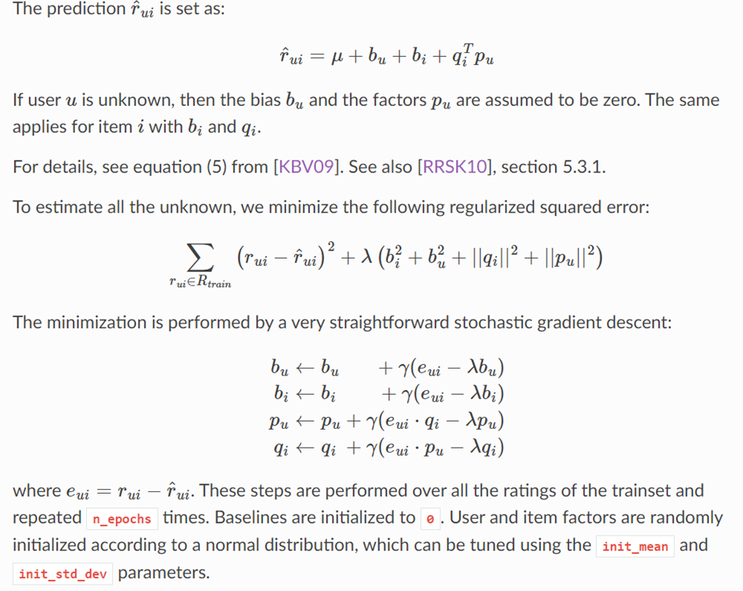

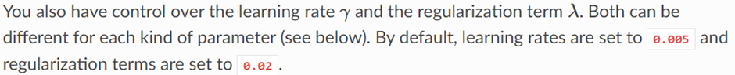

Both screenshots are to explain SVD functions on how the bias and minimization of regularized squared error using stochastic gradient descent. SVD won a third prize for Netflix prize competition, popularized by Simon Funk.

**Pros:**

SVD method has benefits such as reducing data complexity through extraction of latent factors, removing noise, improving algorithm efficiency, and being more reliable than other matrix factorization techniques. SVD also tackles data sparsity and scalability issues in recommendation systems.

**Cons:**

SVD is sensitive to outliers and irrelevant data. SVD also has difficulty in handling implicit feedback data. Many users do not rate their purchased items upon which to base a prediction, therefore collaborative filtering cannot provide recommendations for new items. Accurate recommendations for an item may not be possible until enough ratings have been received, which may take some time even after users start rating the item.

SVD:

| Pros | Cons |
| --- | --- |
| Reducing data complexity through extraction of latent factors | Sensitive to outliers and irrelevant data |
| Remove noise and increase efficiency of the Algorithm | Difficulty in handling implicit feedback data |
| Tackles data sparsity and scalability issues in recommendation systems | Must have enough recommendations to have a decent accuracy |

#### 

#### SVD++:

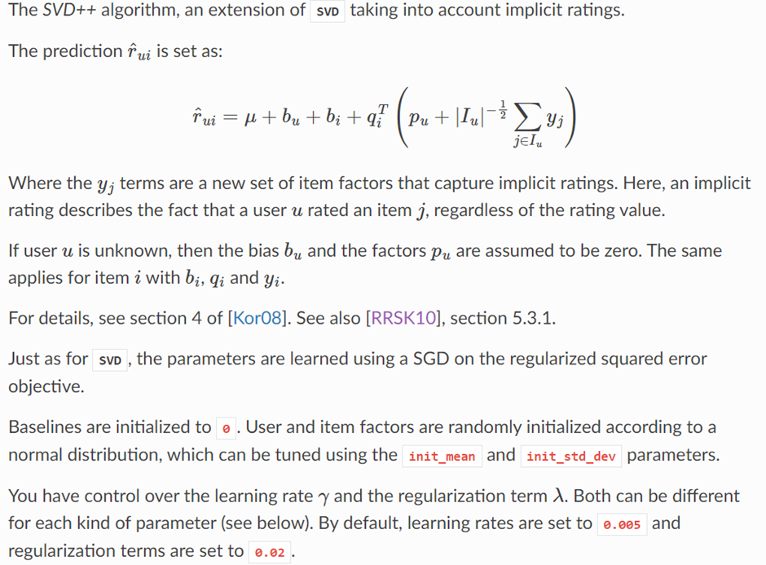

Screenshot taken to explain SVD++ functions.

SVD(++) works by improving Matrix Factorization, matrix R into the product of three matrices: R = U*D*Vt.

**Pros:**

Like SVD, SVD++ can be scalable to fit in large datasets. Nevertheless, SVD++ takes in implicit account ratings.

**Cons:**

SVD++ faces similar cons as SVD. However, SVD++ takes in implicit account ratings, therefore eliminating SVD (difficulty in handling implicit feedback data) drawback.

| Pros | Cons |
| --- | --- |
| Reducing data complexity through extraction of latent factors | Sensitive to outliers and irrelevant data |
| Remove noise and increase efficiency of the Algorithm | Must have enough recommendations to have a decent accuracy |
| Tackles data sparsity and scalability issues in recommendation systems |  |

#### 

#### RandomForestRegressor:

**Pros:**

The RandomForestRegressor contains a bundle of decision trees to make a classification and it is also considered a saving technique when it comes to overfitting of a decision tree model. RandomForestRegressor are efficient to train, depending on the number of trees needed to create.

**Cons:**

A significant drawback of Random Forest is that an excessive number of trees can render the algorithm sluggish and unsuitable for predictions in real-time with sparse data. They tend to be slow when generating predictions after training. The accuracy of prediction can increase due to the greater number of trees. Random forest requires a higher time and space to train the model as a larger number of trees are involved. If the number of weak learners (decision trees) in the Random Forest, represented by n, is not sufficient, it can result in underfitting. On the other hand, if n is excessive, it leads to increased computational cost, and beyond a certain point, increasing n will have minimal impact on improving the model. Therefore, it is essential to find an optimal value of n that balances both the tree number and learning efficiency.

| Pros | Cons: |
| --- | --- |
| Building a bundle of trees helps it to overcome overfitting of a decision tree model | Unsuitable for predictions with sparse data |
| Efficient to train, depending on the number of trees needed to create | Greater the number of trees, the higher time to train |
|  | Sensitive to setting the number of learners (decision trees) which may lead to underfitting or increased computational cost |
|  | Slow when generating predictions after training |

#### 

#### Summary:

| **Machine Learning Algorithms** | **SVD** | **SVD++** | **RandomForestRegressor** |
| --- | --- | --- | --- |
| **Matrix Factorization (with SGD)** | ✔ | ✔✔ | ✖ |
| **Decision Trees** | ✖ | ✖ | ✔ |
| **Scalable for large datasets** | ✔ | ✔ | ✔ |
| **Implicit Account Ratings** | ✖ | ✔ | ✖ |
| **Stop overfitting of dataset** | ✔ | ✔ | ✔ |
| **Sparse data** | ✔ | ✔ | ✖ |
| **Accuracy** | ✔ | ✔✔ | ✔ |

#### 

#### References:

* *https://surprise.readthedocs.io/en* [Online]. Available at: https://surprise.readthedocs.io/en/stable/matrix_factorization.html (Accessed: 30 January 2023).
* *https://sifter.org* [Online]. Available at: https://sifter.org/~simon/journal/20061211.html (Accessed: 31 January 2023).
* *www.mdpi.com* [Online]. Available at: https://www.mdpi.com/2504-2289/6/4/121 (Accessed: 31 January 2023).
* www.analyticsvidhya.com [Online]. Available at: https://www.analyticsvidhya.com/blog/2018/06/comprehensive-guide-recommendation-engine-python/?utm_source=blog&utm_medium=5-applications-singular-value-decomposition-svd-data-science (Accessed: 1 February 2023).
* https://surprise.readthedocs.io [Online]. Available at: https://surprise.readthedocs.io/en/stable/matrix_factorization.html (Accessed: 1 February 2023).
* www.mpdi.com [Online]. Available at: https://www.mdpi.com/2078-2489/11/7/369 (Accessed: 1 February 2023).
* *www.section.io* [Online]. Available at: https://www.section.io/engineering-education/introduction-to-random-forest-in-machine-learning/ (Accessed: 2 February 2023).
* www.rebellionresearch.com [Online]. Available at: https://www.rebellionresearch.com/what-are-the-disadvantages-of-random-forest (Accessed: 2 February 2023).
* https://builtin.com [Online]. Available at: https://builtin.com/data-science/random-forest-algorithm (Accessed: 3 February 2023).

### 

### Programming Languages

#### Analysis of Python vs R

##### Python

**Pros:** Python is a versatile programming language that can be used for a variety of tasks, including web development, data manipulation, and machine learning, due to its general-purpose nature. Even if the designers try to use a lower-level language like C, C++, or Java, it is often more effective to integrate different components using a Python wrapper. Free to download and has many IDEs to code on like Visual Studio, Notepad++ or Jupyter Notebook through Anaconda.

**Cons:** Includes a very few statistical model packages. The Global Interpreter Lock (GIL) makes threading in Python challenging and causes multi-threaded CPU-bound applications tend to perform slower than single-threaded ones. Therefore, for AI projects, it is more advantageous to use multiprocessing instead of multithreaded programming.

| Pros | Cons |
| --- | --- |
| Versatile programming language | Includes a very few statistical model packages |
| Can be used for wide range of tasks such as data manipulation and machine learning | Multi-threaded workloads tend to not work as well and have to use multiprocessing to overcome multithreading |
| Effective to integrate different lower-level languages like C, C++, or Java |  |
| Free to download and has many IDEs to code on like Visual Studio, Notepad++, etc. |  |

##### 

##### R

**Pros:** R is a statistical programming language. R is primarily used for statistical analysis and data visualization. Free to download and have a good IDE like Rstudio.

**Cons:** R has a steep learning curve to new users. Learning every new package slows down development and the lack of comprehensive documentation for R exacerbates the problem. Not backwards compatible with older basic libraries versions e.g. R3.6.3 version, unable to use Hmsic v4.5.

| Pros | Cons |
| --- | --- |
| Statistical programming language | Steep learning curve |
| Good for statistical analysis and data visualization | Lack of comprehensive documentation for packages slows down development speed |
| Free to download and have a good IDE like Rstudio | Not backwards compatible with older machine learning or basic libraries |

##### 

##### Summary

| Programming Language | **Python** | **R** |
| --- | --- | --- |
| Compatible with other languages | ✔ | ✖ |
| Machine Learning packages | ✔ | ✔ |
| Backwards compatible to older libraries | ✔ | ✖ |
| Learning Curve | ✔ | ✖ |
| Free | ✔ | ✔ |

##### References:

* *www.datacamp.com* [Online]. Available at:<https://www.datacamp.com/blog/python-vs-r-for-data-science-whats-the-difference> (Accessed: 6 February 2023).
* *https://towardsdatascience.com* [Online]. Available at:<https://towardsdatascience.com/python-vs-r-whats-best-for-machine-learning-93432084b480> (Accessed: 7 February 2023).

## 

#### Python vs PHP vs Java vs C#

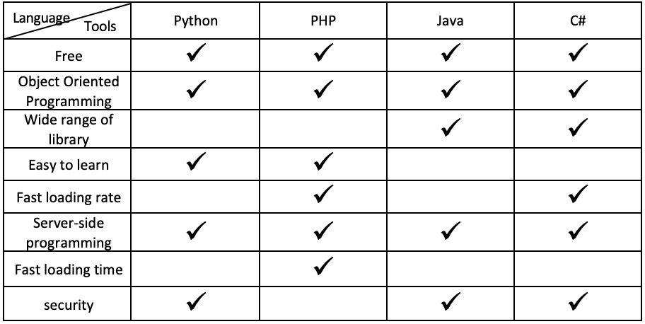

## 

As shown from the table above, we have decided to use PHP as our main web programming language.

PHP is one of the best languages for web development. It is a scripting language mainly used for the server-side of simple, dynamic sites and web apps, which we think will be most suitable for our project.

Although the security for PHP is not the best, we can prevent those vulnerabilities ourselves with good coding practice. One of the examples will be SQL injection. Instead of normal SQL query with no validation or sanitization, we can use a prepared statement to prevent it.

### Database comparison

## 

As shown from the table above, we decided to use MySQL as our database for the web application.

MySQL is one of the most popular relational database systems. It is also renowned for being the most secure and reliable database management system used in web applications. It features a different storage engine framework that facilitates system administrators to configure the MySQL database server for flawless performance.

##### 

### Individual Pros and Cons of language and database chosen

**PHP:**

Pros of PHP:

· Faster rate of loading over slow internet speed.

· Offers embedded HTML programming. Good synergy between HTML and PHP

· Flexible and combines well with other web development technologies.

· Open-source web language, hence, is completely free (budget friendly)

Cons of PHP:

· Security is not at its best as the ACSII text files will be easily accessible.

**MYSQL database:**

Pros of MySQL:

· Assurance of 24/7 uptime.

· offers host-based verification and password encryption.

· It has a unique storage engine that makes the administrator easier to configure.

· High performance. Ensure optimal speed with most demanding applications.

· It is open source and free.

Cons of MySQL:

· It is challenging to debug stored procedures.

· challenging to cope with the syntax of SQL in MySQL.

· limited compliance with SQL standard.

**References:**

<https://www.altexsoft.com/blog/business/comparing-database-management-systems-mysql-postgresql-mssql-server-mongodb-elasticsearch-and-others/>

### Hosting Platforms

#### Hosting platform comparison

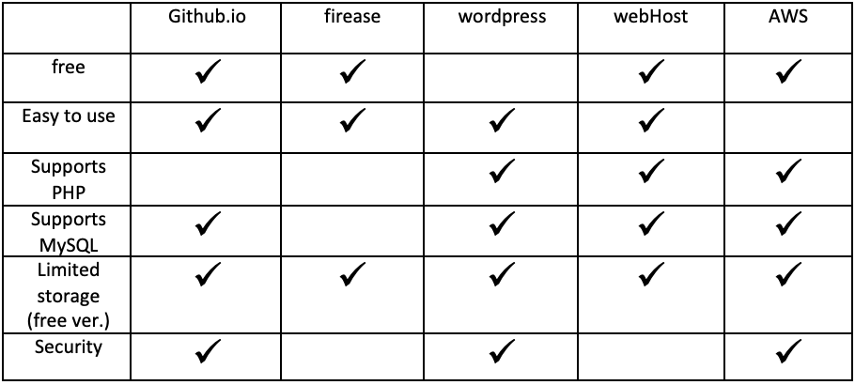

Webhost is an online web hosting platform that is completely free. Although it is not one of the most secure providers as SSL certificates are not included, it has most of the basic features of a paid service.

For security such as password, it will be hashed before storing it in the database.

For now we are using a website called webhost (<https://www.000webhost.com>). But as we progress, we may not be able to use it as if our data set comes in, I think it will hit the limited space of the free version.

The link below is the in-production webpage. One sample data for username as password is also provided. You should be able to log in and out.  
(Username: Tan, Password: Pass123) (https://trailrun123.000webhostapp.com/index.php)

WordPress needs to subscribe to and pay before you can use it, Github.io doesn’t support PHP as we tried it and have to change to HTML before it can run.

For AWS, it is quite complicated. We have tried different ways to play around it and it is not what we are looking for. We followed the steps in YouTube and it was something like we have to have a virtual setup to publish it there.

## Requirements

### Product Features Mind Map

### 

### Functional Requirements

| **#** | **Requirement Description** | **Priority** | **Use Case ID** |
| --- | --- | --- | --- |
| 1 | As an Administrator I want to be able to log in to my account to perform my administrative duties | High | UC1 |
| 2 | As an Administrator I want there to be 2FA secure log in so that unauthorized access to my account is prevented | medium | UC2 |
| 3 | As an Administrator I want to be able to log out of my account so that I can end session for security reasons | High | UC3 |
| 4 | As an Administrator I want to be able to create user accounts for organizations/individuals who subscribe to the service | High | UC4 |
| 5 | As an Administrator I want to be able to edit user accounts information so that I can assist users in editing their information if needed | High | UC5 |
| 6 | As an Administrator I want to delete user accounts to reduce the risk of inactive accounts | High | UC6 |
| 7 | As an Administrator I want to manage user account so that I can change their account status (suspend/available) and change their price plan for them | Medium | UC7 |
| 8 | As an Administrator I want to be able to monitor users’ subscription plans so that I can help remind/prompt them for renewal | High | UC8 |
| 9 | As a Organization I want to be able to login to access the website workspace and use the service | High | UC9 |
| 10 | As an Organization I want there to be 2FA secure log in so that unauthorized access to my account is prevented | medium | UC10 |
| 11 | As a Organization I want to be able to log out so I can end the session and prevent unauthorized access/use of my account | High | UC11 |
| 12 | As an Organization I want to be able to create my own user account to access and use the service | High | UC12 |
| 13 | As an Organization I want to be able to choose what category of products I am selling so that I get more relevant rating predictions and recommendations on products | High | UC13 |
| 14 | As an Organization I want to be able to edit the category of products I am selling so that I get more relevant rating predictions and recommendations on products | High | UC14 |
| 15 | As an Organization I want to be able to edit my account information so I can edit my details if there are changes | High | UC15 |
| 16 | As an Organization I want to be able to upload my own customer data set into the system to create the predictive model used for ratings prediction and recommendations | High | UC16 |
| 17 | As an Organization I want to be able to delete my uploaded data set so that I remove old data set that is no longer relevant | High | UC17 |
| 18 | As an Organization I want to be able to able to use my uploaded data to generate a ratings prediction to predict how a user ‘x’ will rate a product ‘x’ | High | UC18 |
| 19 | As an Organization I want to be able to use my uploaded data generate product recommendations based on the entered product so that I can recommend them to my customers | High | UC19 |
| 20 | As an Organization I want to be able to add a list of URLs so that those ecommerce sites can be crawled and be used to create a new prediction model | High | UC20 |
| 21 | As an Organization I want RECS to crawl the URL links i uploaded, so that they can create a new prediction algorithm based on that for me to use | High | UC21 |
| 22 | As an Organization I want to be able to generate a ratings prediction based on the crawled URLs to predict how a user ‘x’ will rate a product ‘x’ | High | UC22 |
| 23 | As an Organization I want to be able to generate product recommendations of a product I entered, based on the crawled URLs so that I can use them to recommend to my customers | High | UC23 |
| 24 | As an Organization I want to be able to able to use RECS’ data to generate a ratings prediction to predict how a user ‘x’ will rate a product ‘x’ | High | UC24 |
| 25 | As an Organization I want to be able to use RECS’ data generate product recommendations based on the entered product so that I can recommend them to my customers | High | UC25 |
| 26 | As an Organization I want to be able to view the result history of ratings/recommendations I generated | Medium | UC26 |
| 27 | As an Organization I want to be able to upgrade my subscription plan so that I can use the features freely | High | UC27 |
| 28 | As an Organization I want to be able to monitor my plan’s expiry so that I can know when to renew the plan | High | UC28 |
| 29 | As an Individual I want to be able to login to access the web workspace and service | High | UC29 |
| 30 | As an Individual I want 2FA I want there to be 2FA secure log in so that unauthorized access to my account is prevented | Medium | UC30 |
| 31 | As an Individual I want to be able to log out so that I can end my session to ensure no unauthorized access/use of my account | High | UC31 |
| 32 | As an Individual I want to be able to create a user account to access and use the service | High | UC32 |
| 33 | As an Individual I want to be able to choose what category of products I am interested in so that I get more relevant rating predictions and recommendations on products | High | UC33 |
| 34 | As an Individual I want to be able to edit the category of products I am interested in so that I get more relevant rating predictions and recommendations on products | High | UC34 |
| 35 | As an Individual I want to be able to edit my account information to edit my details if there are any changes | High | UC 35 |
| 36 | As an Individual I want to be able to able to use RECS’ data to generate a ratings prediction to predict how a user ‘x’ will rate a product ‘x’ | High | UC36 |
| 37 | As an Individual I want to be able to use RECS’ data generate product recommendations based on a product i enter so i can get recommendations for similar products | High | UC37 |
| 38 | As an Individual I want to be able to add a list of URLs so that those ecommerce sites can be crawled and be used to create a new prediction model | High | UC38 |
| 39 | As an Individual I want RECS to crawl the URL links i uploaded, so that they can create a new prediction algorithm based on that for me to use | High | UC39 |
| 40 | As an Individual I want to be able to generate a ratings prediction based on the crawled URLs to predict how a user ‘x’ will rate a product ‘x | High | UC40 |
| 41 | As an Individual I want to be able to retrieve recommendations based on the crawled URLs so that I can get product recommendations for the product I entered | High | UC41 |
| 42 | As an Individual I want to be able view result history of ratings and recommendations I generated | Medium | UC42 |
| 43 | As an Individual I want to be able to upgrade my subscription plan so that I can use of all the features available without limits | High | UC43 |
| 44 | As an Individual I want to be able to monitor my plan expiry plan so that I can know when to renew my subscription | High | UC44 |

#### 

#### Administrator Use Cases

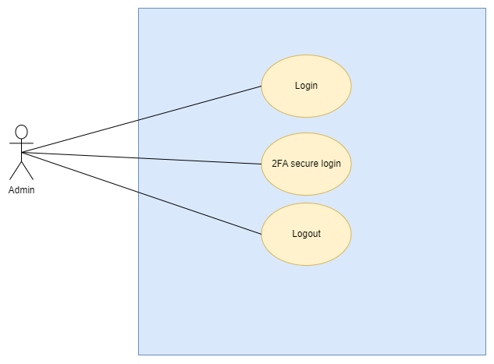

*Figure 1: UC1,UC2,UC3*

Use Case Description 1 & 2

| Use Case ID | UC1 & UC2 |
| --- | --- |
| Use Case Name | Admin login & 2FA verification |
| Actor(s) | Admin |
| Goal | Admin is able to login to their account |
| Pre-Condition | Admin already has an account created |
| Post-Condition | Admin successfully logged in |
| Trigger(s) | Admin wants to log in to their account |
| Main Flow | 1. Admin sees website display form asking for login credentials 2. Admin enters credentials 3. Clicks the “sign in” button 4. Website authenticates the login credentials 5. Website asks Admin to enter the 2FA code sent to the registered email 6. Admin enters the received 2FA code 7. Website verifies the 2FA code and redirect Admin to the home page. 8. End of flow |
| Sub Flow | N.A |
| Exception | Invalid password:   1. Admin see error message “Incorrect password” 2. Admin re-enters their credentials 3. Admin clicks “sign in” and gets authenticated 4. Redirected to the 2FA page 5. End of flow   Invalid 2FA code:   1. Admin sees “verification failed” 2. Admin re-enters the 2FA code 3. website verifies the code 4. Admin redirected to home page 5. End of flow |

Use Case Description 3

| Use Case ID | UC3 |
| --- | --- |
| Use Case Name | Admin log out |
| Actor(s) | Admin |
| Goal | Admin is able to log out of their account |
| Pre-Condition | Admin already logged in their account |
| Post-Condition | Admin successfully logs out of their account |
| Trigger(s) | Admin wants to log out to their account to end their session |
| Main Flow | 1. Admin clicks the “logout” button 2. website logs admin out 3. Admin will be redirected back to the login page 4. Session ended 5. End of flow |
| Sub Flow | N.A |
| Exception | N.A |

*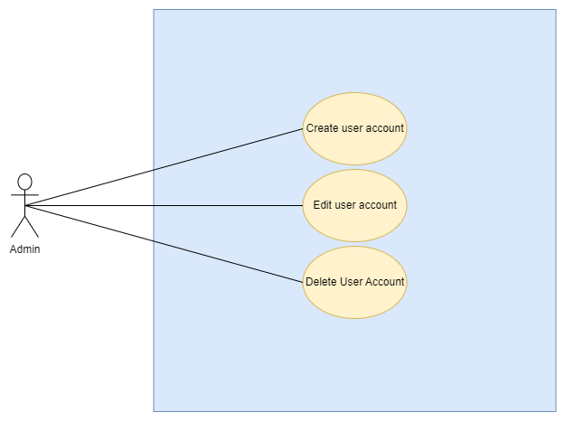 Figure 2: UC4, UC5, UC6*

Use Case Description 4

| Use Case ID | UC4 |
| --- | --- |
| Use Case Name | Admin creates user account |
| Actor(s) | Admin |
| Goal | Admin will be able to create user accounts for Organization/Individual/Admin user |
| Pre-Condition | Admin must be logged into their account |
| Post-Condition | A new user account has been created |
| Trigger(s) | Admin creating a user account for new Organization/Individual/Admin user |
| Main Flow | 1. Admin clicks on the “create new account” button 2. A new account form is displayed by website 3. Admin chooses the respective type of form (organization/individual/admin) and fills in the informations of the new user 4. Admin makes password for the new user to use for logging in 5. Admin clicks “create” button to submit 6. The website validates and stores the new account and its information 7. New user account has been created 8. End of flow |
| Sub Flow | N.A |
| Exception | Invalid input:   1. Website display error “password does not match” 2. Repeat main flow 3. End of flow |

Use Case Description 5

| Use Case ID | UC5 |
| --- | --- |
| Use Case Name | Admin edits user account |
| Actor(s) | Admin |
| Goal | Admin will be able to edit user accounts for Organization/Individual users |
| Pre-Condition | Admin must be logged into their account  User account has to exists/already been created  Admin is at manage accounts page |
| Post-Condition | User account information has been edited. |
| Trigger(s) | Organization/Individual user asks admin to help edit their user account information |
| Main Flow | 1. Admin clicks on the “edit” button 2. Website displays edit form 3. Admin changes the informations of the user as per requested 4. Admin clicks “update” button to submit 5. The website validates and stores changes made 6. User account successfully edited 7. User account reflect changes made 8. End of flow |
| Sub Flow | N.A |
| Exception | Invalid input:   1. Website display error pop up “password does not match” 2. Repeat main flow 3. End of flow   Admin cancels:   1. Admin clicks “cancel” button 2. Admin redirected to the manage accounts page 3. End of flow |

Use Case Description 6

| Use Case ID | UC6 |
| --- | --- |
| Use Case Name | Admin deletes user account |
| Actor(s) | Admin |
| Goal | Deleting inactive organization/individual/admin user accounts |
| Pre-Condition | Admin logged into their account  User account has to exist/already been created  Admin is at manage accounts page |
| Post-Condition | Selected user account is successfully deleted. |
| Trigger(s) | Admin deletes user account of organization/individual/admin accounts that are no longer active  Organization/Individual users request for their account to be deleted |
| Main Flow | 1. Admin clicks “delete” button 2. Admin redirected to delete page displaying user account to be deleted 3. Admin clicks “delete” 4. website deletes stored user account information 5. Page refreshes and user account successfully deleted 6. End of flow |
| Sub Flow | N.A |
| Exception | Cancel:   1. On Delete page Admin clicks cancel 2. User account not deleted 3. End of flow |

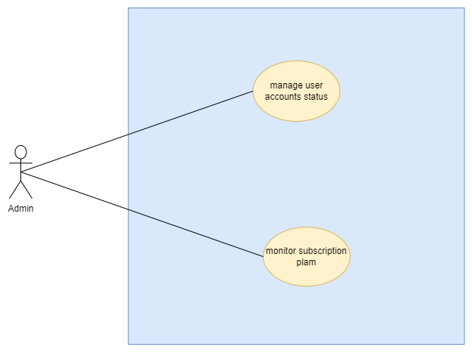

*Figure 3: UC7 and UC8*

Use Case Description 7

| Use Case ID | UC7 |
| --- | --- |
| Use Case Name | Admin manages user account |
| Actor(s) | Admin |
| Goal | To change Organization/Individual accounts status from available to suspend and vice versa, this is to suspend users who violate our website's terms of service |
| Pre-Condition | Admin logged into their account  User account has to exist/already been created  Admin at the manage accounts page |
| Post-Condition | Selected user account is suspended or is made available again |
| Trigger(s) | Admin suspending Organization/Individual users’ account of those who violate our website's terms of service  Admin wants to unsuspend their account and make it available again |
| Main Flow | Suspend account:   1. Admin clicks “manage account” button 2. Admin redirected to manage user page displaying the user account’s detail 3. Admin changes account status to“suspend” 4. Clicks confirm 5. Admin redirected to main manage accounts page and user account successfully suspended 6. End of flow |
| Sub Flow | Unsuspend account:   1. Admin clicks “manage account” button 2. Admin redirected to manage user page displaying the user account’s detail 3. Admin changes account status to“Available” 4. Clicks confirm 5. website changes the user account status 6. Admin redirected to main manage accounts page and user account successfully unsuspended and made available again 7. End of flow |
| Exception | N.A |

Use Case Description 8

| Use Case ID | UC8 |
| --- | --- |
| Use Case Name | Admin monitors user’s subscription plan |
| Actor(s) | Admin |
| Goal | Admin is able to monitor each user’s subscription plan and when it expires so that Admin can help remind the Organization/Individual users’ to renew their plan |
| Pre-Condition | Admin logged into their account, in the manage accounts page |
| Post-Condition | nil |
| Trigger(s) | Admin wants to check and see how long till an Organization/Individual user subscription plan expires |
| Main Flow | 1. Admin clicks “manage” button 2. Admin is redirected to the manage user page displaying the user info of the selected account 3. Admin can see on the manage user page the number of days left till expiry of the user’s current subscription plan 4. End of flow |
| Sub Flow | N.A |
| Exception | N.A |

#### Organization Use Cases

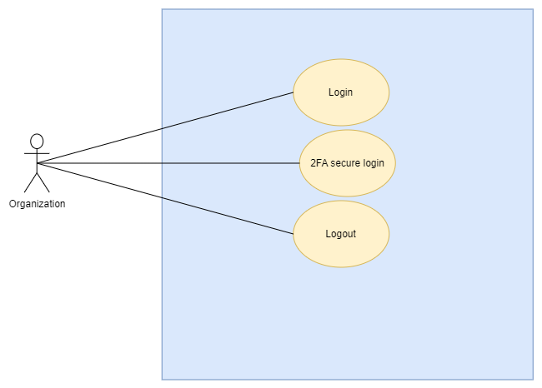

*Figure 4: UC9, UC10, UC11*

Use Case Description 9 & 10

| Use Case ID | UC9 & UC10 |
| --- | --- |
| Use Case Name | Organization login and 2FA verification |
| Actor(s) | Organization user |
| Goal | Organization user able to log in and access their account |
| Pre-Condition | Organization already created an account |
| Post-Condition | Organization successfully logged in to the account |
| Trigger | Organization wants to login and access the service |
| Main Flow | 1. Organization user sees website display form asking for login credentials 2. User enters credentials 3. Clicks the “sign in” button 4. Website authenticates the login credentials 5. Website asks Organization user to enter the 2FA code sent to the registered email 6. User enters the received 2FA code 7. Website verifies the 2FA code and redirects user to the home page. 8. End of flow |
| Sub Flow | N.A |
| Exception | Invalid password:   1. User see error message “Incorrect password” 2. User re-enters their credentials 3. User clicks “sign in” and gets authenticated 4. Redirected to the 2FA page 5. End of flow |

Use Case Description 11

| Use Case ID | UC11 |
| --- | --- |
| Use Case Name | Organization log out |
| Actor(s) | Organization user |
| Goal | Organization User is able to log out of their account |
| Pre-Condition | Organization user already logged in their account |
| Post-Condition | Organization successfully logs out of their account |
| Trigger(s) | Organization wants to log out to their account to end their session |
| Main Flow | 1. Organization user clicks the “logout” button 2. website logs user out 3. User will be redirected back to the login page 4. Session ended 5. End of flow |
| Sub Flow | N.A |
| Exception | N.A |

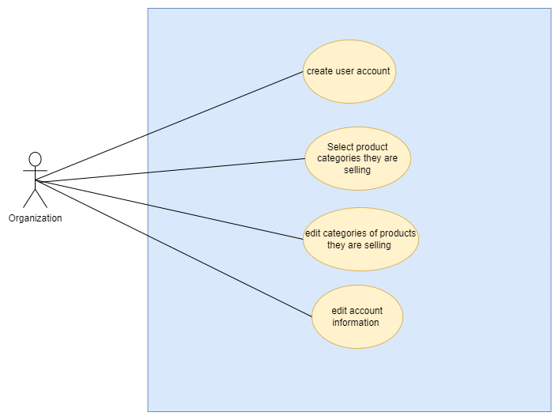

*Figure 5:UC12, UC13, UC14 and UC15*

Use Case Description 12 & 13

| Use Case ID | UC12 & 13 |
| --- | --- |
| Use Case Name | Organization creates user account and selects category of product they sell |
| Actor(s) | Organization user |
| Goal | Organization will be able to create their own user account |
| Pre-Condition | Organization is at the sign up page |
| Post-Condition | A new Organization user account has been created |
| Trigger(s) | Organization creating a new user account for themselves |
| Main Flow | 1. Organization user fills in their necessary information 2. User enters password for them to use for logging in 3. User clicks “Continue” button to submit 4. Website gets Organization user to select the type of product they sell 5. User selects as many categories as they want and click “Sign up” button 6. Website sends Organization user verification code to their registered email to confirm and verify email 7. User enters the received verification code 8. End of flow |
| Sub Flow | N.A |
| Exception | Invalid password:   1. Website display error message“invalid Password” 2. Repeat main flow (from entering the password) 3. End of flow |

Use Case Description 14

| Use Case ID | UC14 |
| --- | --- |
| Use Case Name | Organization edit the category of products they sell |
| Actor(s) | Organization user |
| Goal | Organization edits the category of products they are selling |
| Pre-Condition | Organization has to be logged into their user account and be on their profile page |
| Post-Condition | Organization user “Types of product sold” edited |
| Trigger(s) | Organization wants to change and update the categories of products they sell |
| Main Flow | 1. Organization user clicks “Edit” 2. Website redirects user to edit category page and displays the categories they can choose from 3. User selects the categories they want 4. User clicks “confirm” at the bottom right 5. Website saves changes and update database 6. Website redirects to profile page and display newly selected categories 7. End of flow |
| Sub Flow | N.A |
| Exception | Cancel:   1. Organization user clicks “cancel” at the top right 2. Website redirects back to the profile page 3. End of flow |

Use Case Description 15

| Use Case ID | UC15 |
| --- | --- |
| Use Case Name | Organization user wants to edit their account information |
| Actor(s) | Organization users |
| Goal | Organization edits their user account information |
| Pre-Condition | Organization has to be logged into their user account and at the account setting page |
| Post-Condition | Organization user account information has been edited |
| Trigger(s) | Organization wants to change and update their user account information (e.g name, password, organization name and website) |
| Main Flow  (1st example : password) | 1. Organization clicks “edit” on the password field 2. User will be redirected to the edit password page being prompted for current password, new password and to confirm new password 3. Organization makes changes to their user info that they wanted to update 4. Organization clicks “confirm” at the bottom right 5. Website saves changes and update database 6. Website redirects Organization back to account settings page and display newly updated info 7. End of flow |
| Sub Flow (example 2: Organization Name) | 1. Organization clicks “edit” on the Organization website field 2. User will be redirected to a page where they can update the new website 3. Organization makes changes to their user info that they wanted to update 4. Organization clicks “confirm” at the bottom right 5. Website saves changes and update database 6. Website redirects Organization back to account settings page and display newly updated info 7. End of flow |
| Exception | Cancel:   1. Organization clicks “cancel” at the top right 2. Website redirects user back to the account settings page without any changes 3. End of flow   Invalid password:   1. Organization sees error message next to text field saying “passwords do not matcht” 2. Repeat main flow (from 4) 3. End of flow |

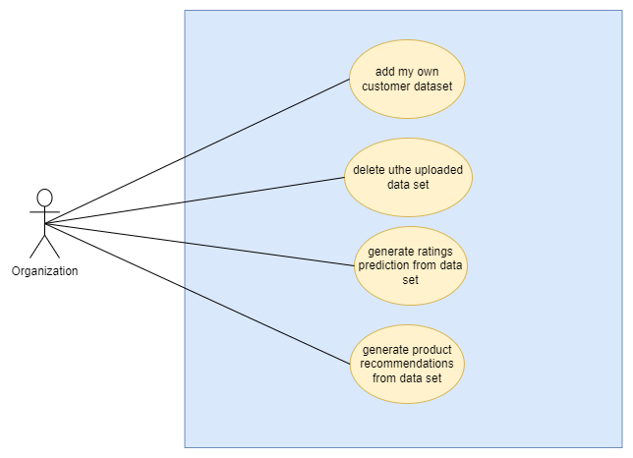

*Figure 6: UC16, UC17, UC18, UC19*

Use Case Description 16

| Use Case ID | UC16 |
| --- | --- |
| Use Case Name | Organization user add their own data set |
| Actor(s) | Organization user |
| Goal | Organization will be able to input their own data set for RECS system to learn |
| Pre-Condition | Organization must have already been logged into their account at the “Workspace” -> “Add Data Set” page |
| Post-Condition | Data set added into RECS system |
| Trigger(s) | Organization wants to input their own customer data set into the RECS system to train it |
| Main Flow | 1. Organization clicks on the “choose file” button 2. File explorer is popup appears prompting Organization to upload their data set 3. Organization clicks “upload” after selecting the file has been added 4. Website takes the data set and sends it to the RECS backend where a directory will be created to store the dataset 5. RECS system process and learn the data set 6. Website redirects Organization user to the “Uploaded Data Set” page displaying “The file has been uploaded” 7. End of flow |
| Sub Flow | N.A |
| Exception | Cancel:   1. Organization clicks “cancel” 2. file explorer window close 3. End of flow |

Use Case Description 17

| Use Case ID | UC17 |
| --- | --- |
| Use Case Name | Organization deletes the previously added data set |
| Actor(s) | Organization user |
| Goal | Organization user will be able to delete the data set previously uploaded so they can remove the dataset when that dataset becomes irrelevant |
| Pre-Condition | Organization user must have already been logged into their account  Organization user must have already added a data set previously  Organization user must be at the uploaded data set page |
| Post-Condition | New Data set inputted into RECS system |
| Trigger(s) | Organization wants to change/update the previous data set |
| Main Flow | 1. Organization clicks on the “delete” button 2. A popup appears prompting Organization to confirm 3. Organization clicks “ok” button at the bottom of popup 4. Website takes removes data set from RECS backend system 5. End of flow |
| Sub Flow | N.A |
| Exception | Cancel:   1. Organization clicks “cancel” 2. Popup window close, data set file doesn’t get deleted 3. End of flow |

Use Case Description 18

| Use Case ID | UC18 |
| --- | --- |
| Use Case Name | Organization generates predicted rating using uploaded dataset |
| Actor(s) | Organization user |
| Goal | Organization generates predicted rating for products based on the data set they input into RECS |
| Pre-Condition | Organization must have already been logged into their account  Organization must have already added a data set into RECS  Organization user currently on the “Generate Ratings/Recommendations (your data)” page |
| Post-Condition | RECS generates and return predicted rating of user x for product x as requested by Organization user (using Organization’s dataset) |
| Trigger(s) | Organization user to wants generate predicted rating of product ‘x” by user ‘x’ based on their data set that they added |
| Main Flow | 1. Organization clicks on the “generate rating” tab 2. User redirected to predicted ratings page 3. User sees a text field prompting for user to enter user ID and product ID for user to enter 4. User enters the user ID and product ID that they want to predict ratings for 5. Click “generate” 6. RECS processes request and returns predicted rating 7. End of flow |
| Sub Flow | N.A |
| Exception | Invalid input:   1. Organization sees error message next to text field “user ID does not exist” 2. Repeat main flow (from 4) 3. End of flow |

Use Case Description 19

| Use Case ID | UC19 |
| --- | --- |
| Use Case Name | Organization user generate recommendations using their dataset |
| Actor(s) | Organization user |
| Goal | Organization generates recommendations for products that are similar to well-liked products they enter from their added dataset |
| Pre-Condition | Organization must have already been logged into their account  Organization must have already added a data set into RECS  Organization user currently on the “Generate Ratings/Recommendations (your data)” page |
| Post-Condition | RECS generates recommendations of products to suggest to their customer base |
| Trigger(s) | Organization wants get recommendations of products similar to the well-liked products in their given data set |
| Main Flow | 1. Organization user clicks on the “recommendations” tab 2. User redirected to predicted recommendations page 3. User enters product ID and clicks “generate” button 4. Website sends request to RECS 5. RECS processes request and returns recommendations 6. Website displays recommendations 7. End of flow |
| Sub Flow | N.A |
| Exception | Wrong product ID:   1. Organization user sees error message “Product ID incorrect please try again. 2. Repeat main flow (from step 3) 3. End of flow |

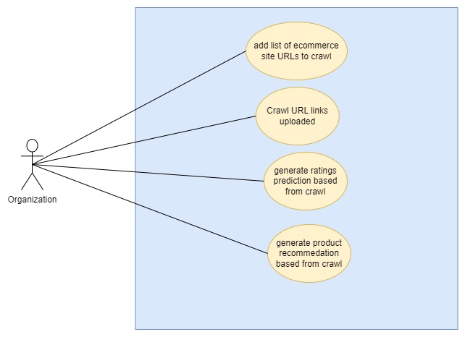

*Figure 7: UC20, UC21, UC22, UC23*

Use Case Description 20

| Use Case ID | UC20 |
| --- | --- |
| Use Case Name | Organization user add a list of URL link |
| Actor(s) | Organization user |
| Goal | Organization will be able to input a list of URL links for RECS to crawl |
| Pre-Condition | Organization must have already been logged into their account at the “Workspace” -> “Add List of URLs” page |
| Post-Condition | List added into RECS system |
| Trigger(s) | Organization wants to input a list of URL links for RECS to crawl |
| Main Flow | 1. Organization clicks on the “choose file” button 2. File explorer is popup appears prompting Organization to upload a text file containing the list of URL links 3. Organization clicks “upload” after selecting the file has been added 4. Website takes the URL list and sends it to the RECS backend where a directory will be created to store the URL list 5. Website redirects Organization user to the “Uploaded List of URLs” page displaying “The file has been uploaded” 6. End of flow |
| Sub Flow | N.A |
| Exception | Cancel:   1. Organization clicks “cancel” 2. file explorer window close 3. End of flow |

Use Case Description 21

| Use Case ID | UC21 |
| --- | --- |
| Use Case Name | RECS crawls URL links found in text file uploaded |
| Actor(s) | Organization user |
| Goal | Organization user wants to use RECS’ web crawling service and crawl the URL links uploaded in the text file |
| Pre-Condition | Organization user must have already been logged into their account  Organization user must have already added a list of URL links  Organization user must be at the “Uploaded List of URLs” page |
| Post-Condition | RECS’ crawled URL links and has new data to use for the predicted ratings and recommendations |
| Trigger(s) | Organization wants RECS’ to crawl their uploaded list of URLs |
| Main Flow | 1. Organization clicks on the “crawl” button 2. RECS begin to crawl in the background on the backend 3. Once done, a pop up message appears saying “crawled” 4. End of flow |
| Sub Flow | N.A |
| Exception | N.A |

Use Case Description 22

| Use Case ID | UC22 |
| --- | --- |
| Use Case Name | Organization user generates predicted rating from Crawled URLs |
| Actor(s) | Organization user |
| Goal | Organization generates predicted rating for products based on RECS on web crawling service |
| Pre-Condition | Organization user must have already been logged into their account  Uploaded a list of URL links that has to already been crawled  At the “Generate Ratings/Recommendations (uploaded URL)” page |
| Post-Condition | RECS generates and return predicted rating (using the crawled URL links) of user x for product x as requested by Organization user |
| Trigger(s) | Organization wants generate and find predicted rating for products they input to RECS, based on the crawled URL links |
| Main Flow | 1. Organization user clicks on the “generate ratings” tab 2. User redirected to predicted ratings page 3. User sees a text field prompting for user to enter user ID and product ID for user to enter 4. User enters the user ID and product ID that they want to predict ratings for 5. Click “generate” 6. RECS processes request and returns predicted rating 7. End of flow |
| Sub Flow | N.A |
| Exception | Invalid input:   1. Organization sees error message next to text field “user ID does not exist” 2. Repeat main flow (from 4) 3. End of flow |

Use Case Description 23

| Use Case ID | UC23 |
| --- | --- |
| Use Case Name | Organization retrieve recommendations from Crawled URLs |
| Actor(s) | Organization |
| Goal | Organization generates recommendations for products that are well-liked products found from RECS own web crawling |
| Pre-Condition | Organization user must have already been logged into their account  Uploaded a list of URL links that has to already been crawled  At the “Generate Ratings/Recommendations (uploaded URL)” page |
| Post-Condition | RECS generates recommendations of products to suggest to their customer base |
| Trigger(s) | Organization wants get recommendations of products that are well-liked products from RECS web crawling other e-commerce site |
| Main Flow | 1. Organization user clicks on the “recommendations” tab 2. User redirected to predicted recommendations page 3. User enters product ID and clicks “generate” button 4. Website sends request to RECS 5. RECS processes request and returns recommendations 6. Website displays recommendations 7. End of flow |
| Sub Flow | N.A |
| Exception | Wrong product ID:   1. Organization user sees error message “Product ID incorrect please try again. 2. Repeat main flow (from step 3) 3. End of flow |

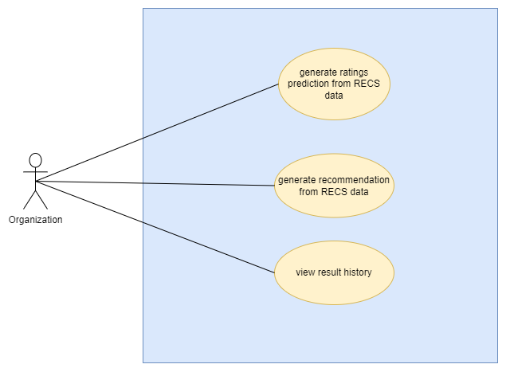

*Figure 8: UC24, UC25 and UC26*

Use Case Description 24

| Use Case ID | UC24 |
| --- | --- |
| Use Case Name | Organization generates predicted rating using RECS’ data |
| Actor(s) | Organization user |
| Goal | Organization generates predicted rating for products based on the RECS’ default crawled data |
| Pre-Condition | Organization must have already been logged into their account  Organization user currently on the “Generate Ratings/Recommendations (Our data)” page |
| Post-Condition | RECS generates and return predicted rating of user x for product x as requested by Organization user using our default data |
| Trigger(s) | Organization user to wants generate predicted rating of product ‘x’ by user ‘x’ |
| Main Flow | 1. Organization clicks on the “generate rating” tab 2. User redirected to predicted ratings page 3. User sees a text field prompting for user to enter user ID and product ID for user to enter 4. User enters the user ID and product ID that they want to predict ratings for 5. Click “generate” 6. RECS processes request and returns predicted rating 7. End of flow |
| Sub Flow | N.A |
| Exception | Invalid input:   1. Organization sees error message next to text field “user ID does not exist” 2. Repeat main flow (from 4) 3. End of flow |

Use Case Description 25

| Use Case ID | UC25 |
| --- | --- |
| Use Case Name | Organization user generate recommendations using RECS’ data |
| Actor(s) | Organization user |
| Goal | Organization generates recommendations for products that are similar to well-liked products from RECS’ default dataset |
| Pre-Condition | Organization must have already been logged into their account  Organization user currently on the “Generate Ratings/Recommendations (your data)” page |
| Post-Condition | RECS generates recommendations of products to suggest to their customer base |
| Trigger(s) | Organization wants get recommendations of products similar to the well-liked products |
| Main Flow | 1. Organization user clicks on the “recommendations” tab 2. User redirected to predicted recommendations page 3. User enters product ID and clicks “generate” button 4. Website sends request to RECS 5. RECS processes request and returns recommendations 6. Website displays recommendations 7. End of flow |
| Sub Flow | N.A |
| Exception | Wrong product ID:   1. Organization user sees error message “Product ID incorrect please try again. 2. Repeat main flow (from step 3) 3. End of flow |

Use Case Description 26

| Use Case ID | UC26 |
| --- | --- |
| Use Case Name | Organization view history |
| Actor(s) | Organization user |
| Goal | View the history of the predicted ratings and/or recommendations of products that they retrieved previously |
| Pre-Condition | Organization is logged into their account  Organization has previously retrieved either a predicted rating of a product or retrieved recommended product |
| Post-Condition | Organization all previously retrieved rating/recommendation |
| Trigger | Organization wants to check what product they had previously viewed the predicted ratings for and/or the recommended products they previously checked |
| Main Flow | 1. At the workspace page, Organization clicks “results” under “History” section 2. Website process request and gets the necessary information from database 3. Organization is brought to results page 4. History of all the types of generated results (both prediction ratings and recommendation ) are displayed 5. End of flow |
| Sub Flow | N.A |
| Exception | N.A |

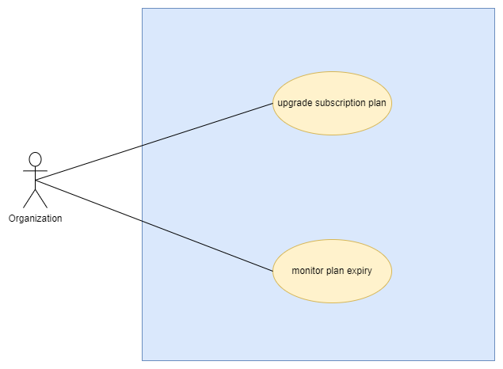

*Figure 9: UC27 and UC28*

Use Case Description 27

| Use Case ID | UC27 |
| --- | --- |
| Use Case Name | Organization wants to be upgrade subscription plan |
| Actor(s) | Organization user |
| Goal | Organization can upgrade their subscription plan according to which ever plan they feel more suitable |
| Pre-Condition | Organization logged into their account  Organization user is at the upgrade plans page |
| Post-Condition | Organization will have upgraded their account to either the standard plan or pro plan |
| Trigger(s) | Organization wants to upgrade their subscription plan |
| Main Flow | 1. Organization user clicks “upgrade to standard” 2. User is redirected to the payment page 3. User fills in their payment details and click pay 4. RECS processes the payment and updates the Organization user’s price plan RECS user database 5. User is redirected to a payment summary page 6. End of flow |
| Sub Flow | 1. Organization user clicks “upgrade to pro” 2. User is redirected to the payment page 3. User fills in their payment details and click pay 4. RECS processes the payment and updates the Organization user’s price plan RECS user database 5. User is redirected to a payment summary page 6. End of flow |
| Exception | N.A |

Use Case Description 28

| Use Case ID | UC28 |
| --- | --- |
| Use Case Name | Organization user wants to be able to monitor plan expiry |
| Actor(s) | Organization user |
| Goal | Organization can monitor when their subscription plan expires so they can renew their plan before expiry |
| Pre-Condition | Organization logged into their account |
| Post-Condition | Organization will be able to see their current plan and days till expiry/renewal |
| Trigger(s) | Organization wants to check when their subscription plan expires |
| Main Flow | 1. Organization user once logs lands on home page 2. On the top right next to “Upgrade plan” and the profile button, subscription type and days left till expiry can be seen 3. End of flow |
| Sub Flow | 1. Organization user can click on the current plan 2. Click on the billing tab 3. Organization user will be able to see the more specific next billing date |
| Exception | N.A |

#### Individual Use Cases

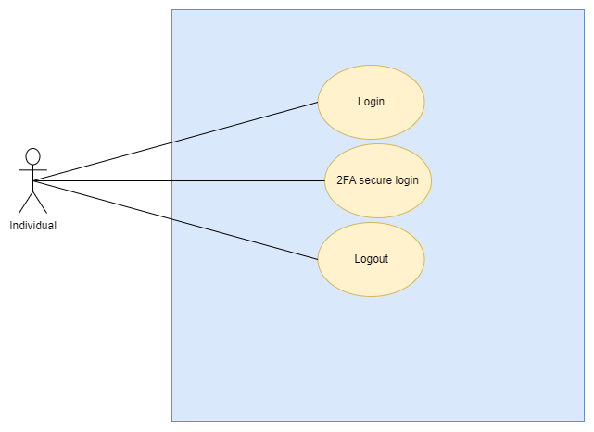

*Figure 10: UC29, UC30 and UC31*

Use Case Description 29 & 30

| Use Case ID | UC29 & 30 |
| --- | --- |
| Use Case Name | Individual login & 2FA verification |
| Actor(s) | Individual users |
| Goal | Individual user is able to login to their account |
| Pre-Condition | Individual user already has an account created |
| Post-Condition | Individual user successfully logged in |
| Trigger(s) | Individual wants to log in to their account |
| Main Flow | 1. Individual user sees website display form asking for login credentials 2. Individual enters credentials 3. Clicks the “sign in” button 4. Website authenticates the login credentials 5. Website asks Individual user to enter the 2FA code sent to the registered email 6. Individual user enters the received 2FA code 7. Website verifies the 2FA code and redirect user to the home page. 8. End of flow |
| Sub Flow | N.A |
| Exception | Invalid Password:   1. Individual user see error message “Incorrect password” 2. User re-enters their credentials 3. User clicks “sign in” and gets authenticated 4. Redirected to the 2FA page 5. End of flow   Invalid 2FA code:   1. User sees “verification failed” 2. User re-enters the 2FA code 3. website verifies the code 4. user redirected to home page 5. End of flow |

Use Case Description 31

| Use Case ID | UC31 |
| --- | --- |
| Use Case Name | Individual log out |
| Actor(s) | Individual user |
| Goal | Individual user is able to log out of their account |
| Pre-Condition | Individual already logged in their account |
| Post-Condition | Individual successfully logs out of their account |
| Trigger(s) | Individual user wants to log out to their account to end their session |
| Main Flow | 1. Individual user clicks the “logout” button 2. website logs admin out 3. User will be redirected back to the login page 4. Session ended 5. End of flow |
| Sub Flow | N.A |
| Exception | N.A |

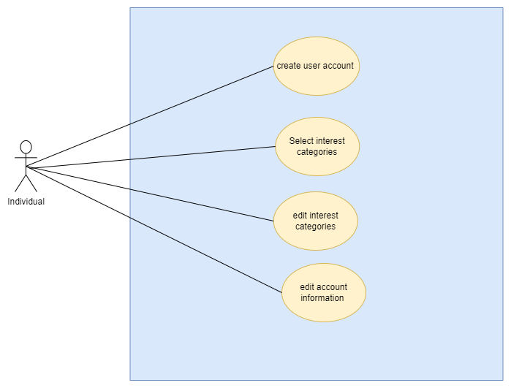

*Figure 11: UC32,UC33,UC34 and UC35*

Use Case Description 32 & 33

| Use Case ID | UC32 & 33 |
| --- | --- |
| Use Case Name | Individual creates user account and selects category of product they sell |
| Actor(s) | Individual user |
| Goal | Individual will be able to create their own user account |
| Pre-Condition | Individual is at the sign up page |
| Post-Condition | A new Individual user account has been created |
| Trigger(s) | Individual creating a new user account for themselves |
| Main Flow | 1. Individual user fills in their necessary information 2. User enters password for them to use for logging in 3. User clicks “Continue” button to submit 4. Website gets Individual user to select the type of product they sell 5. User selects as many categories as they want and click “Sign up” button 6. Website sends Individual user verification code to their registered email to confirm and verify email 7. User enters the received verification code 8. End of flow |
| Sub Flow | N.A |
| Exception | Invalid password:   1. Website display error message “password does not match” 2. Repeat main flow (from entering the password) 3. End of flow |

Use Case Description 34

| Use Case ID | UC34 |
| --- | --- |
| Use Case Name | Individual user edit the category of products they sell |
| Actor(s) | Individual user |
| Goal | Individual edits the category of products they are selling |
| Pre-Condition | Individual has to be logged into their user account and be on their profile page |
| Post-Condition | Individual user “Types of product sold” edited |
| Trigger(s) | Individual wants to change and update the categories of products they sell |
| Main Flow | 1. Individual user clicks “Edit” 2. Website redirects user to edit category page and displays the categories they can choose from 3. User selects the categories they want 4. User clicks “confirm” at the bottom right 5. Website saves changes and update database 6. Website redirects to profile page and display newly selected categories 7. End of flow |
| Sub Flow | N.A |
| Exception | Cancel:   1. Individual clicks “cancel” at the top right 2. Website redirects back to the profile page 3. End of flow |

Use Case Description 35

| Use Case ID | UC35 |
| --- | --- |
| Use Case Name | Individual user wants to edit their account information |
| Actor(s) | Individual users |
| Goal | Individual edits their user account information |
| Pre-Condition | Individual has to be logged into their user account and at the account setting page |
| Post-Condition | Individual user account information has been edited |
| Trigger(s) | Individual wants to change and update their user account information (e.g name, password) |
| Main Flow | 1. Individual user clicks “edit” on the password field 2. User will be redirected to the edit password page being prompted for current password, new password and to confirm new password 3. User makes changes to their user info that they wanted to update 4. User clicks “confirm” at the bottom right 5. Website saves changes and update database 6. Website redirects Individual user back to account settings page and display newly updated info 7. End of flow |
| Sub Flow | 1. Individual clicks “edit” on Name field 2. User will be redirected to edit name page where they can change the name they register with 3. User makes changes to their user info that they wanted to update 4. User clicks “confirm” at the bottom right 5. Website saves changes and update database 6. Website redirects Individual back to account settings page and display newly updated info 7. End of flow |
| Exception | Cancel:   1. Individual user clicks “cancel” at the top right 2. Website redirects user back to the account settings page without any changes 3. End of flow   Invalid password:   1. Individual sees error message next to text field saying “passwords do not match” 2. Repeat main flow (from 4) 3. End of flow |

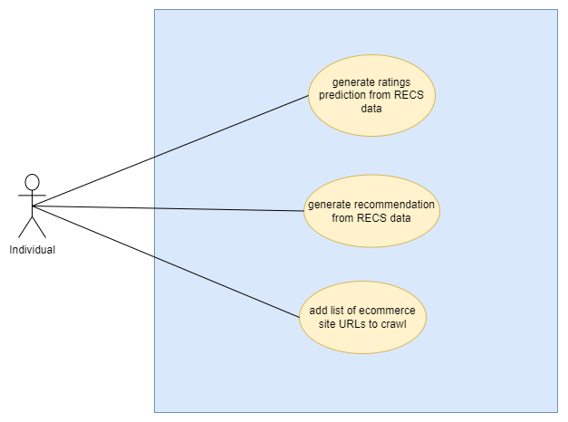

*Figure 12: UC36, UC37 and UC38*

Use Case Description 36

| Use Case ID | UC36 |
| --- | --- |
| Use Case Name | Individual generates predicted rating using RECS’ data |
| Actor(s) | Individual user |
| Goal | Individual generates predicted rating for products based on the RECS’ default crawled data |
| Pre-Condition | Individual user must have already been logged into their account.  Individual user currently on the “Generate Ratings/Recommendations (Our data)” page |
| Post-Condition | RECS generates and return predicted rating of user x for product x as requested by Organization user using our default data |
| Trigger(s) | Individual user to wants generate predicted rating of product ‘x’ by user ‘x’ |
| Main Flow | 1. Individual user clicks on the “generate rating” tab 2. User redirected to predicted ratings page 3. User sees a text field prompting for user to enter user ID and product ID for user to enter 4. User enters the user ID and product ID that they want to predict ratings for 5. Click “generate” 6. RECS processes request and returns predicted rating 7. End of flow |
| Sub Flow | N.A |
| Exception | Invalid input:   1. Individual sees error message next to text field “user ID does not exist” 2. Repeat main flow (from 4) 3. End of flow |

Use Case Description 37

| Use Case ID | UC37 |
| --- | --- |
| Use Case Name | Individual user generate recommendations using RECS’ data |
| Actor(s) | Individual user |
| Goal | Individual generates recommendations for products that are similar to well-liked products from RECS’ default dataset |
| Pre-Condition | Individual must have already been logged into their account  Individual user currently on the “Generate Ratings/Recommendations (your data)” page |
| Post-Condition | RECS generates recommendations of products to suggest to their customer base |
| Trigger(s) | Individual wants get recommendations of products similar to the well-liked products |
| Main Flow | 1. Individual user clicks on the “recommendations” tab 2. User redirected to predicted recommendations page 3. User enters product ID and clicks “generate” button 4. Website sends request to RECS 5. RECS processes request and returns recommendations 6. Website displays recommendations 7. End of flow |
| Sub Flow | N.A |
| Exception | Wrong product ID:   1. Individual user sees an error message “Product ID incorrect please try again. 2. Repeat main flow (from step 3) 3. End of flow |

Use Case Description 38

| Use Case ID | UC38 |
| --- | --- |
| Use Case Name | Individual user add a list of URL link |
| Actor(s) | Individual user |
| Goal | Individual will be able to input a list of URL links for RECS to crawl |
| Pre-Condition | Individual must have already been logged into their account at the “Workspace” -> “Add List of URLs” page |
| Post-Condition | List added into RECS system |
| Trigger(s) | Individual wants to input a list of URL links for RECS to crawl |
| Main Flow | 1. Individual user clicks on the “choose file” button 2. File explorer is popup appears prompting Individual to upload a text file containing the list of URL links 3. Individual clicks “upload” after selecting the file has been added 4. Website takes the URL list and sends it to the RECS backend where a directory will be created to store the URL list 5. Website redirects Individual user to the “Uploaded List of URLs” page displaying “The file has been uploaded” 6. End of flow |
| Sub Flow | N.A |
| Exception | Cancel:   1. Individual clicks “cancel” 2. file explorer window close 3. End of flow |

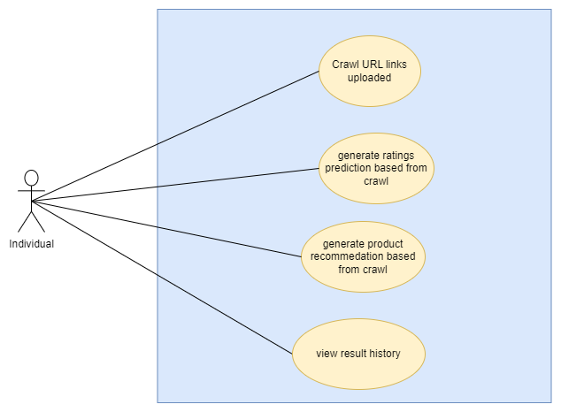

*Figure 13: UC39, UC40, UC41 and UC42*

Use Case Description 39

| Use Case ID | UC39 |
| --- | --- |
| Use Case Name | RECS crawls URL links found in text file uploaded |
| Actor(s) | Individual user |
| Goal | Individual user wants to use RECS’ web crawling service and crawl the URL links uploaded in the text file |
| Pre-Condition | Individual user must have already been logged into their account  Individual user must have already added a list of URL links  Individual user must be at the “Uploaded List of URLs” page |
| Post-Condition | RECS’ crawled URL links and has new data to use for the predicted ratings and recommendations |
| Trigger(s) | Individual wants RECS’ to crawl their uploaded list of URLs |
| Main Flow | 1. Individual user clicks on the “crawl” button 2. RECS begin to crawl in the background on the backend 3. Once done, a pop up message appears saying “crawled” 4. End of flow |
| Sub Flow | N.A |
| Exception | N.A |

Use Case Description 40

| Use Case ID | UC40 |
| --- | --- |
| Use Case Name | Individual user generates predicted rating from Crawled URLs |
| Actor(s) | Individual user |
| Goal | Individual generates predicted rating for products based on RECS on web crawling service |
| Pre-Condition | Individual user must have already been logged into their account  Uploaded a list of URL links that has to already been crawled  At the “Generate Ratings/Recommendations (uploaded URL)” page |
| Post-Condition | RECS generates and return predicted rating (using the crawled URL links) of user x for product x as requested by Individual user |
| Trigger(s) | Individual wants generate and find predicted rating for products they input to RECS, based on the crawled URL links |
| Main Flow | 1. Individual user clicks on the “generate ratings” tab 2. User redirected to predicted ratings page 3. User sees a text field prompting for user to enter user ID and product ID for user to enter 4. User enters the user ID and product ID that they want to predict ratings for 5. Click “generate” 6. RECS processes request and returns predicted rating 7. End of flow |
| Sub Flow | N.A |
| Exception | Invalid input:   1. Individual sees error message next to text field “user ID does not exist” 2. Repeat main flow (from 4) 3. End of flow |

Use Case Description 41

| Use Case ID | UC41 |
| --- | --- |
| Use Case Name | Individual generate recommendations from Crawled URLs |
| Actor(s) | Individual User |
| Goal | Individual generate recommendations for products that are well-liked products found from RECS own web crawling |
| Pre-Condition | Individual user must have already been logged into their account  Uploaded a list of URL links that has to already been crawled  At the “Generate Ratings/Recommendations (uploaded URL)” page |
| Post-Condition | RECS generates recommendations of products to suggest to their customer base |
| Trigger(s) | Individual wants get recommendations of products that are well-liked products from RECS web crawling other e-commerce site |
| Main Flow | 1. Individual user clicks on the “recommendations” tab 2. User redirected to predicted recommendations page 3. User enters product ID and clicks “generate” button 4. Website sends request to RECS 5. RECS processes request and returns recommendations 6. Website displays recommendations 7. End of flow |
| Sub Flow | N.A |
| Exception | Wrong product ID:   1. Individual user sees an error message “Product ID incorrect please try again. 2. Repeat main flow (from step 3) 3. End of flow |

Use Case Description 42

| Use Case ID | UC42 |
| --- | --- |
| Use Case Name | Individual view history |
| Actor(s) | Individual user |
| Goal | View the history of the predicted ratings and/or recommendations of products that they retrieved previously |
| Pre-Condition | Individual is logged into their account  Individual has previously retrieved either a predicted rating of a product or retrieved recommended product |
| Post-Condition | Individual all previously retrieved rating/recommendation |
| Trigger | Individual wants to check what product they had previously viewed the predicted ratings for and/or the recommended products they previously checked |
| Main Flow | 1. At the workspace page, Individual user clicks “results” under “History” section 2. Website process request and gets the necessary information from database 3. Individual is brought to results page 4. History of all the types of generated results (both prediction ratings and recommendation ) are displayed 5. End of flow |
| Sub Flow | N.A |
| Exception | N.A |

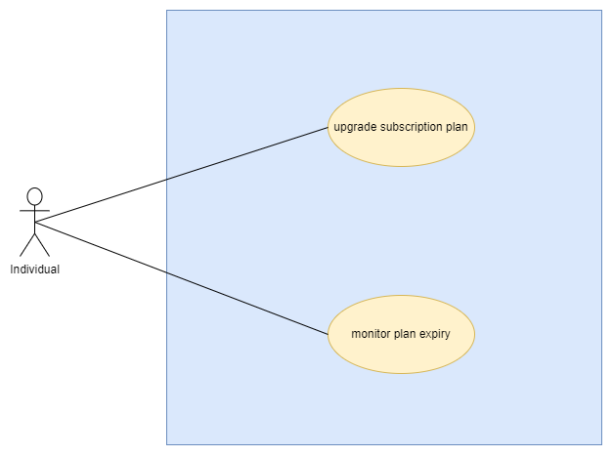

*Figure 14: UC43 and UC44*

Use Case Description 43

| Use Case ID | UC43 |
| --- | --- |
| Use Case Name | Individual wants to be upgrade subscription plan |
| Actor(s) | Individual user |
| Goal | Individual can upgrade their subscription plan according to which ever plan they feel more suitable |
| Pre-Condition | Individual logged into their account  Individual user is at the upgrade plans page |
| Post-Condition | Individual will have upgraded their account to either the standard plan or pro plan |
| Trigger(s) | Individual wants to upgrade their subscription plan |
| Main Flow | 1. Individual user clicks “upgrade to standard” 2. User is redirected to the payment page 3. User fills in their payment details and click pay 4. RECS processes the payment and updates the Individual user’s price plan RECS user database 5. User is redirected to a payment summary page 6. End of flow |
| Sub Flow | 1. Individual user clicks “upgrade to pro” 2. User is redirected to the payment page 3. User fills in their payment details and click pay 4. RECS processes the payment and updates the Individual user’s price plan RECS user database 5. User is redirected to a payment summary page 6. End of flow |
| Exception | N.A |

Use Case Description 44

| Use Case ID | UC44 |
| --- | --- |
| Use Case Name | Individual wants to be able to monitor plan expiry |
| Actor(s) | Individual user |
| Goal | Individual can monitor when their subscription plan expires so they can renew their plan before expiry |
| Pre-Condition | Individual logged into their account |
| Post-Condition | Individual will be able to see their current plan and days till expiry/renewal |
| Trigger(s) | Individual wants to check when their subscription plan expires |
| Main Flow | 1. Individual user once logs lands on home page 2. On the top right next to “Upgrade plan” and the profile button, subscription type and days left till expiry can be seen 3. End of flow |
| Sub Flow | 1. Individual user can click on the current plan 2. Click on the billing tab 3. Individual user will be able to see the more specific next billing date |
| Exception | N.A |

### Sequence Diagrams

#### Admin

UC 1 (login)

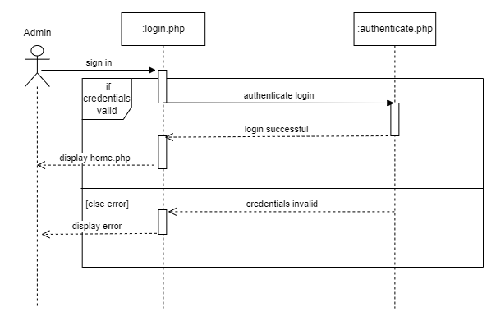

UC 2 (2 FA verification)

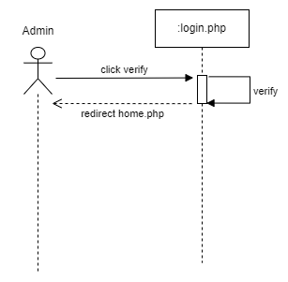

UC 3 (logout)

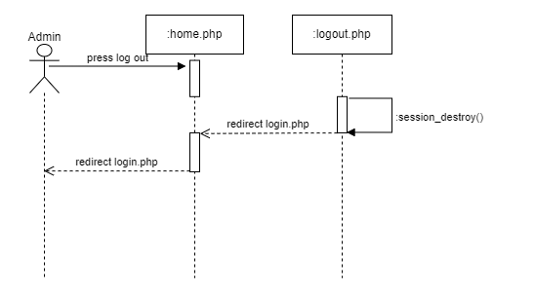

UC 4 (create users)

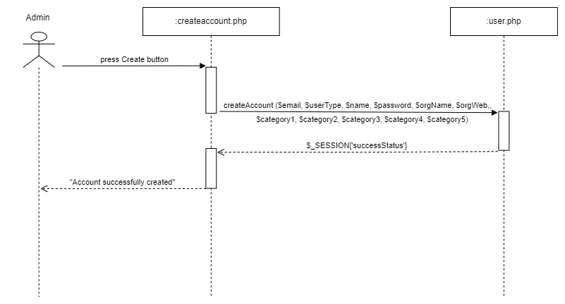

UC 5 (edit user account)

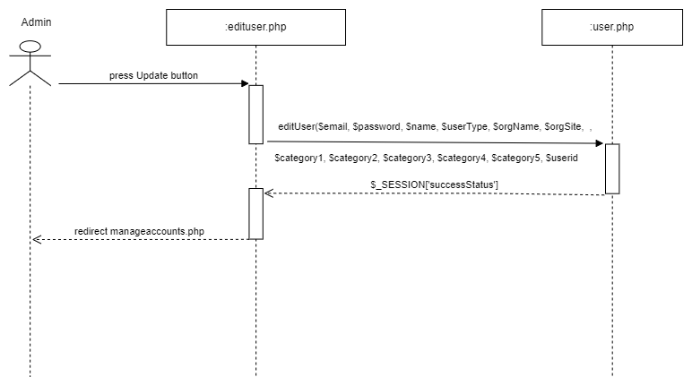

UC 6 (delete users)

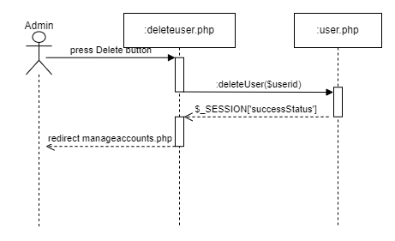

UC 7 (Manage account status)

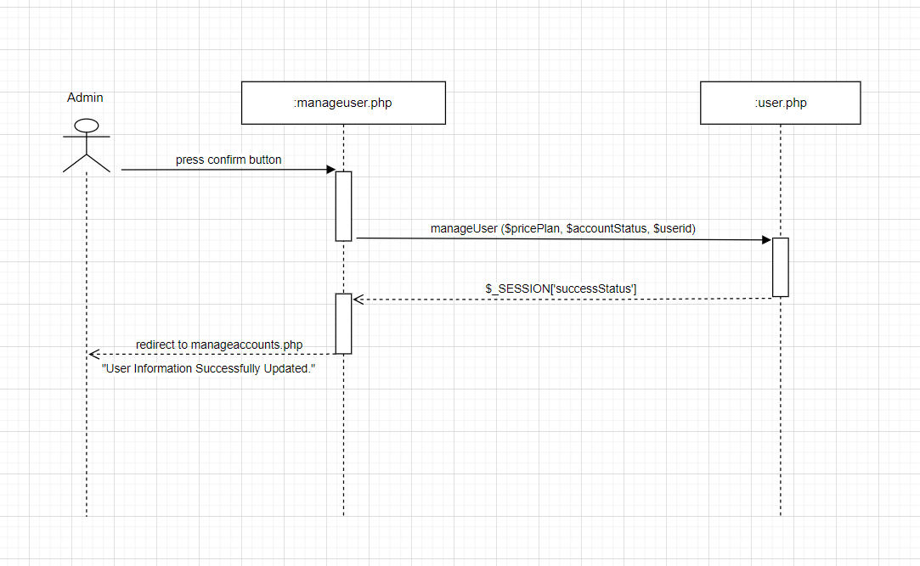

UC 8 (monitor subscription plan)

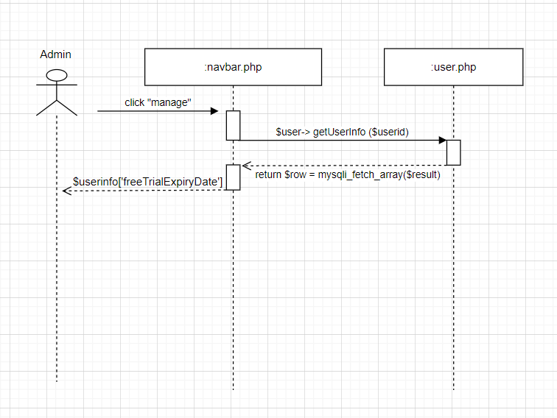

#### 

#### Organization

UC 9 (Login)

#### 

UC 10 (2FA verification)

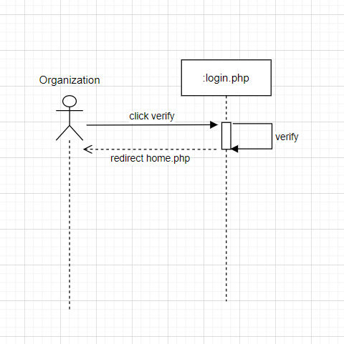

UC 11 (Logout)

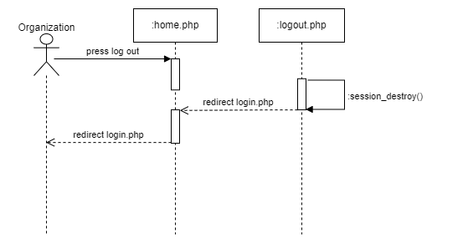

UC 12 & 13 (create account and selecting interest category)

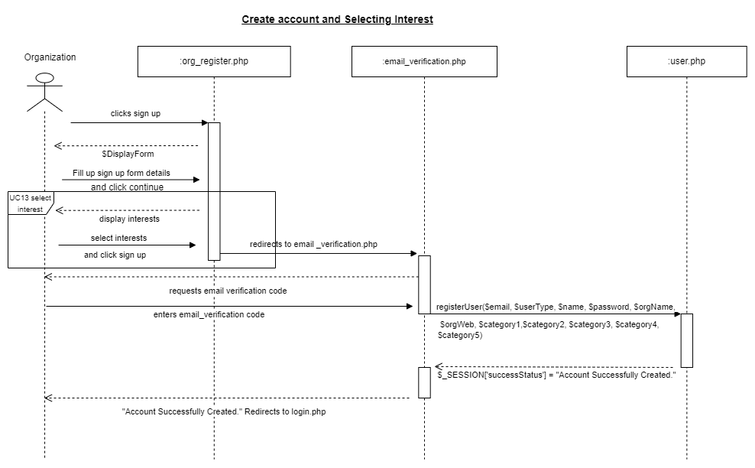

UC 14 (Edit interest category)

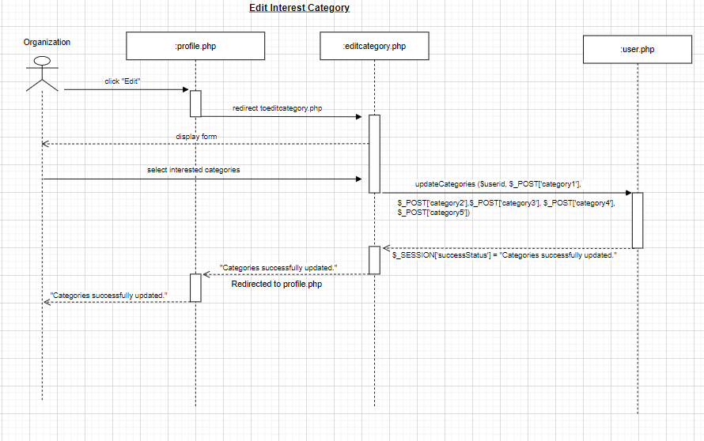

UC 15 (edit account)

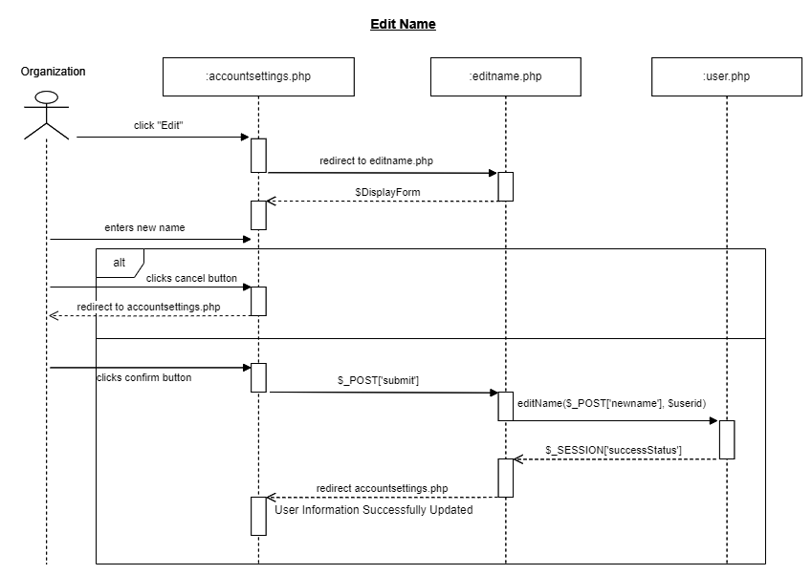

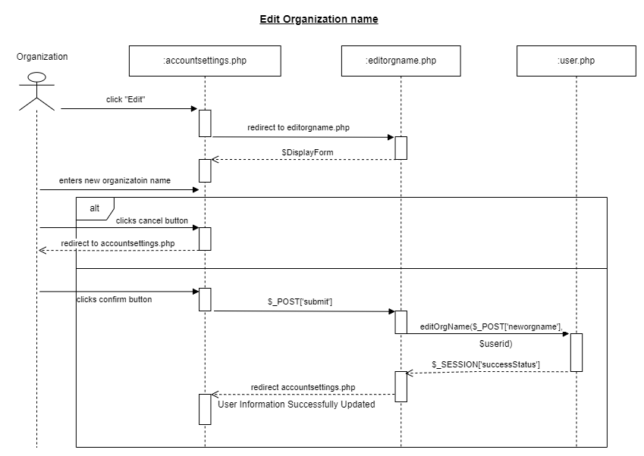

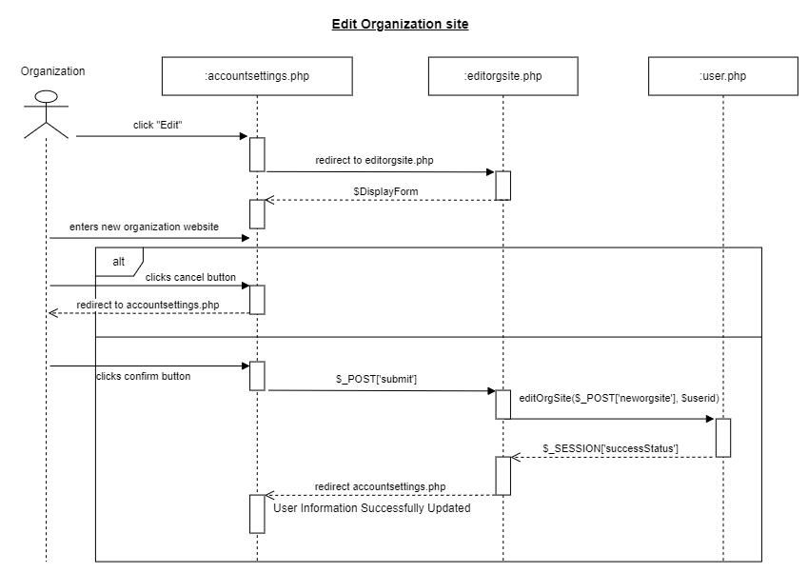

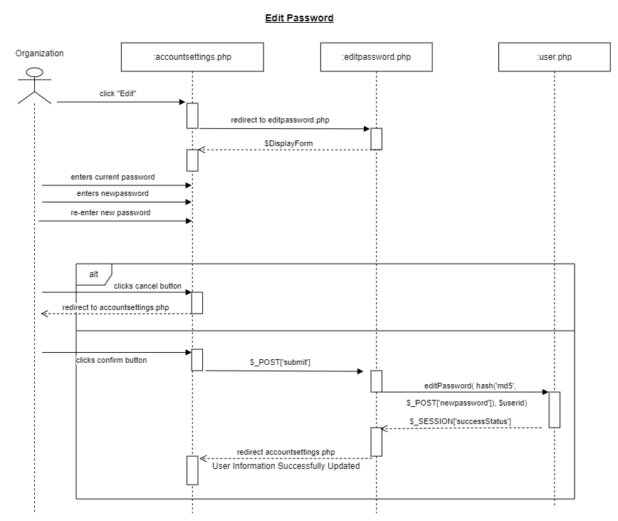

UC 16 (Adding data set)

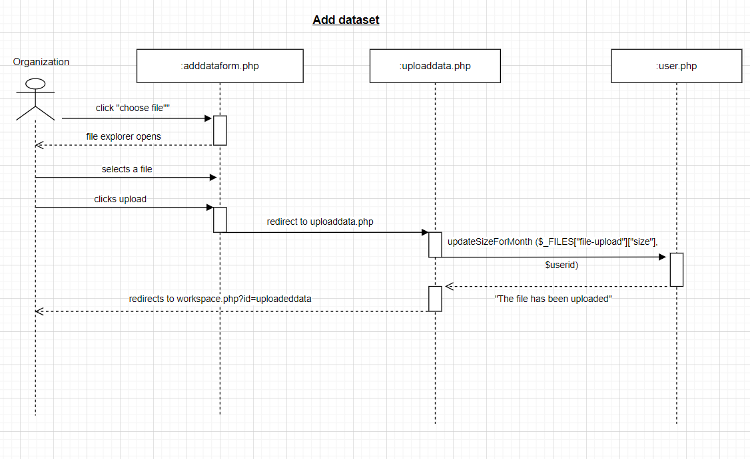

UC 17 (delete dataset)

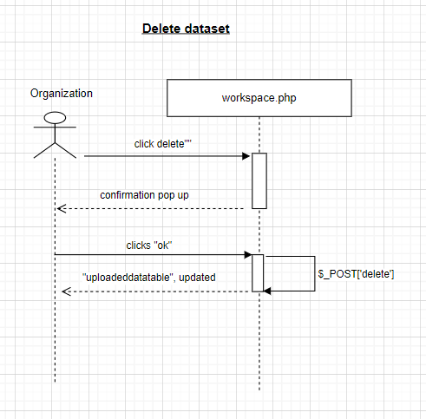

UC 18 (Generate Ratings uploaded dataset)

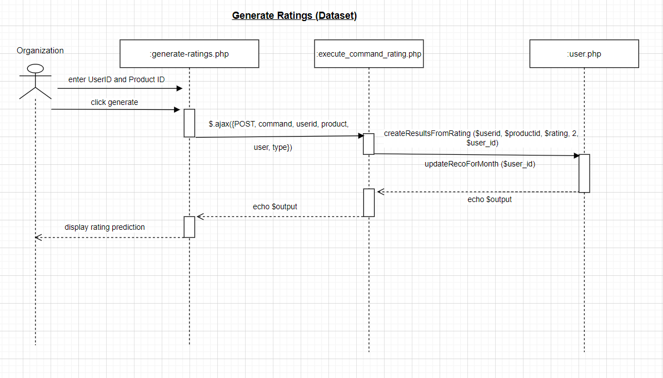

UC 19 (Generate Recommendations uploaded dataset)

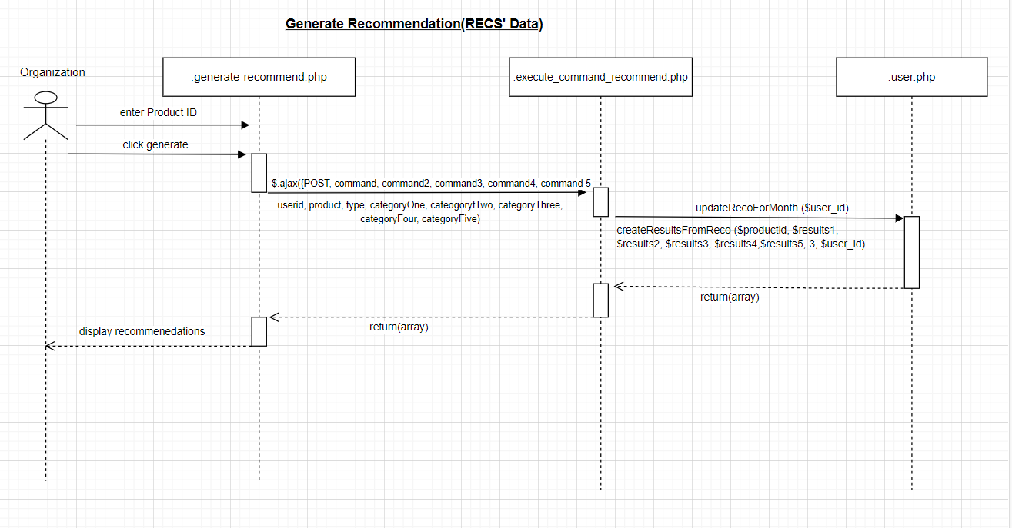

UC 20 (Add list of URLs)

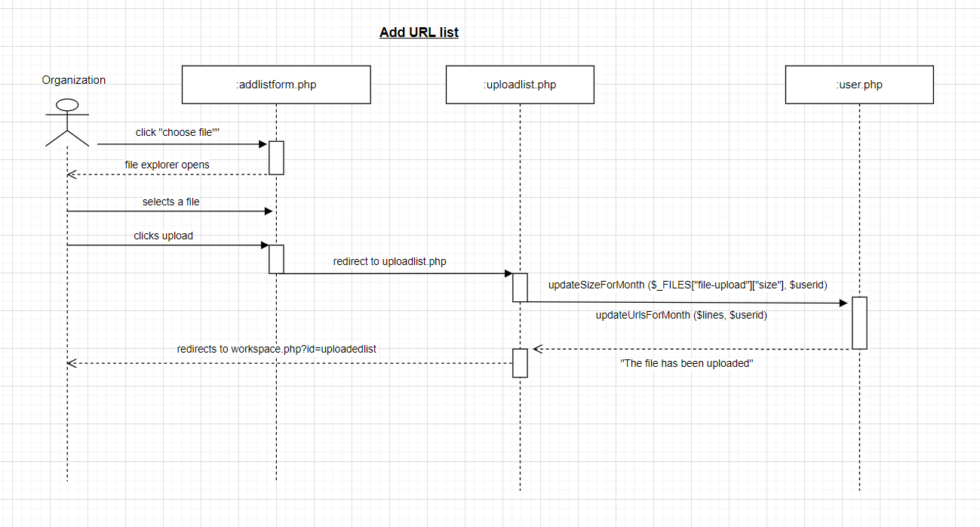

UC 21 (Crawl URL links)

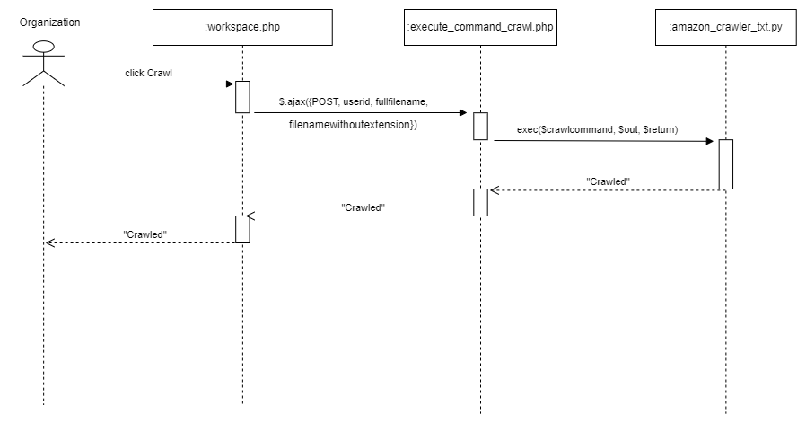

UC 22 (Generate Ratings from crawled URL)

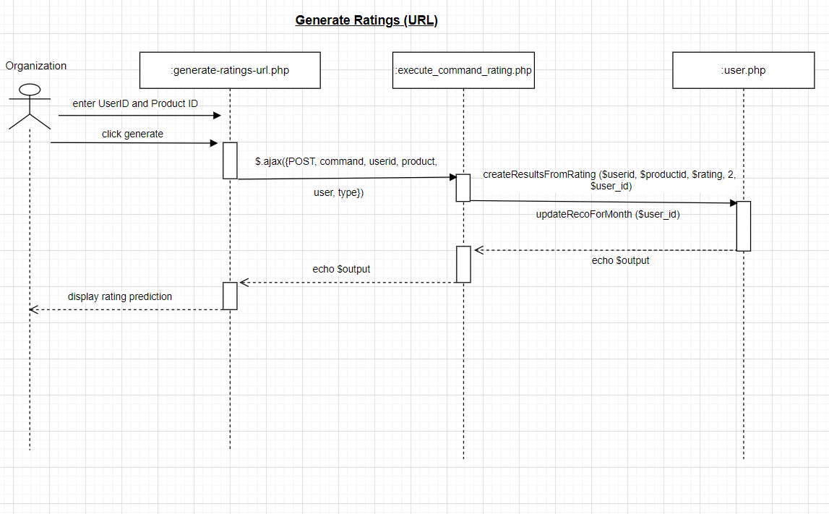

UC 23 (Generate Recommendations URL)

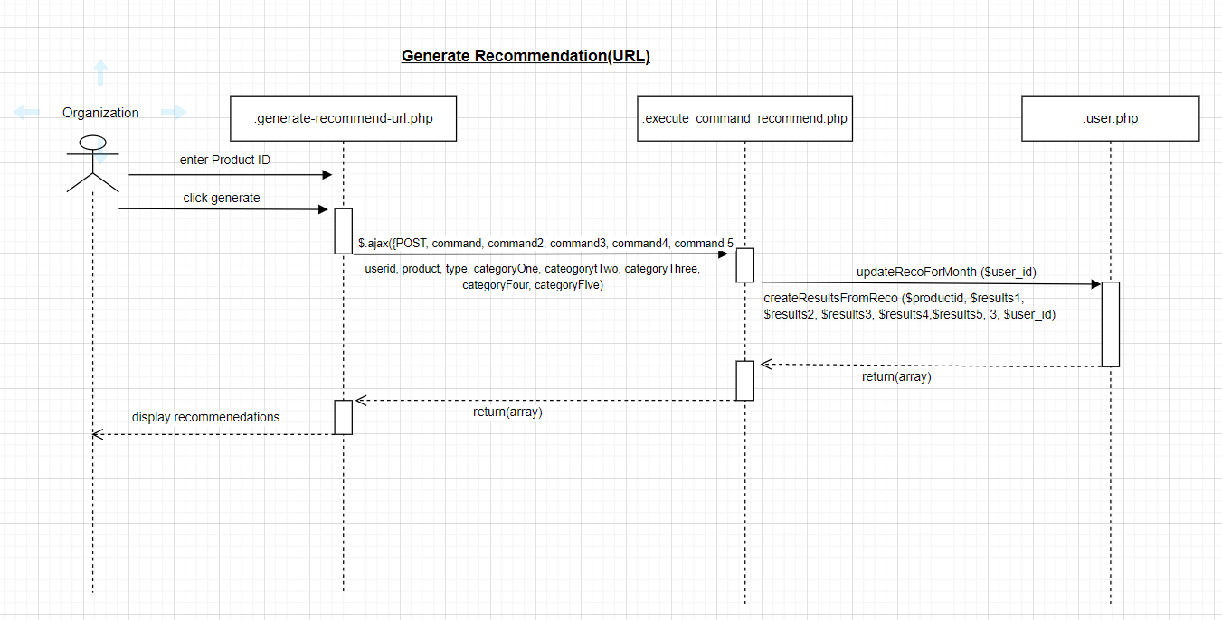

UC 24 (Use RECS’ data generate rating)

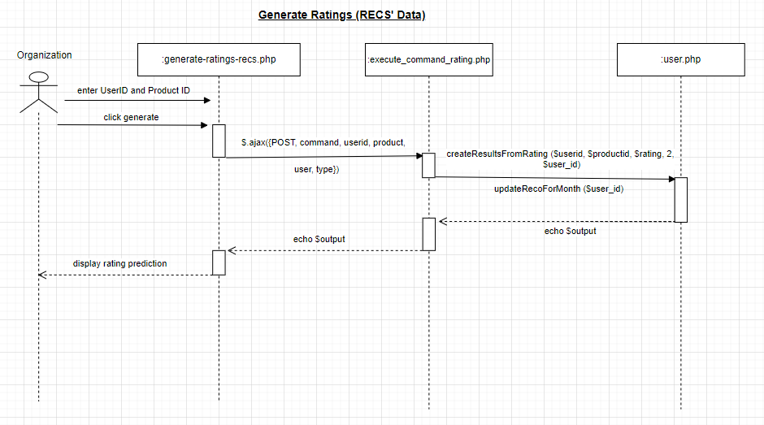

UC 25 (Generate Recommendations RECS’ Data)

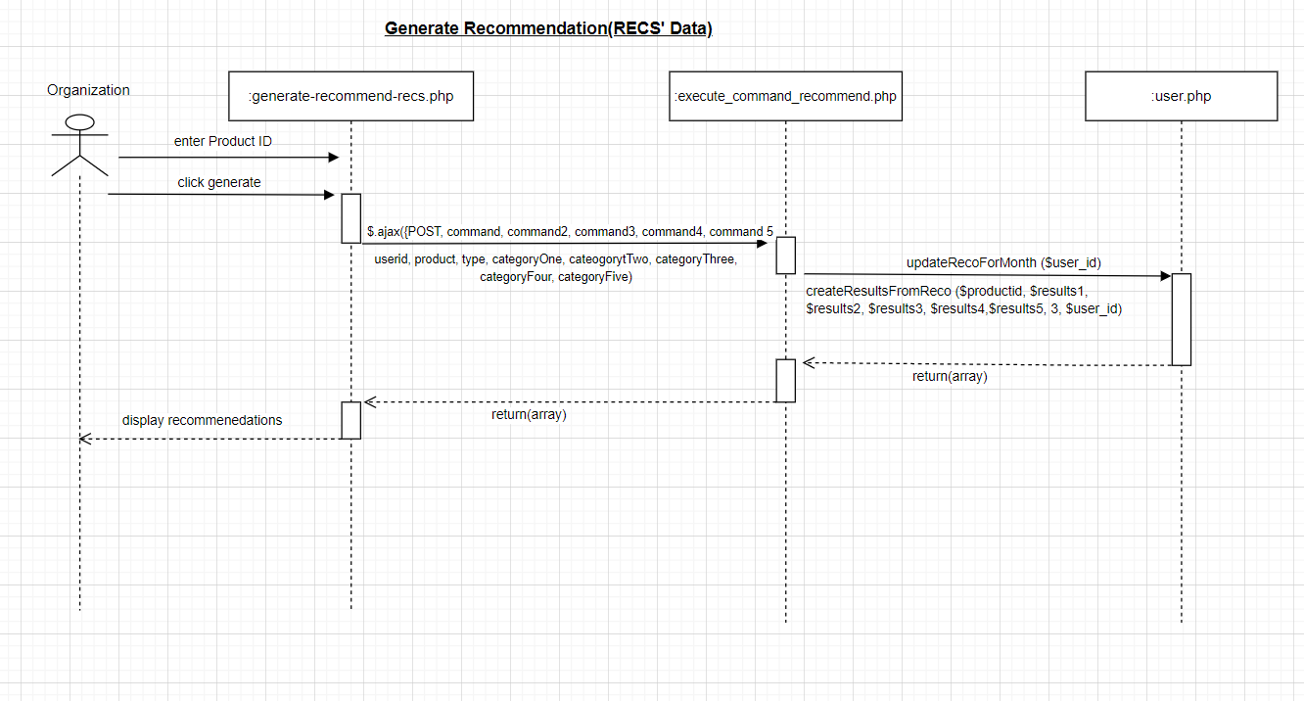

UC 26 (View Result History)

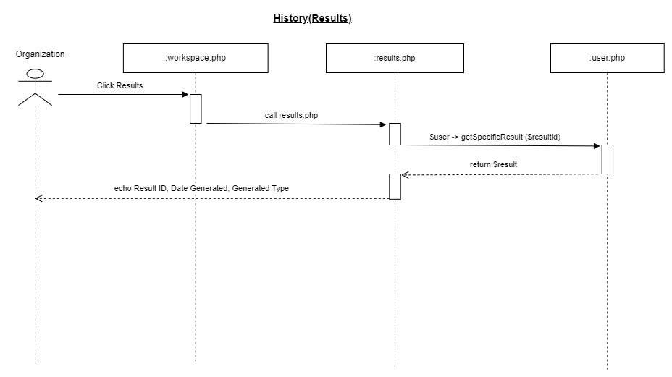

UC 27 (Upgrade subscription plan)

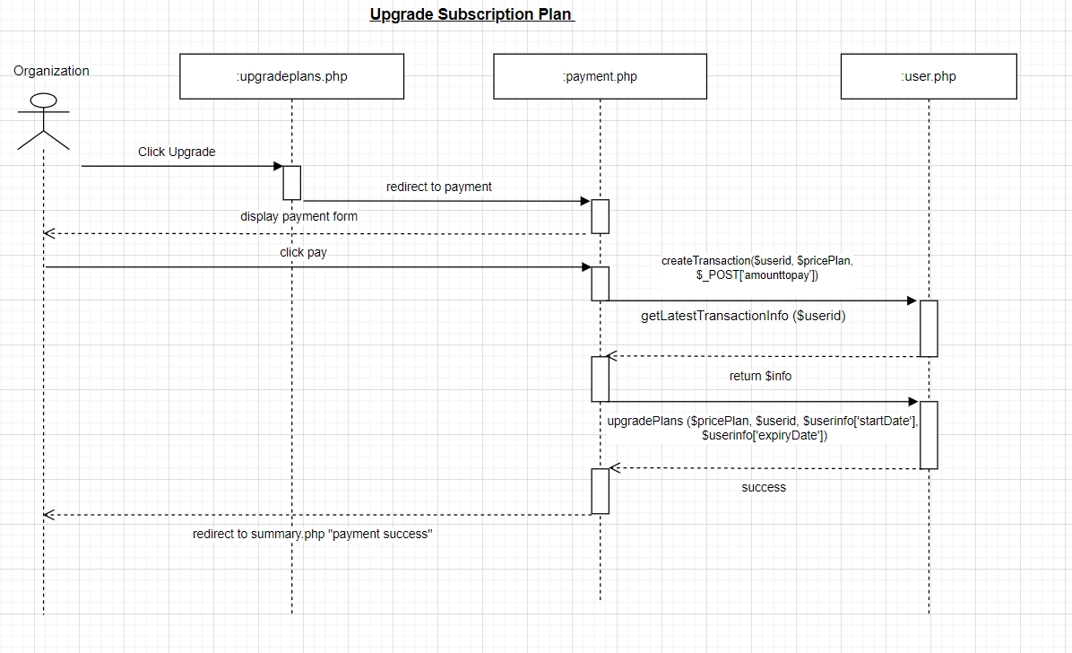

UC 28 (monitor plan expiry)

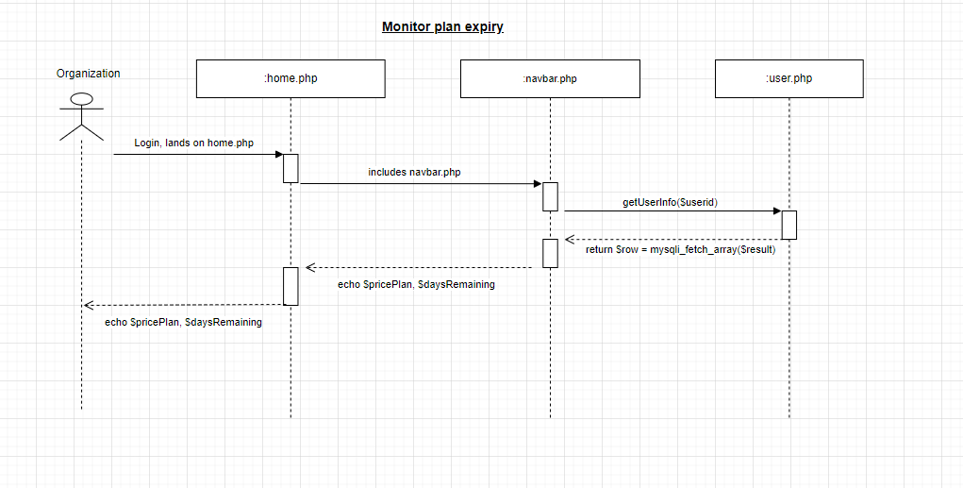

#### Individual

UC 29 (Login)

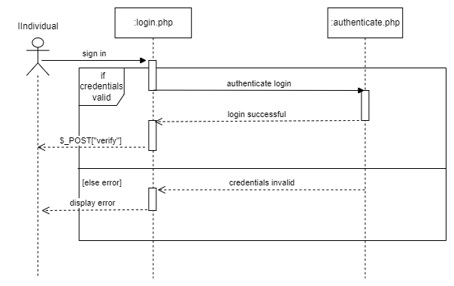

UC 30 (2FA verification)

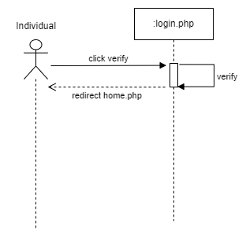

UC 31 (Logout)

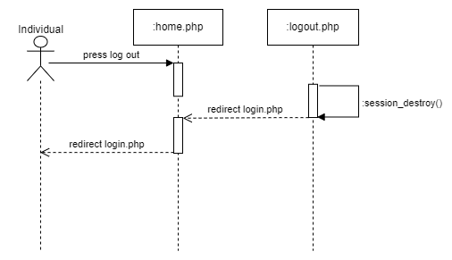

UC 32 & 33 (create account and selecting interest category)

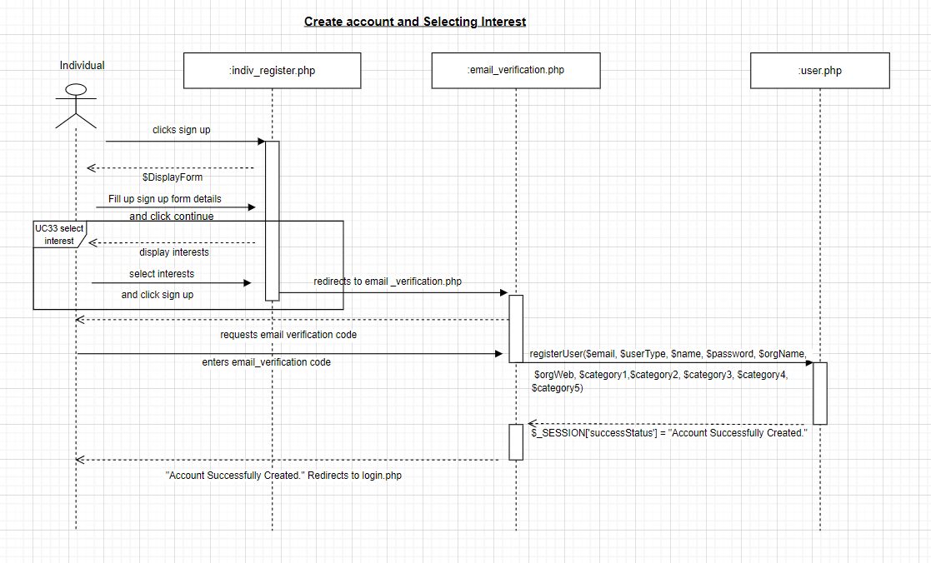

UC 34 (Edit Interest Category)

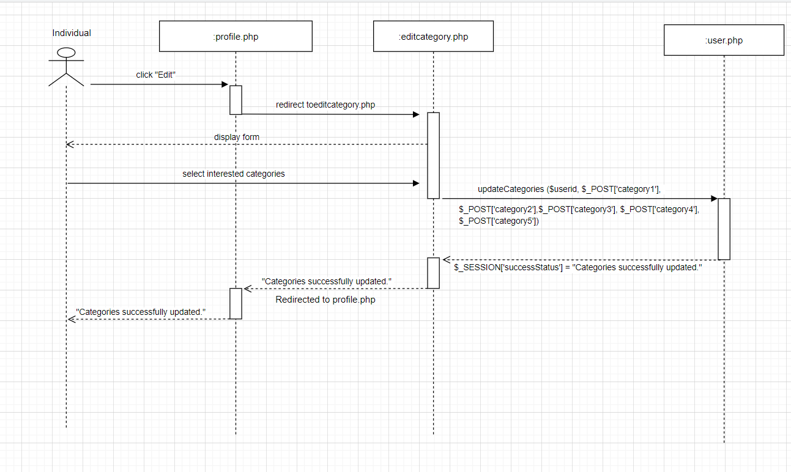

UC 35 (Edit account)

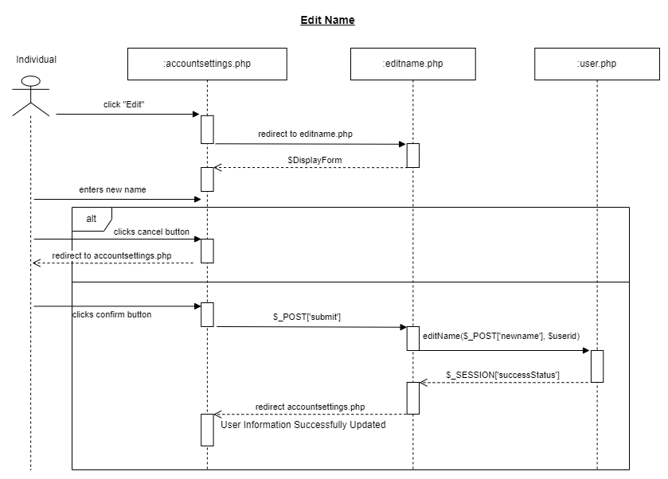

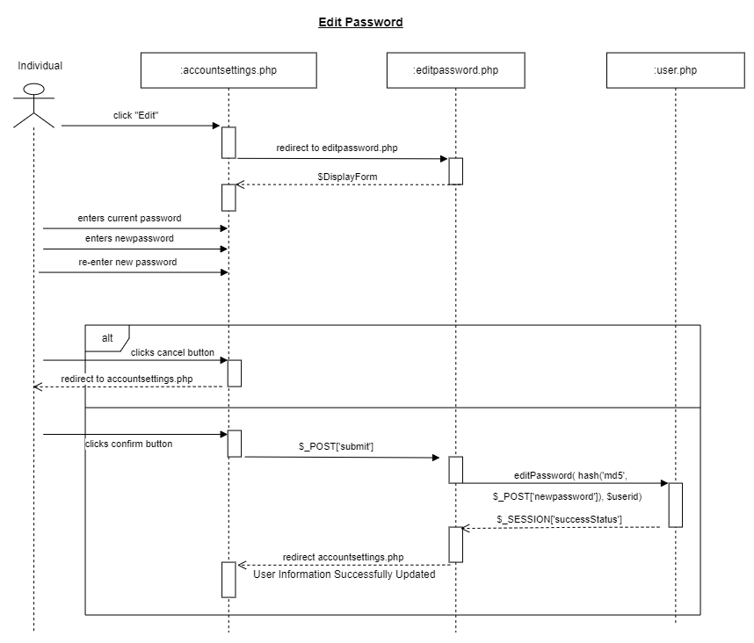

UC 36 (Generate Rating Prediction RECS’ Data)

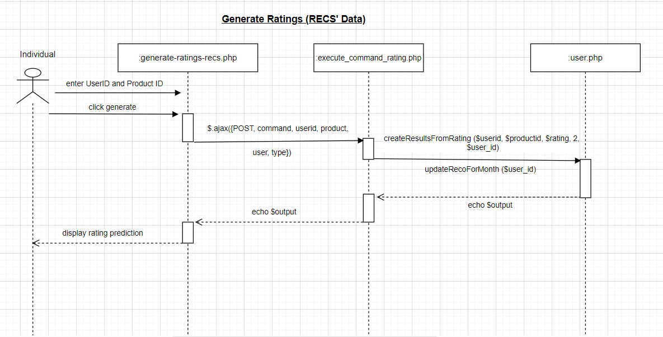

UC 37 (Generate Recommendations RECS’ Data)

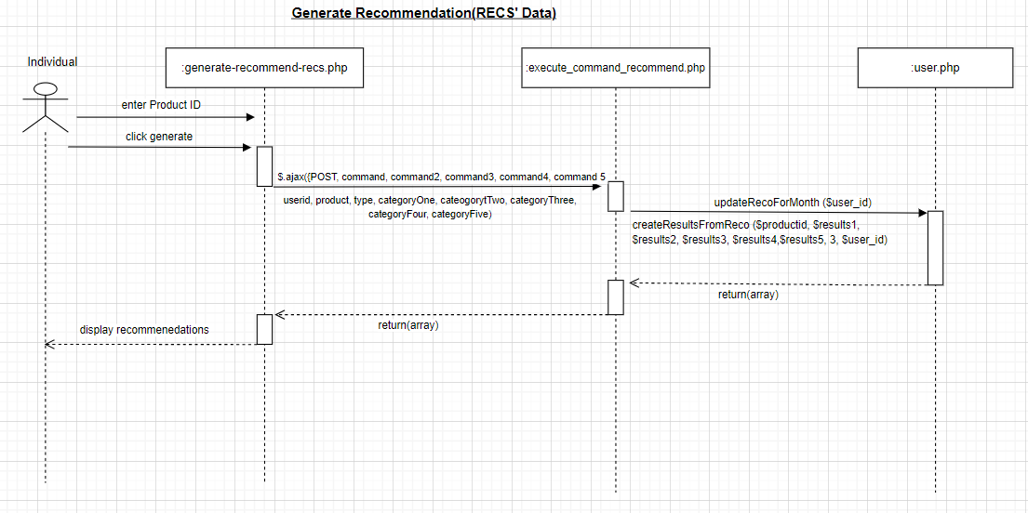

UC 38 (Add Url List)

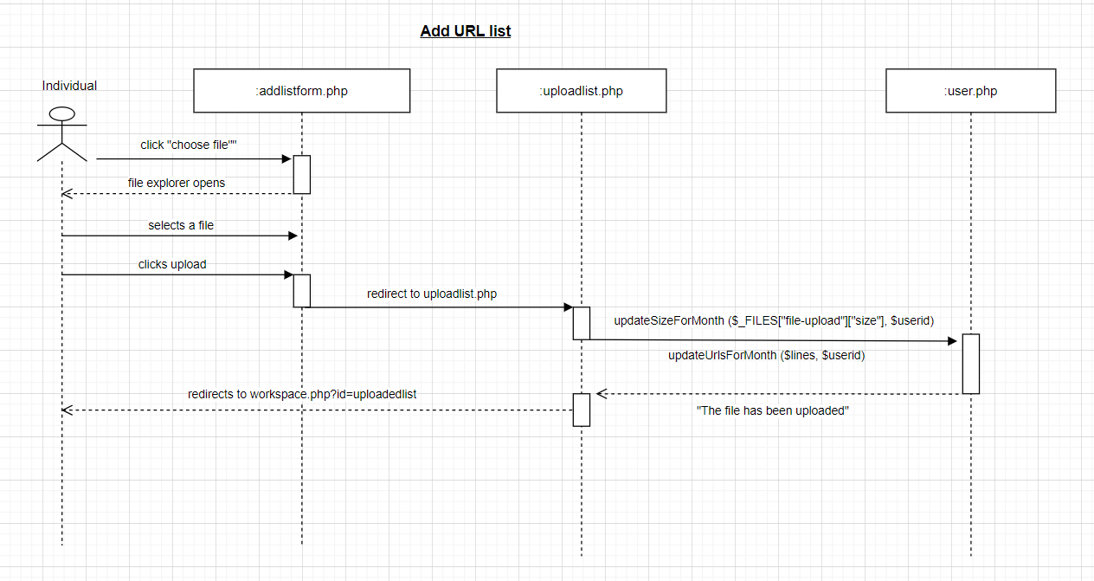

UC 39 (Crawl URL links)

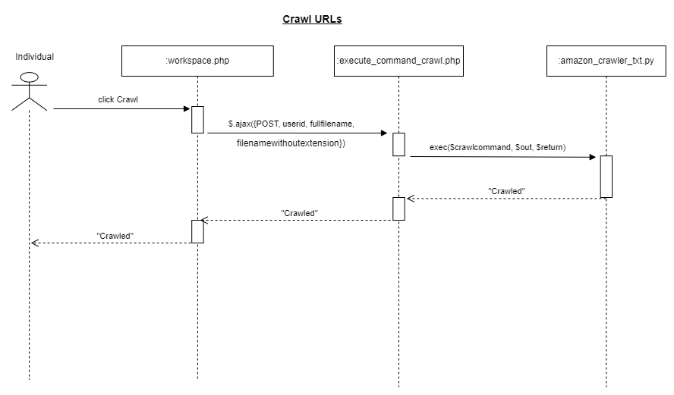

UC 40 (Generate Ratings from crawled URL)

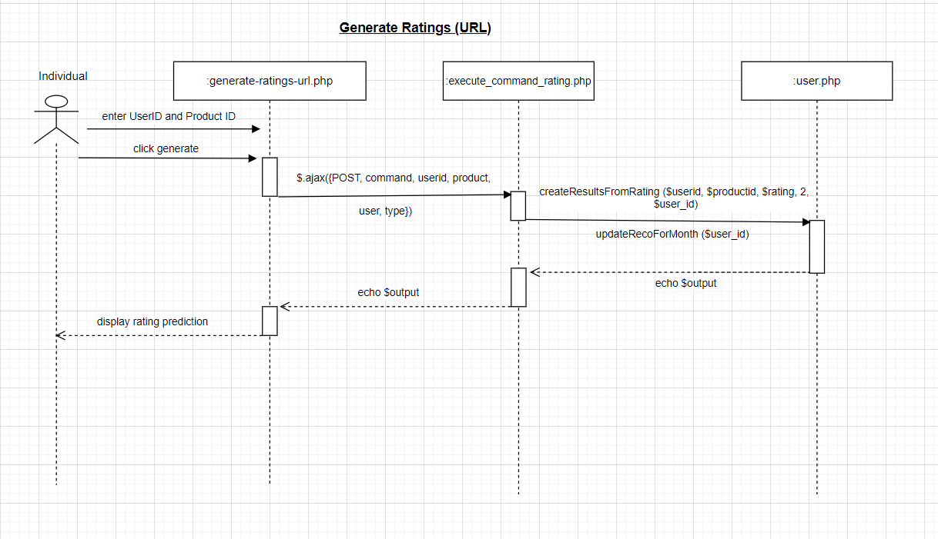

UC 41 (Generate Recommendations from URL)  
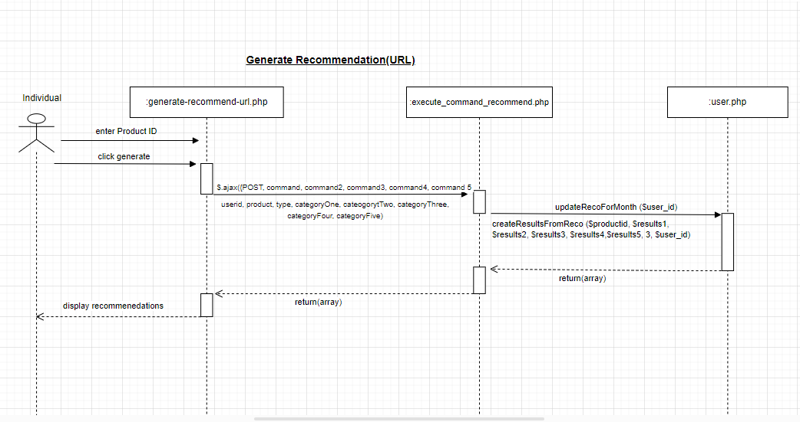

UC 42 (View result history)

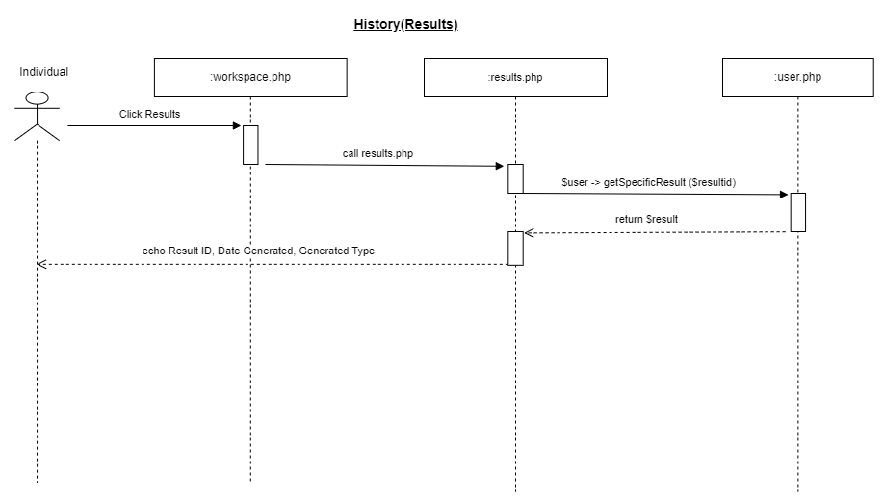

UC 43 (Upgrade Subscription)

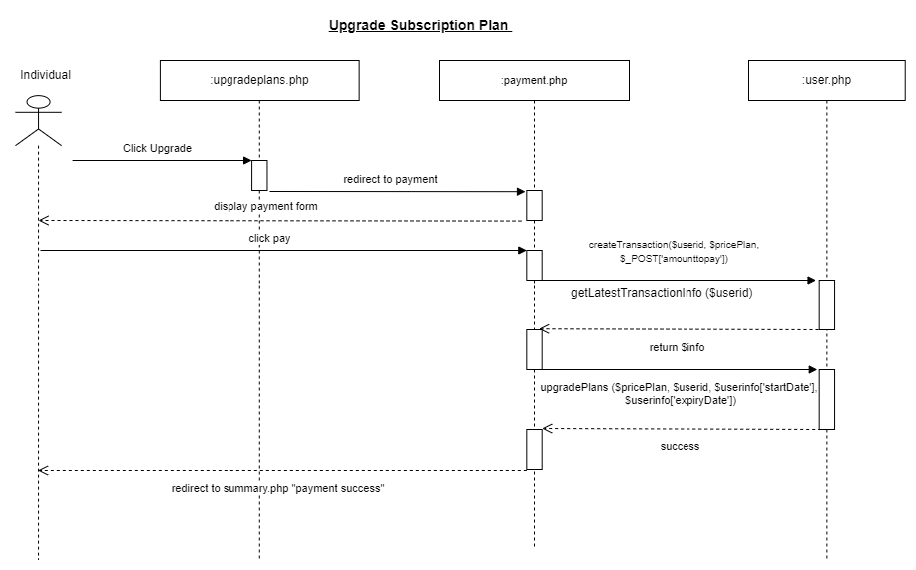

UC 44 (Monitor plan expiry)

### 

### 

### Non-Functional Requirements

| **#** | **Requirement Description** | **Priority** |
| --- | --- | --- |
| 1 | Accuracy | High |
| 2 | Reliability | High |
| 3 | Security | High |
| 4 | Usability | High |
| 5 | Maintainability | High |
| 6 | Availability | Medium |
| 7 | Compatibility | Medium |
| 8 | Portability | Medium |
| 9 | Scalability | Low |

#### Accuracy

Recommender system should be able to predict user ratings of products at an accuracy of 70%.

#### Reliability

#### Recommender system can perform normally even after prolonged usage (up to 1 hour).

#### Security

Ensuring that all accounts and the account information are properly secured and only accessible by the respective owners of the account and administrator. 2 factor authentication to ensure the owner of the account is the one accessing. Database will be password encrypted to prevent any unauthorized access or leakage of data.

#### Usability

Organizations/users with an account should be able to easily access and view the website workspace for rating predictions (of products) and recommendations on similar products to promote to their customers. The input of data set into the recommender system should also be simple, making it easy to use.

#### Maintainability

#### The mean time to restore the system (MTTR) in the event of a system failure will not be greater than an hour.

#### Availability

The recommender system and website workspace will be available to Organizations/users 99% of the time outside of maintenance periods.

#### Compatibility

System should be compatible across Mac OS and Linux. System is able to run across different browsers (chrome, safari, firefox).

#### Portability

System is able to run on windows 10 and should be able to run on windows 11 without any effect on its performance.

#### Scalability

The Recommender system should be scalable enough to support up to 10, 000 visits at the same time while maintaining optimal performance.

### 

### Interface Requirements

#### User Interface

Our recommender system comes with a simple design and acts as a web workspace for which the Organizations can use to view the predicted ratings of products and get recommendations for products they can promote to their customers. When they first land on the webpage they will see two textboxes for them to enter username and password, or for new Organizations users they can create a new account by clicking sign up in the top right corner of the landing page. The web workspace they access after login will have a menu accessible at the top of the website to allow for ease of navigation to other pages. The web workspace will also allow the Organization user to easily add a new data set for the recommender system to use as training data with the aid of a simple add button easily located at the top of the web page on the right corner.

#### Software Interface

Operating System: Windows 10, macOS, linux

Database: MySQL

Front End: PHP

WebCrawler: Scrapy, Python  
Back End: Python

#### Communications Interface

The website workspace will be accessible to all browsers that support PHP. HTTP/HTTPS

#### Hardware Interface

The website workspace does not require any additional or specific hardware as it is able to run on computers as they are.

## 

## Wireframe

### Admin

**UC1:**

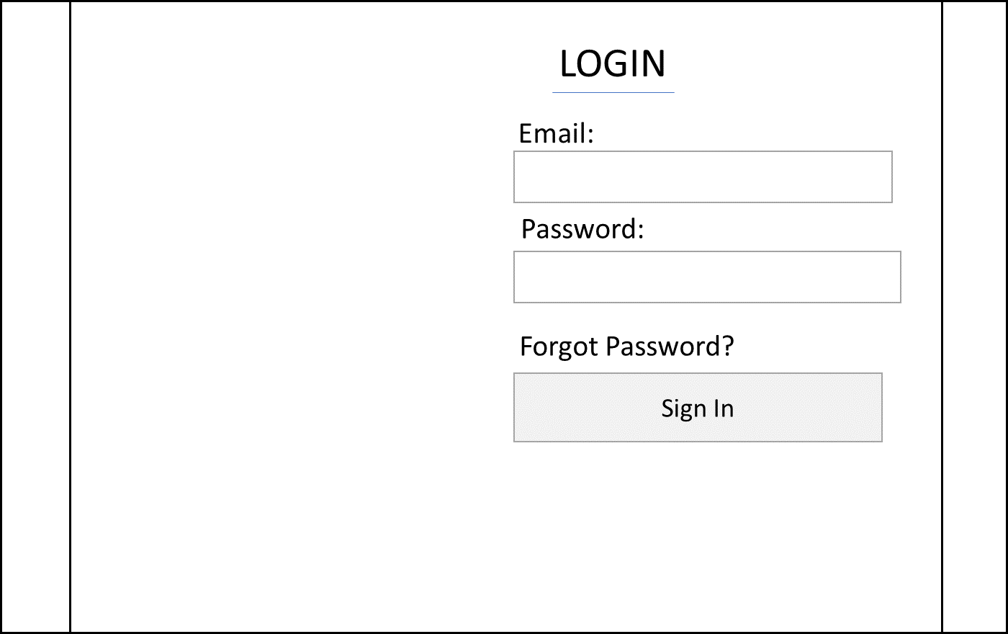

**UC2:**

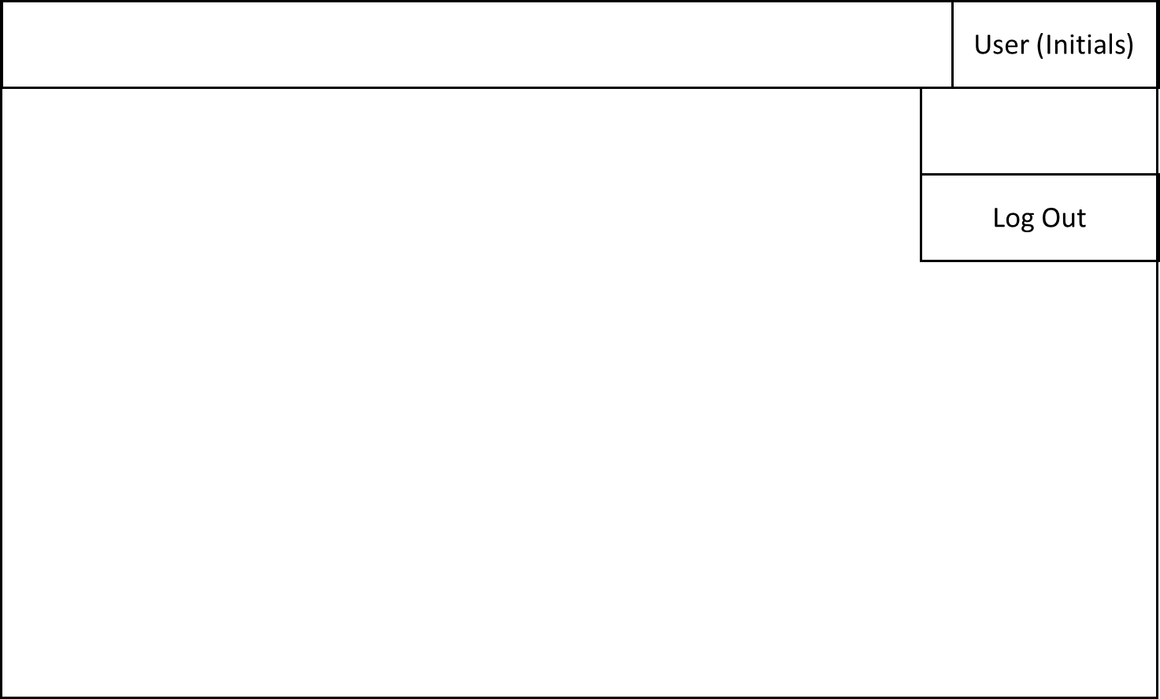

**UC3:**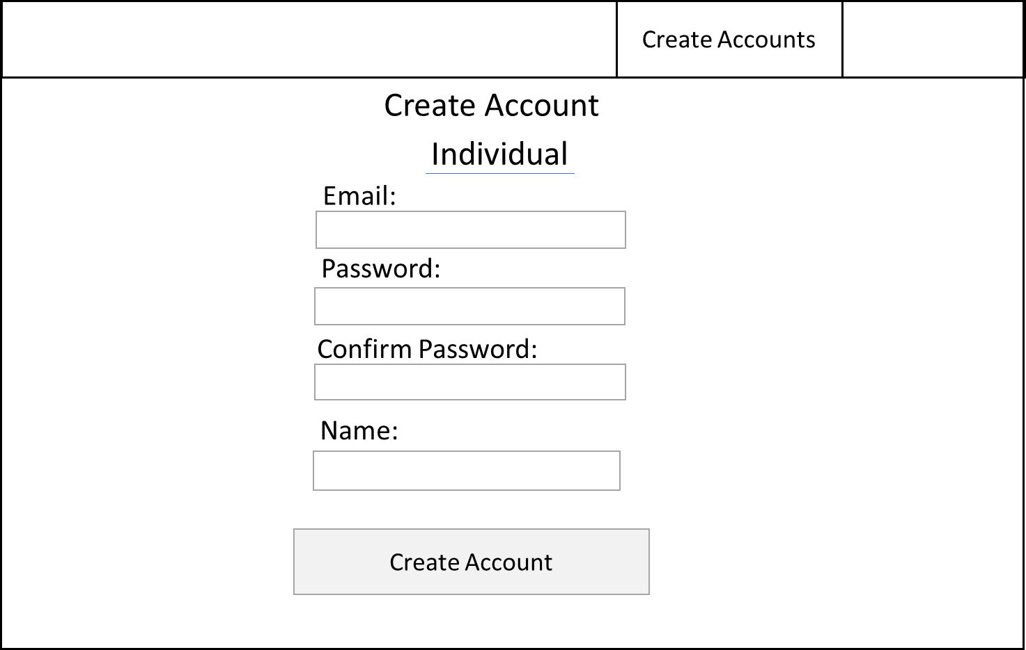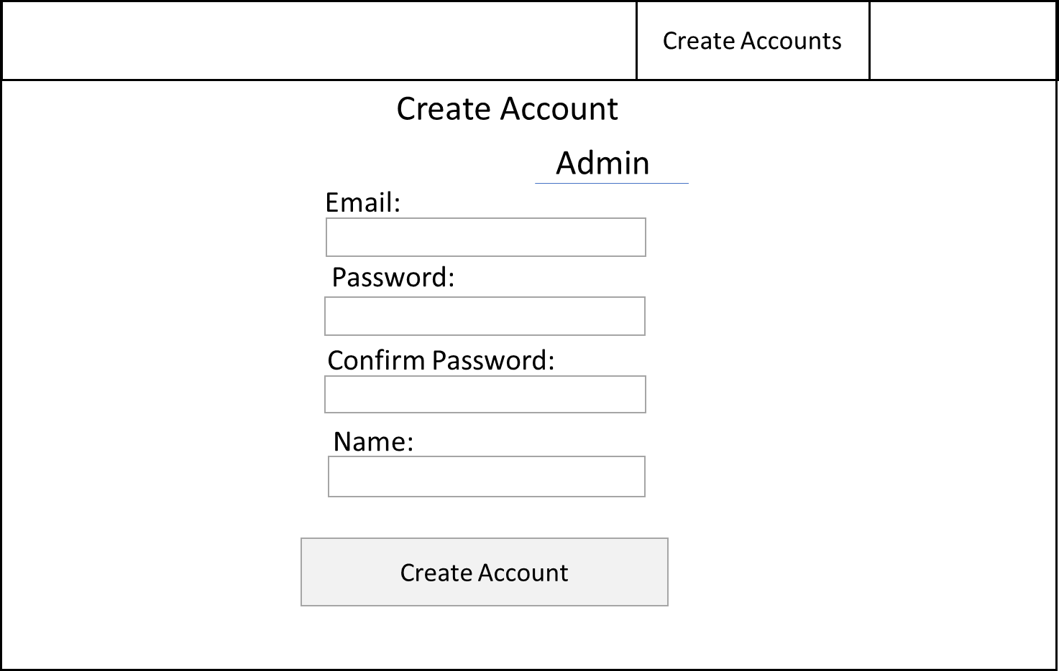

**UC4:**

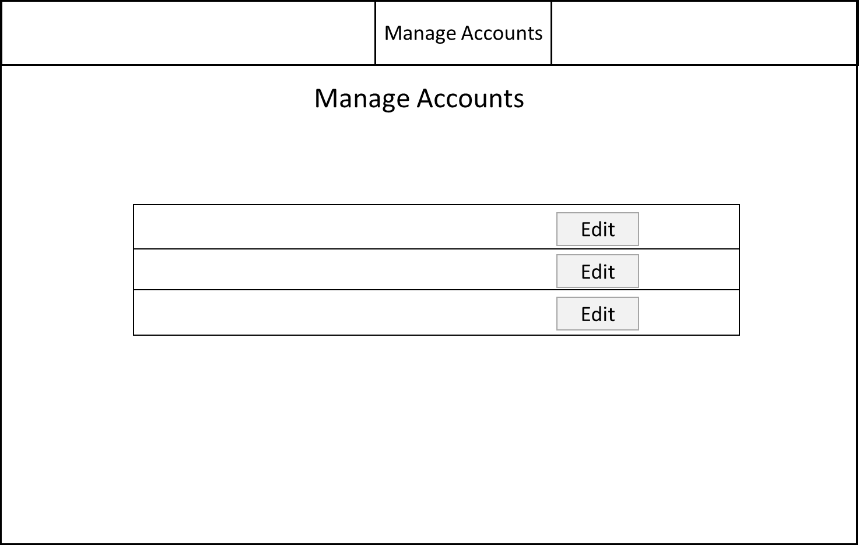

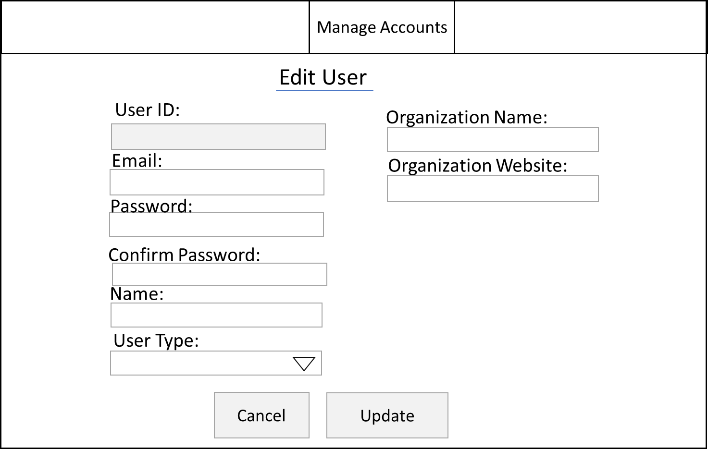

**UC5:**

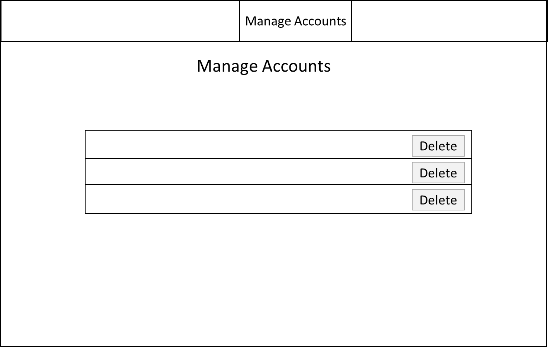

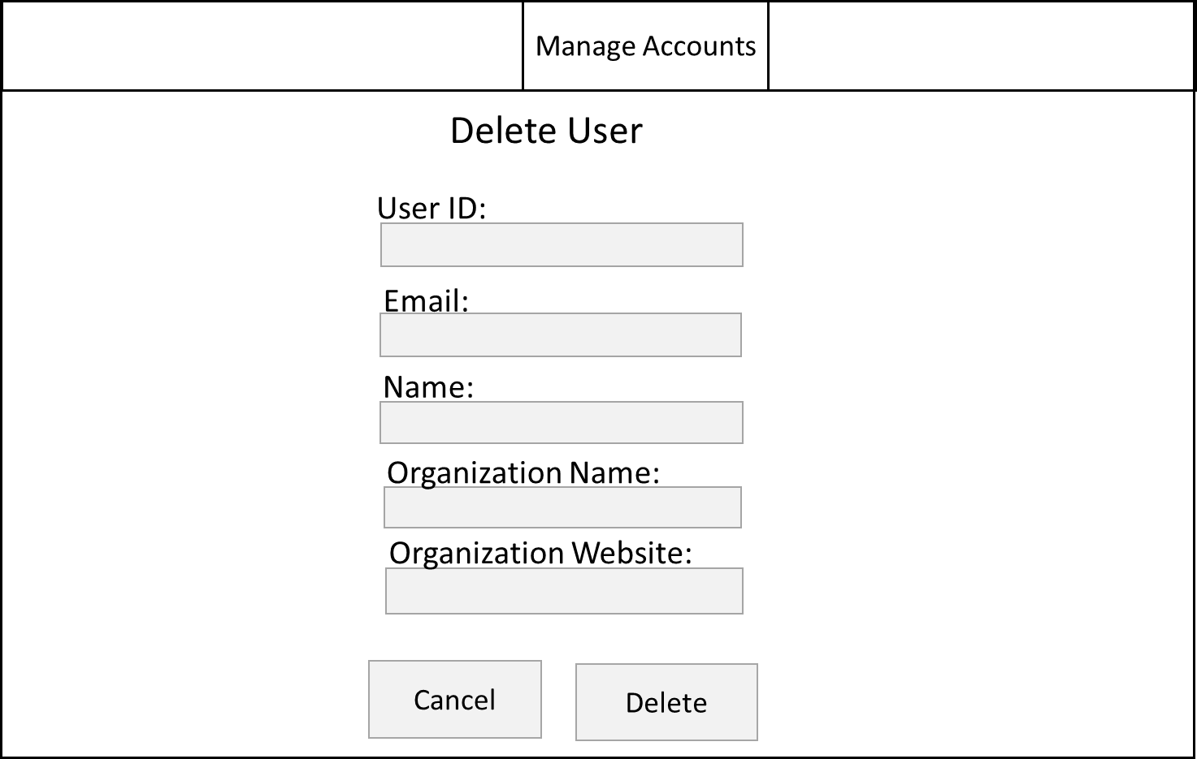

**UC6:**

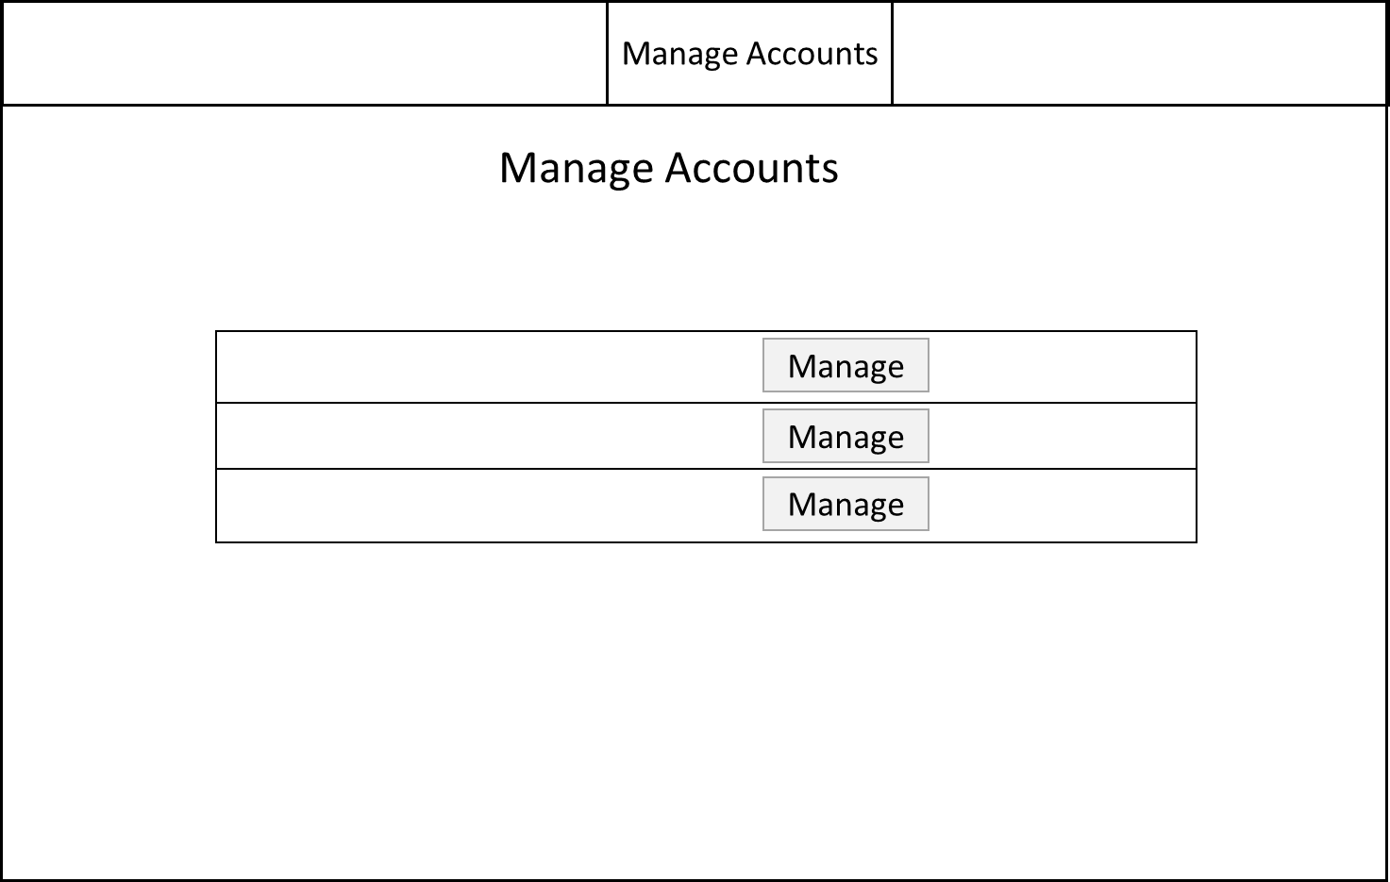

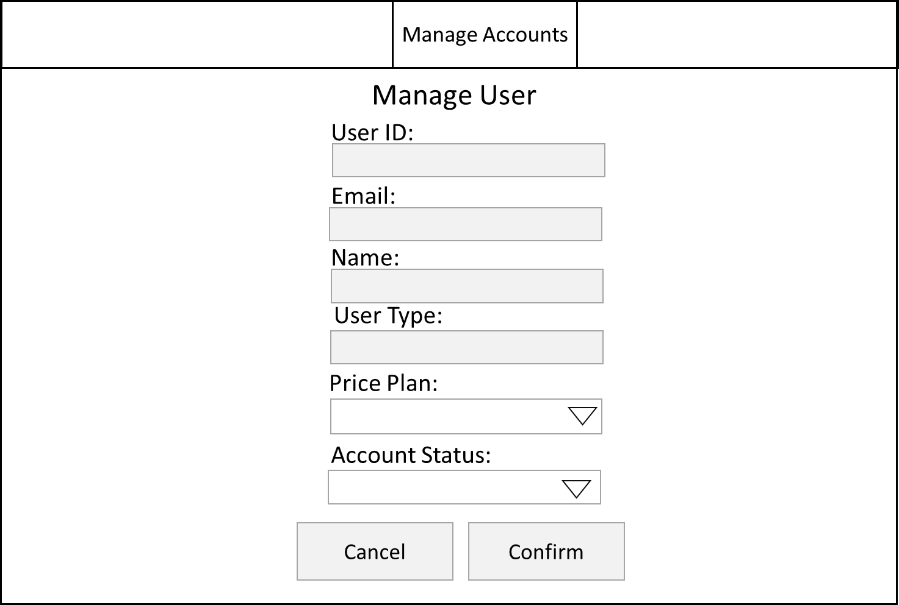

**UC7(Replace manage website contents for now, this is search UC):**

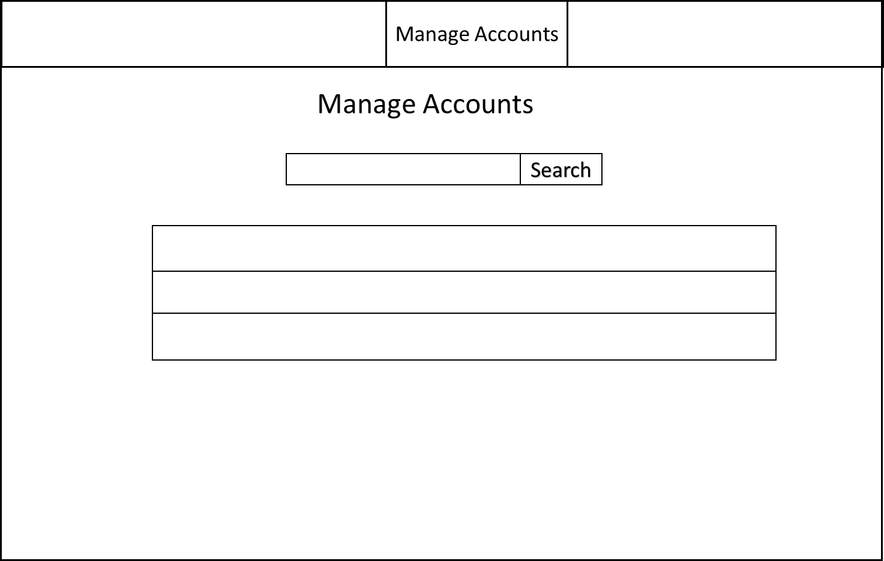

### 

### Organisation

**UC8:**



**UC9:**



**UC10:**

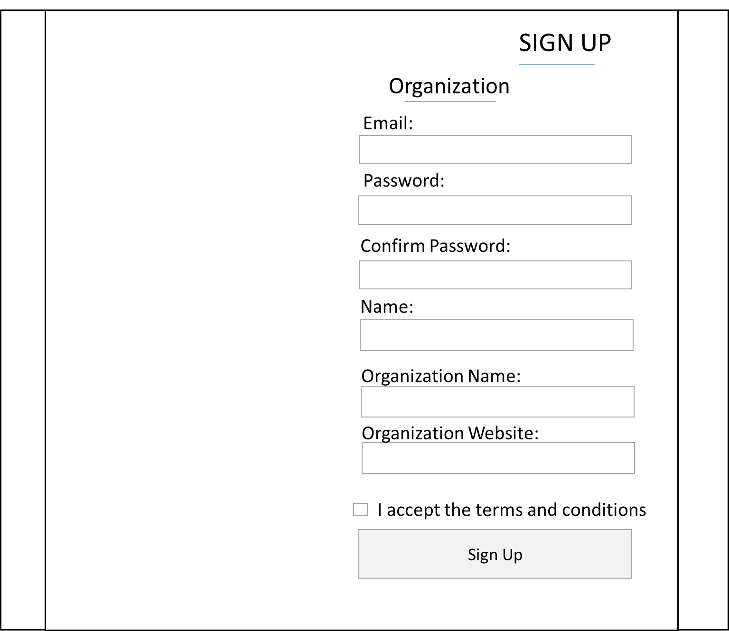

**UC11:**

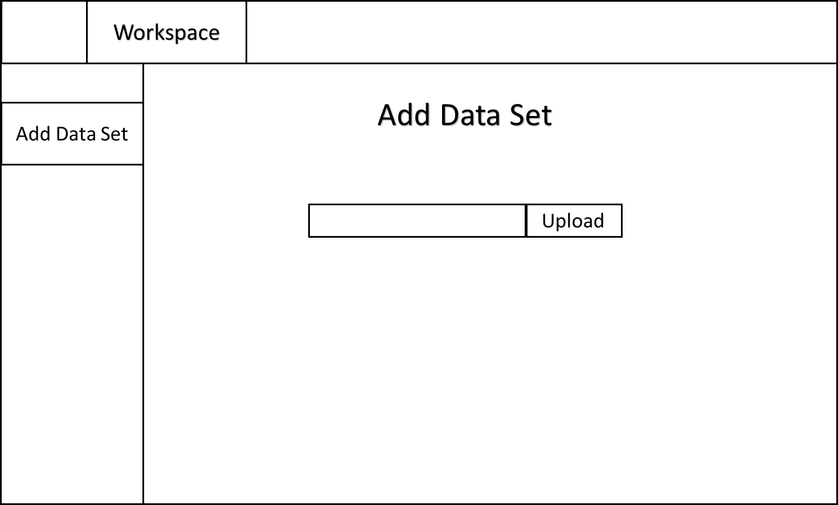

**UPGRADE PLANS:**

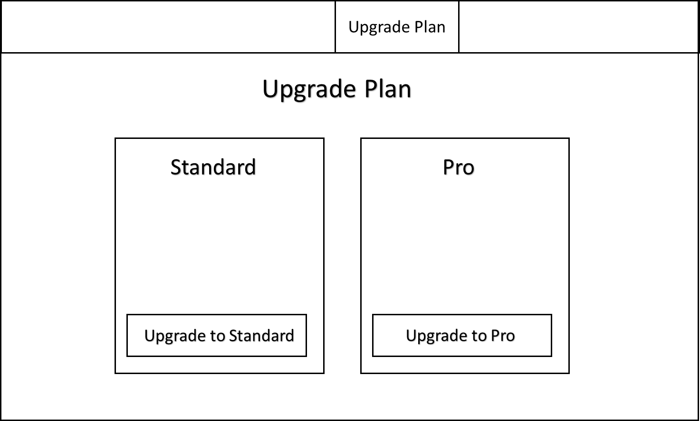

**UC12:**

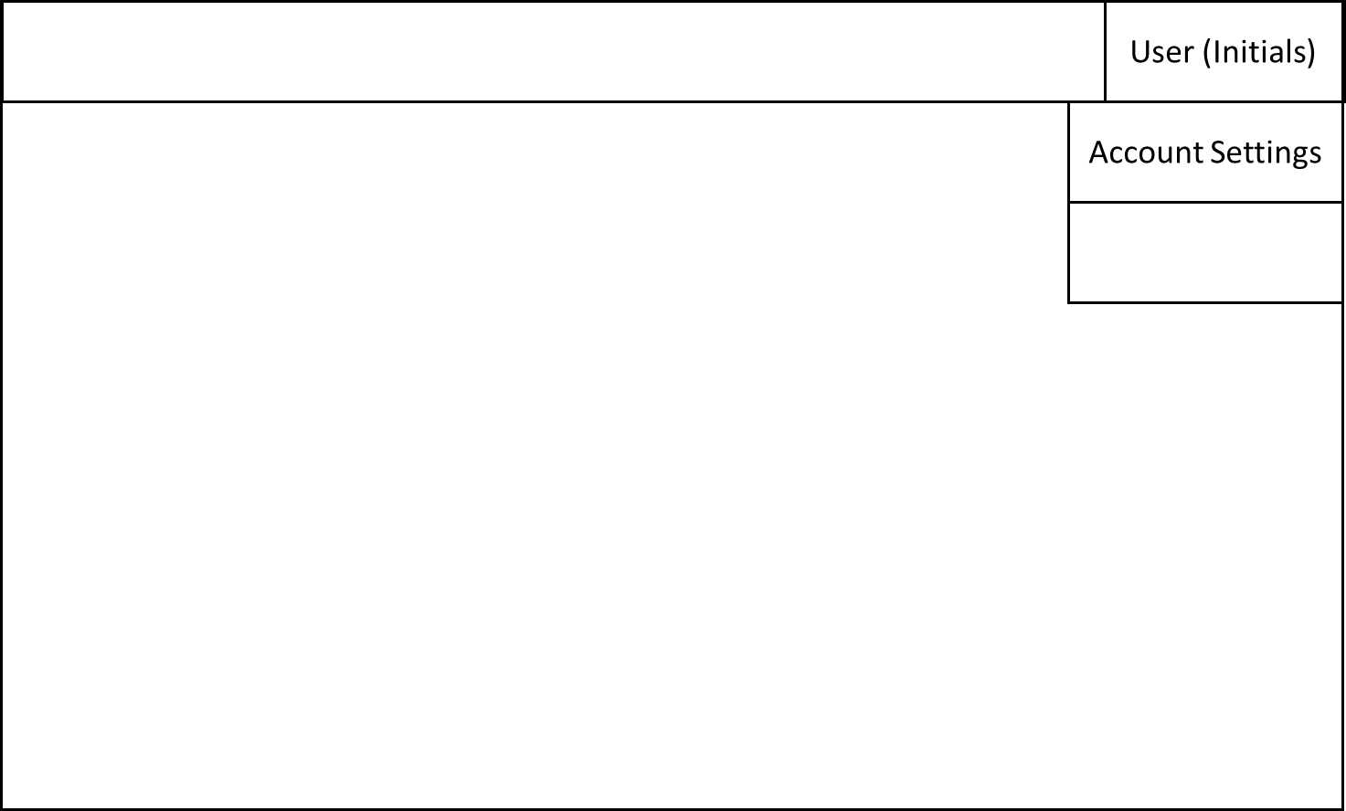

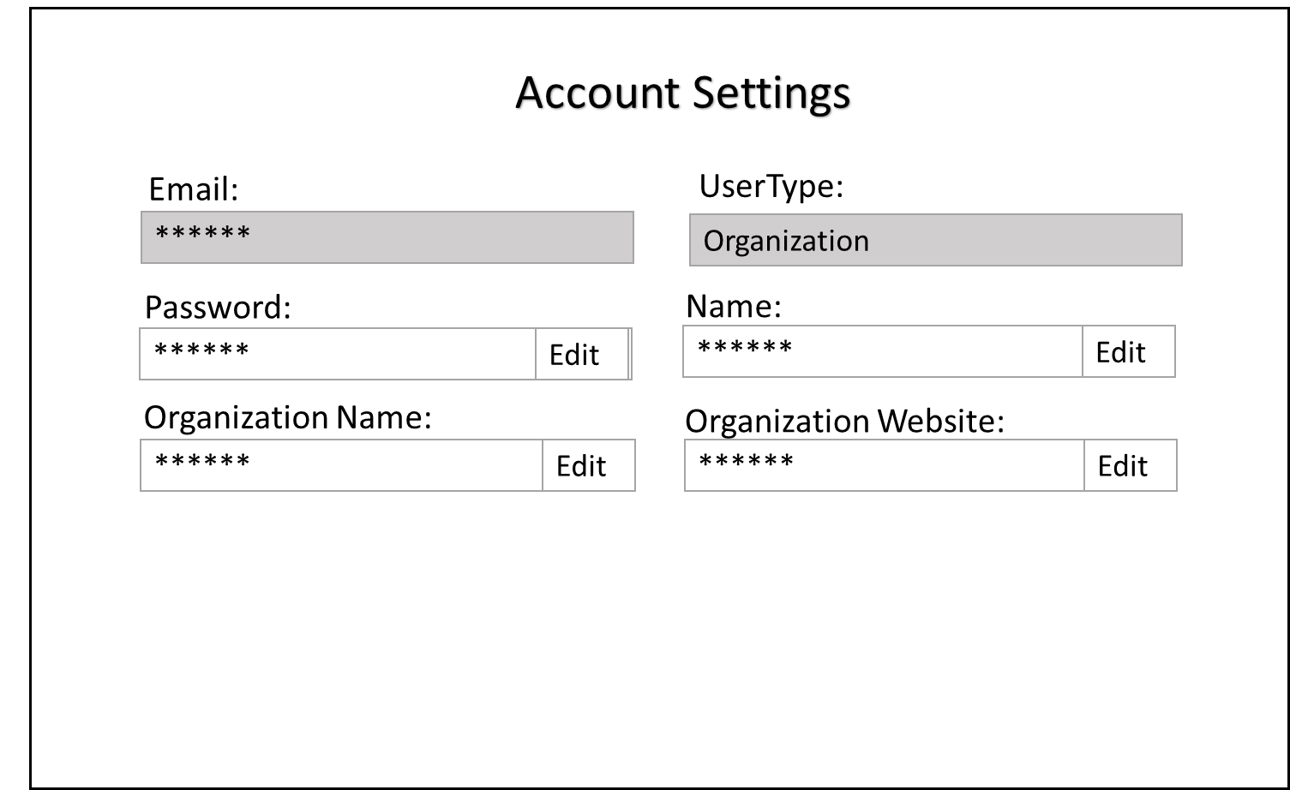

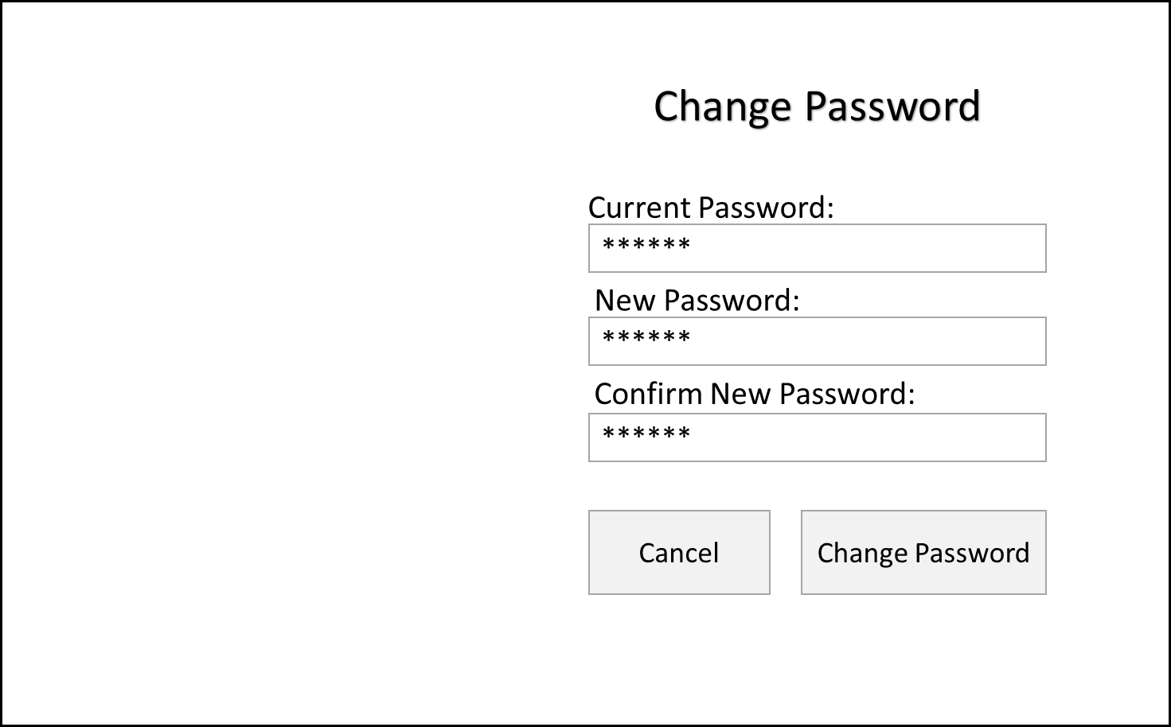

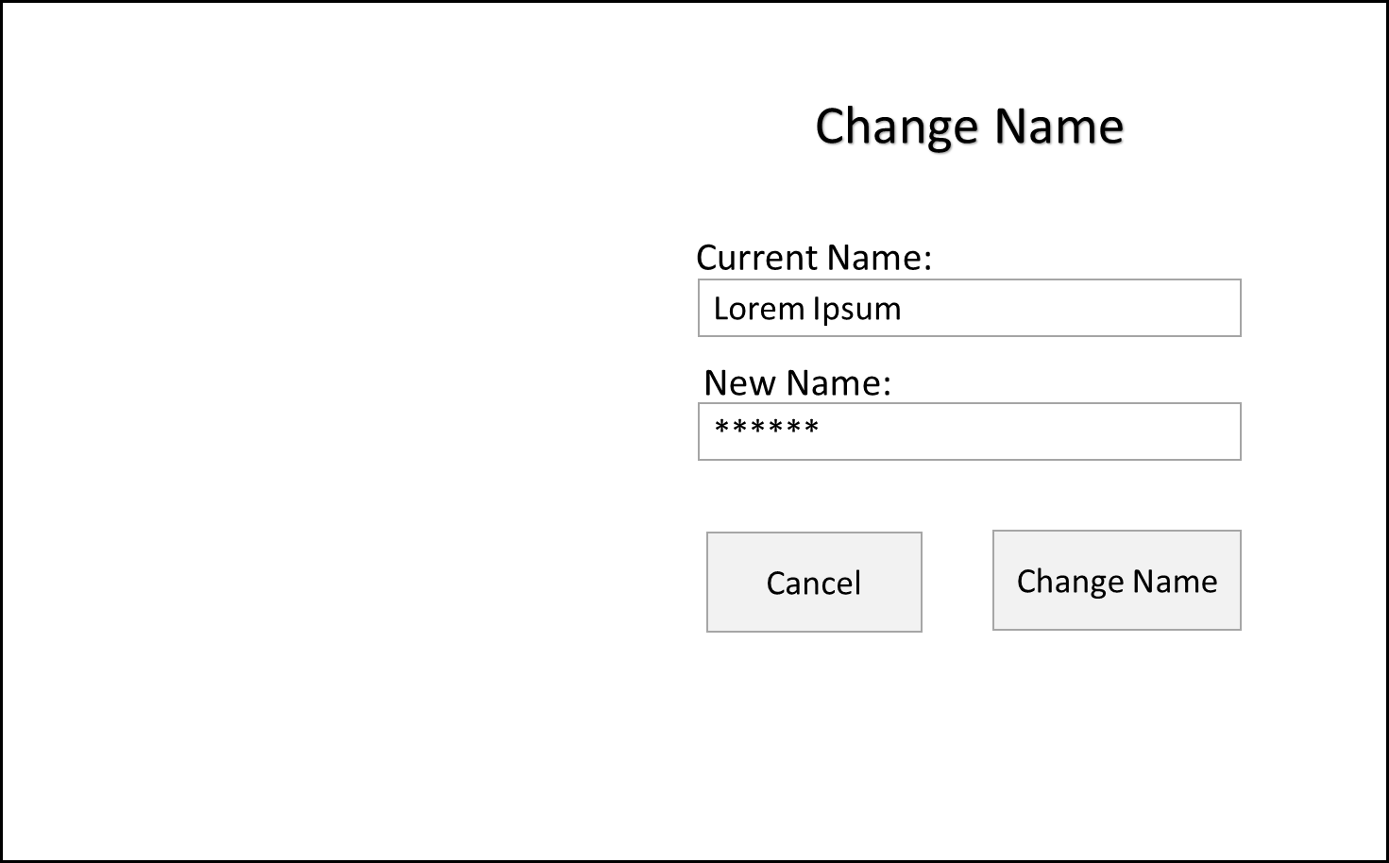

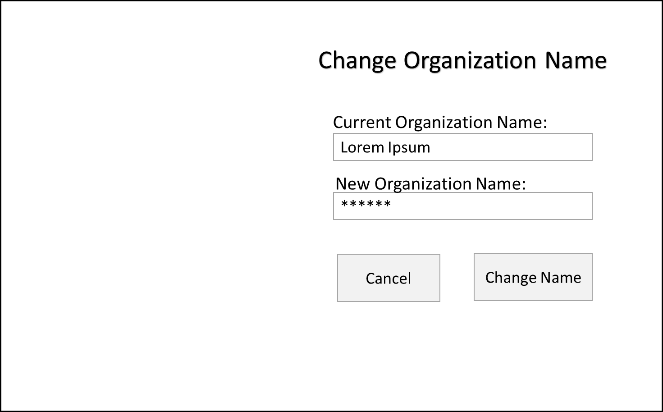

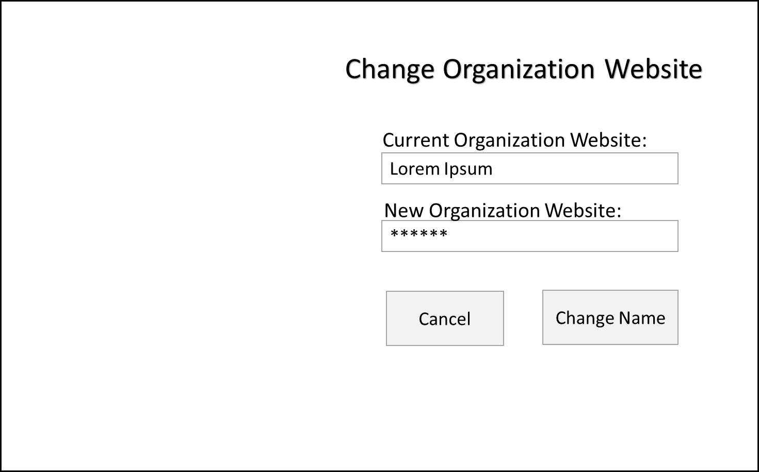

**UC13:**

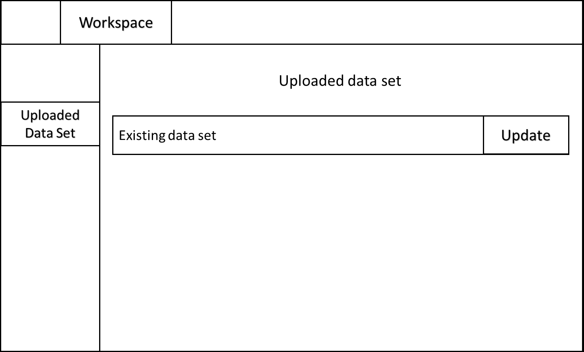

**UC14:**

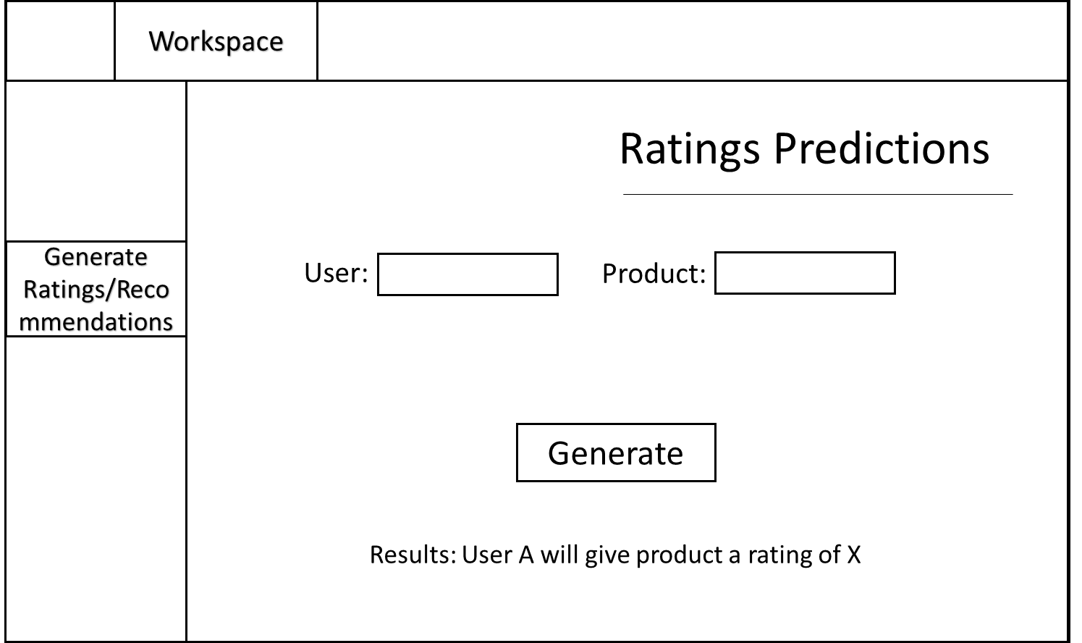

**UC15:**

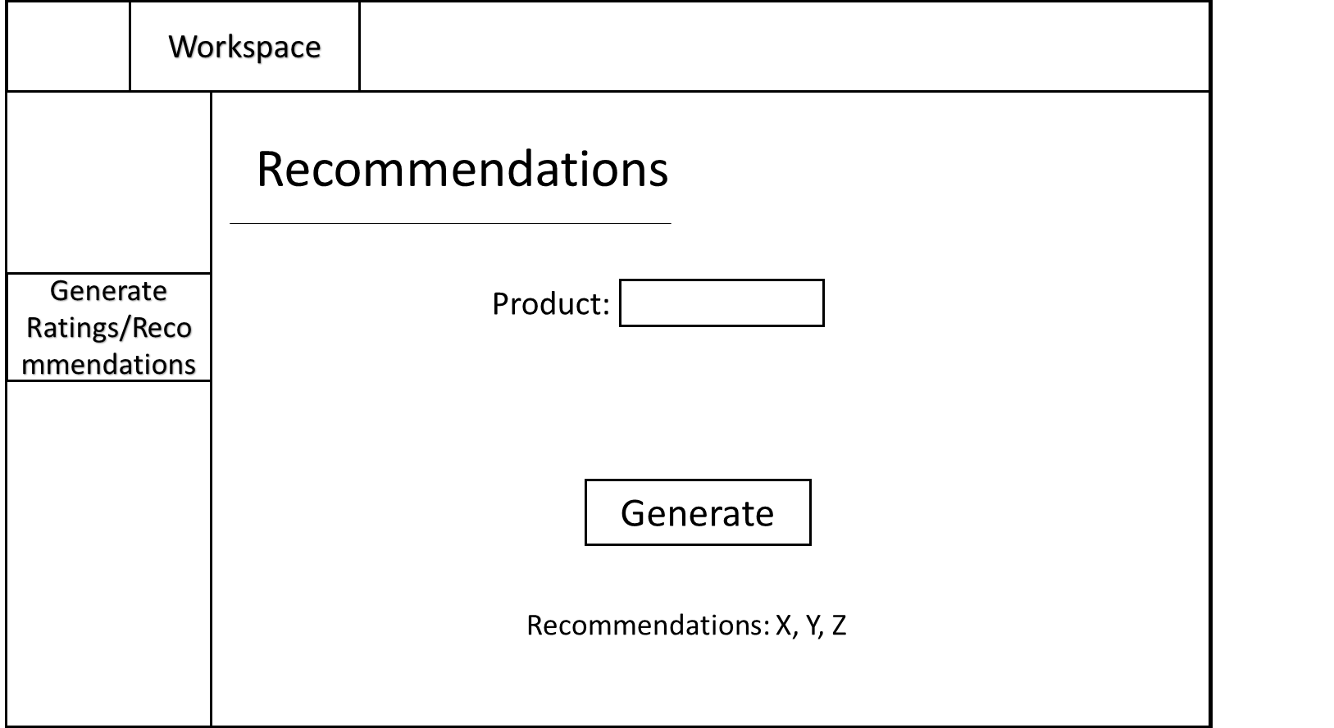

**UC16 (replace current uc16?):**

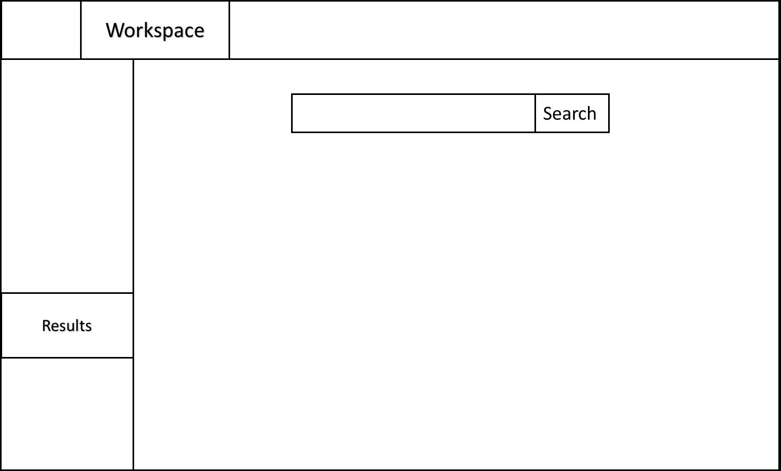

**UC17:**

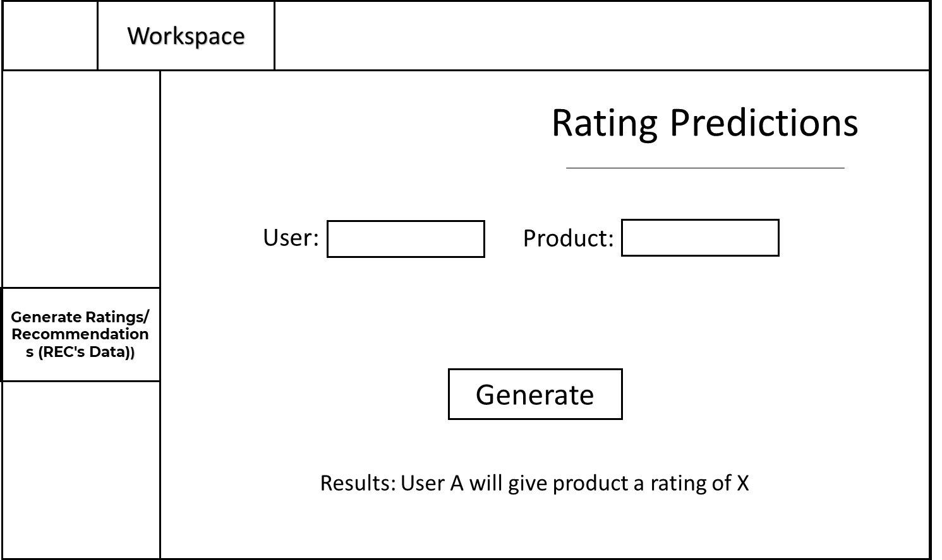

**UC18:**

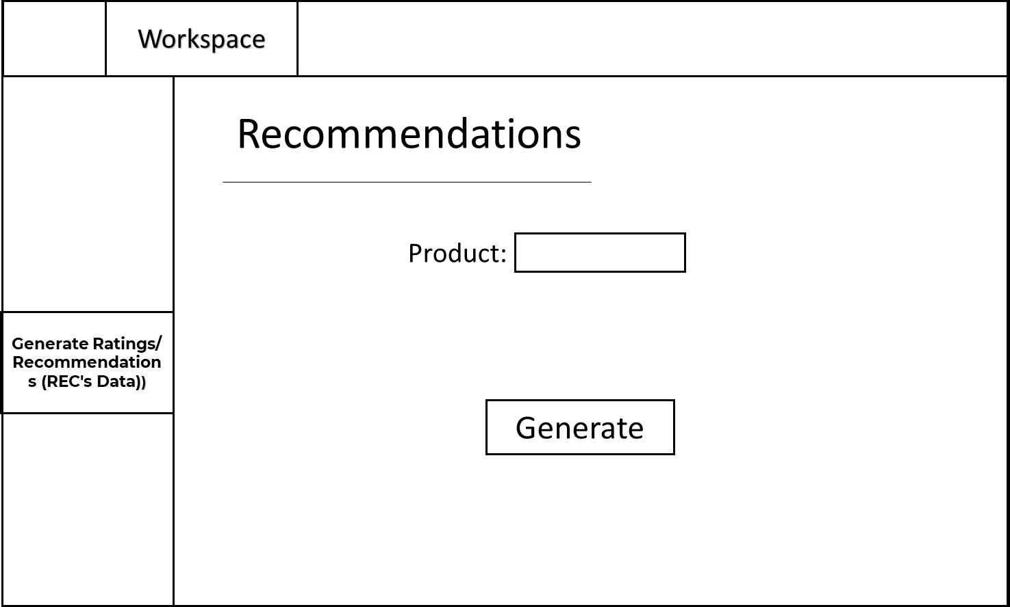

**UC19:**

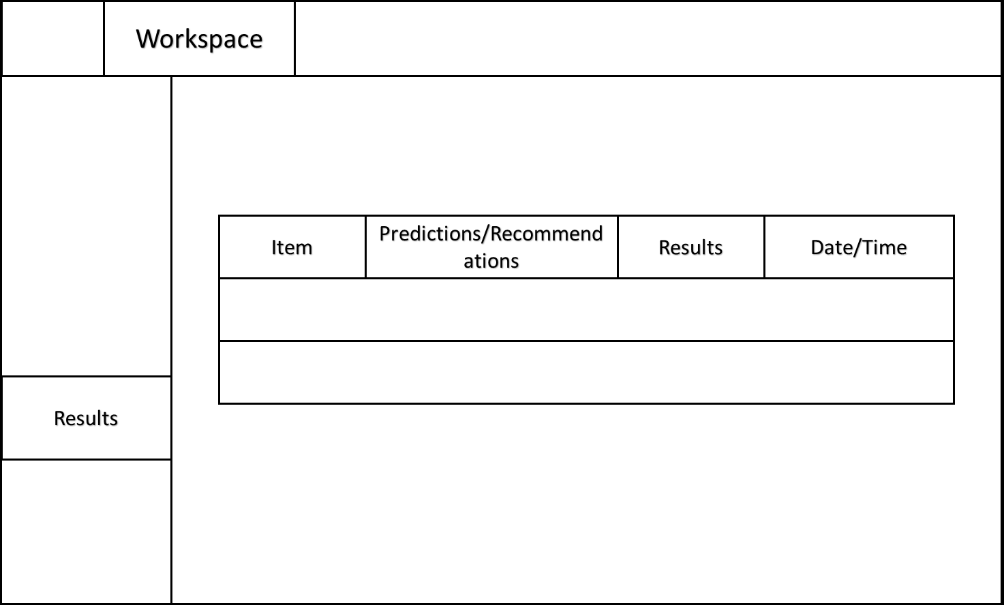

**NEW UCs (add list and uploaded list for web crawling)**

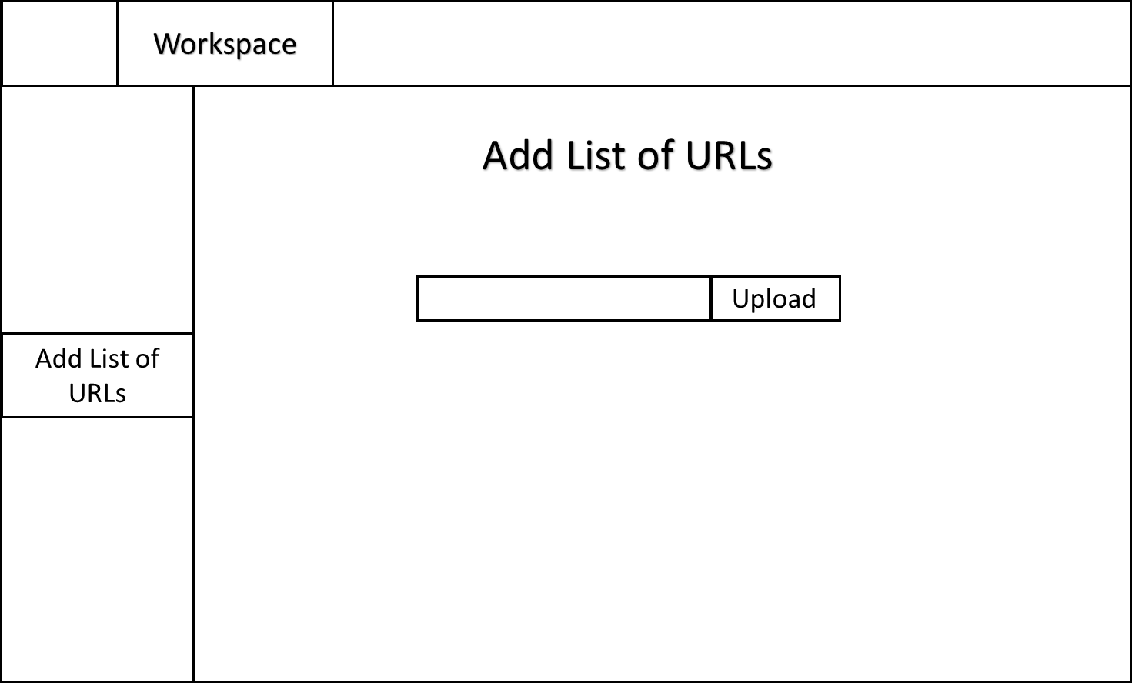

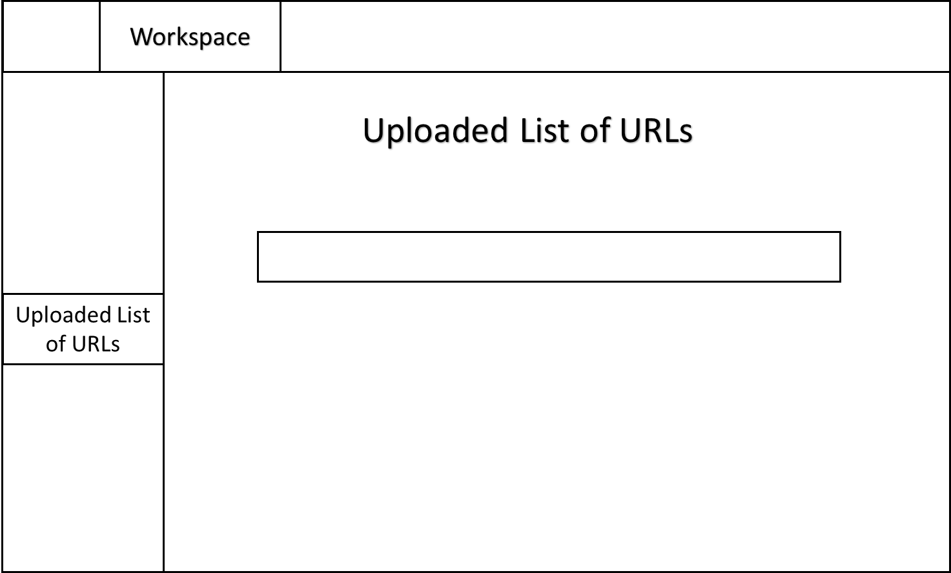

### 

### Individual

**UC20:**

**U21:**



**U22:**

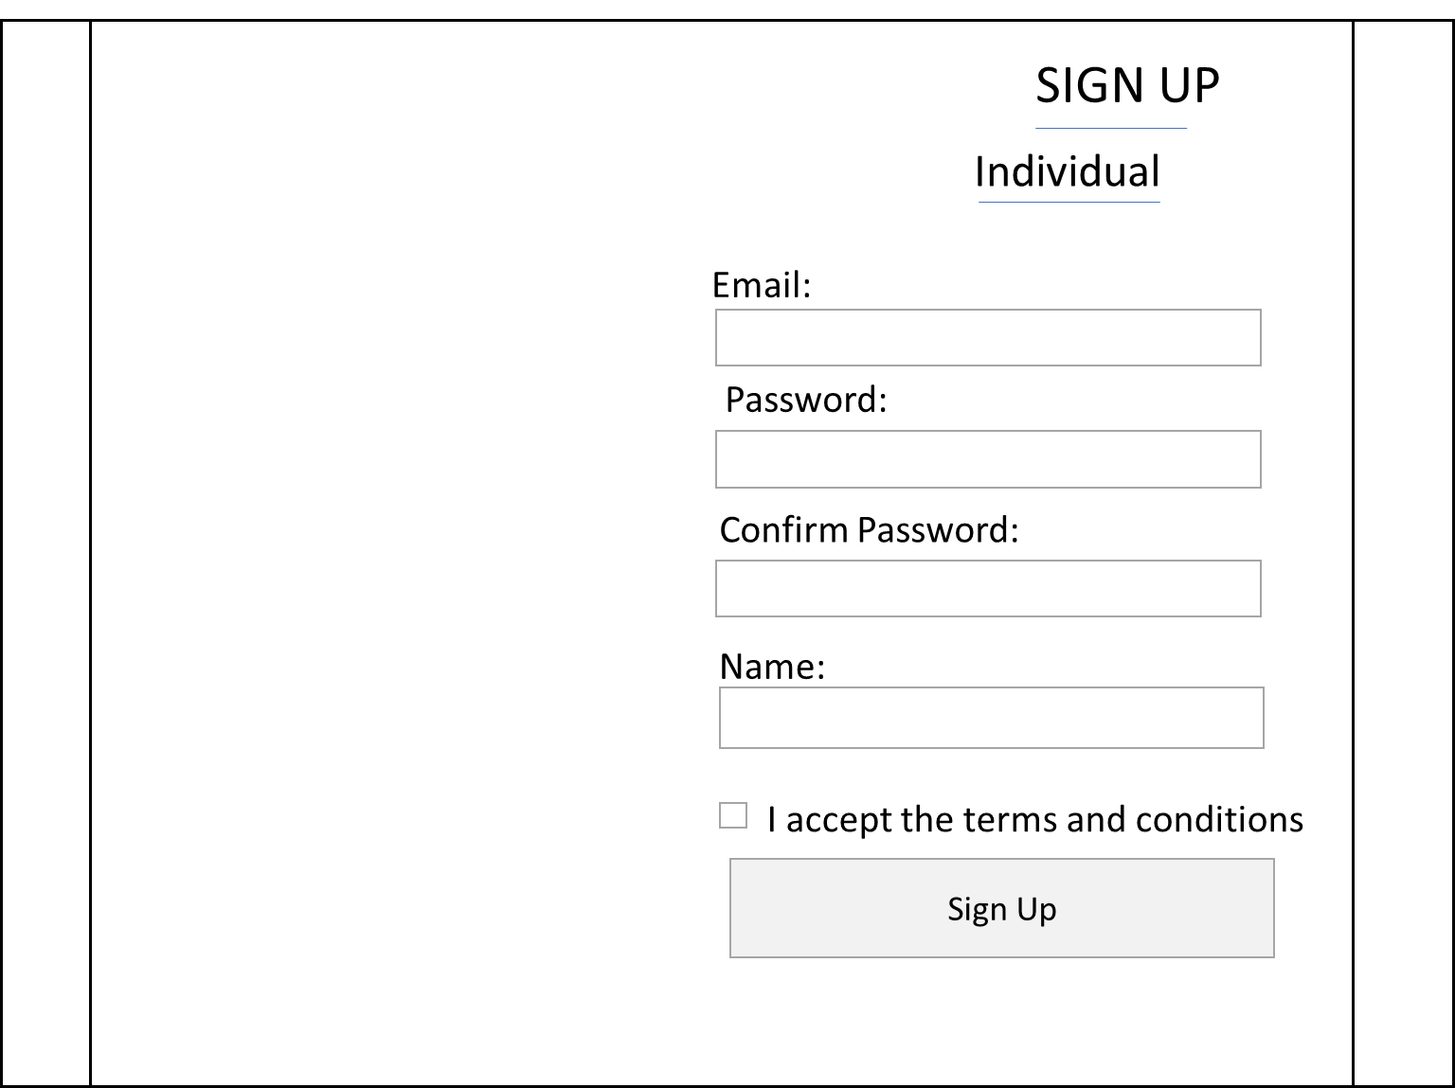

**UPGRADE PLANS:**



**U23:**



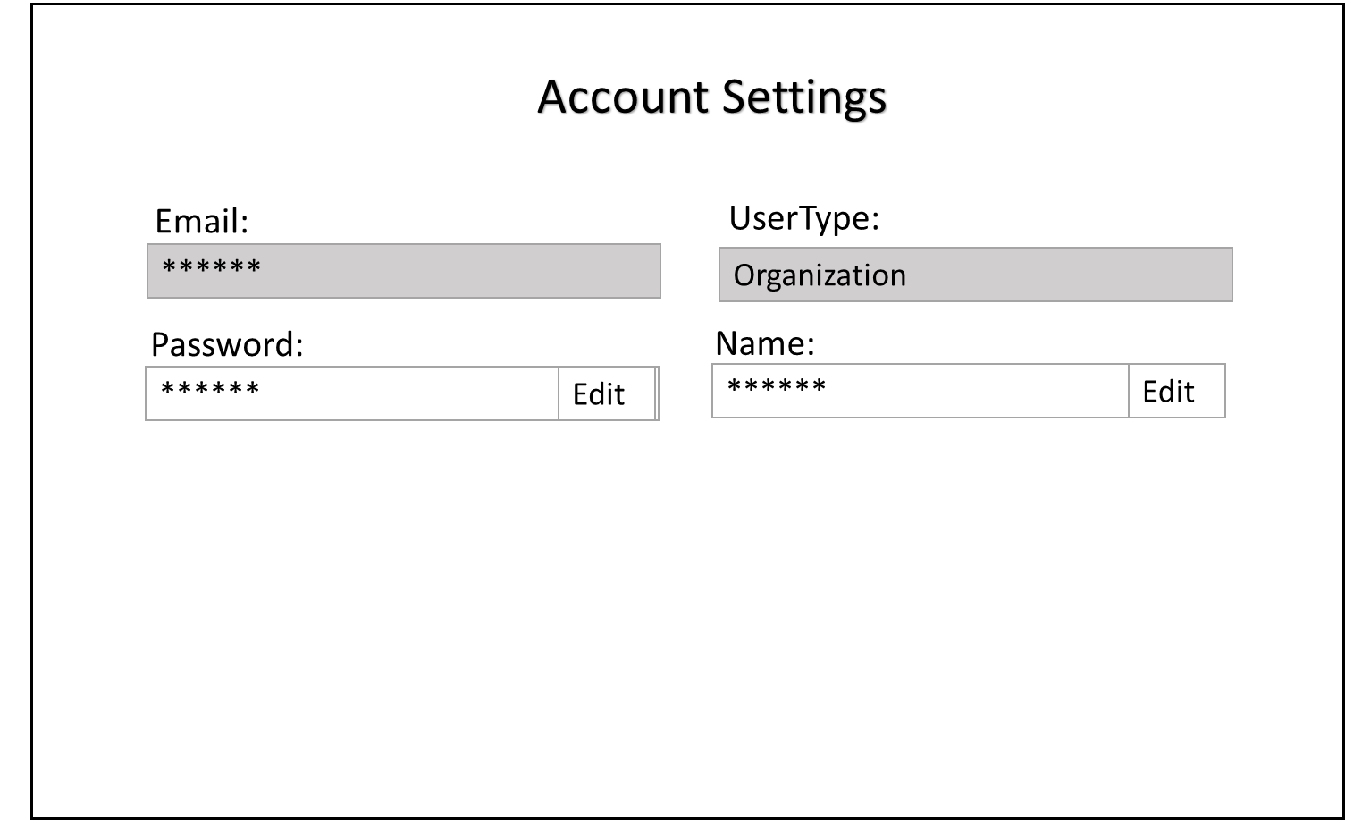





**U24:**

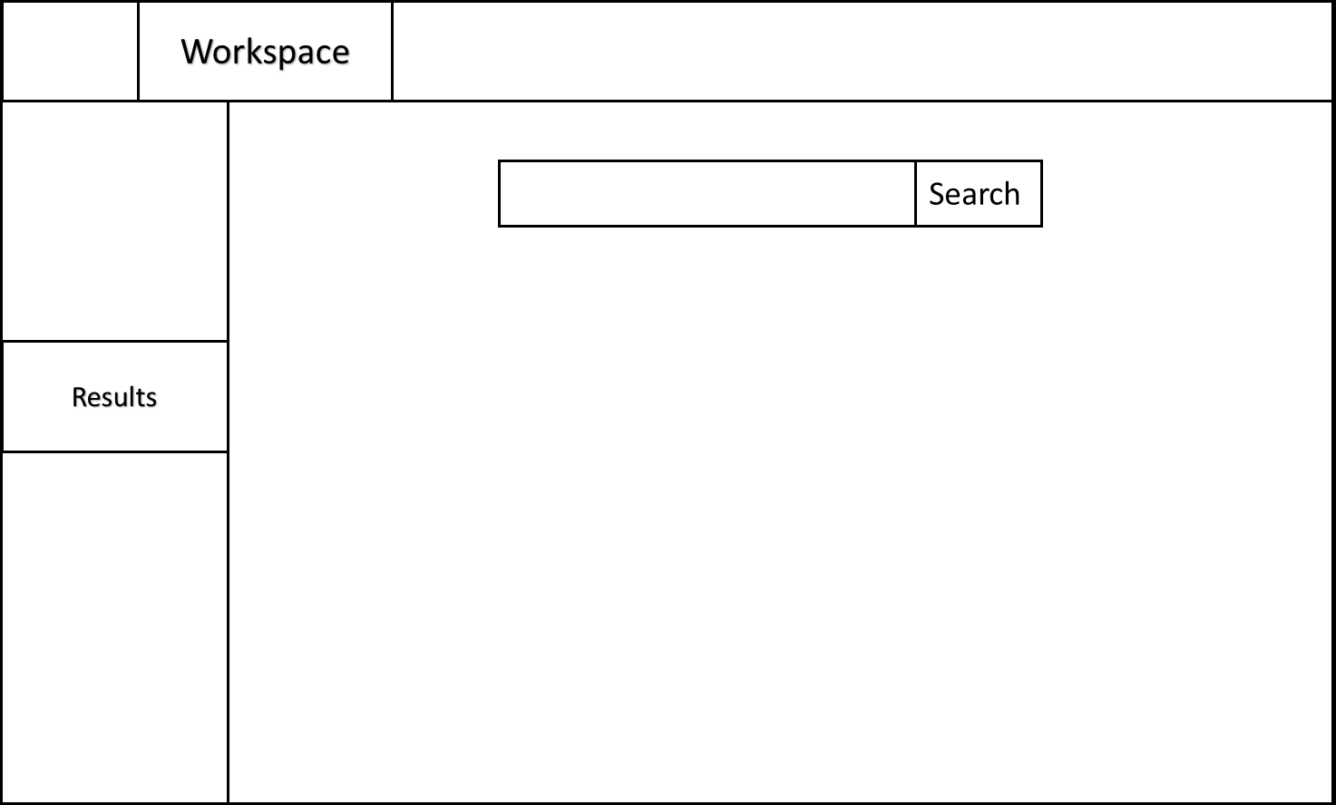

**NEW UCs (add list and uploaded list for web crawling)**





**U25:**

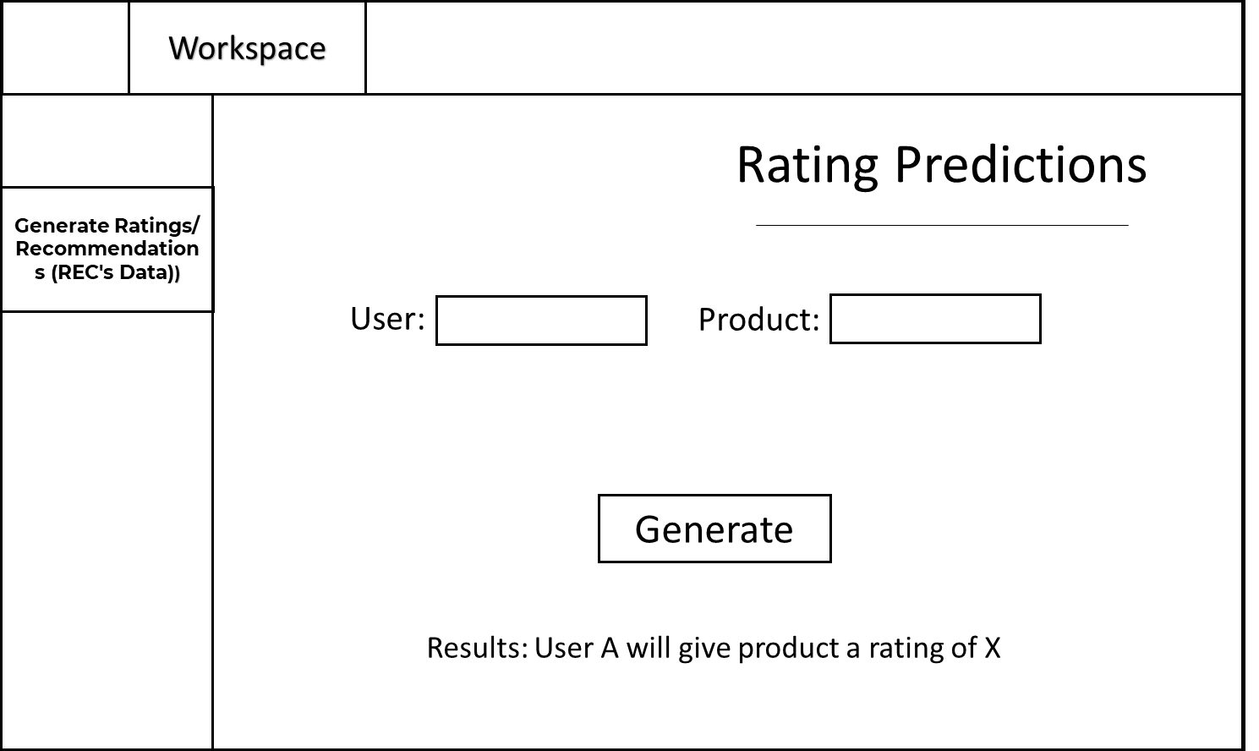

**U26:**

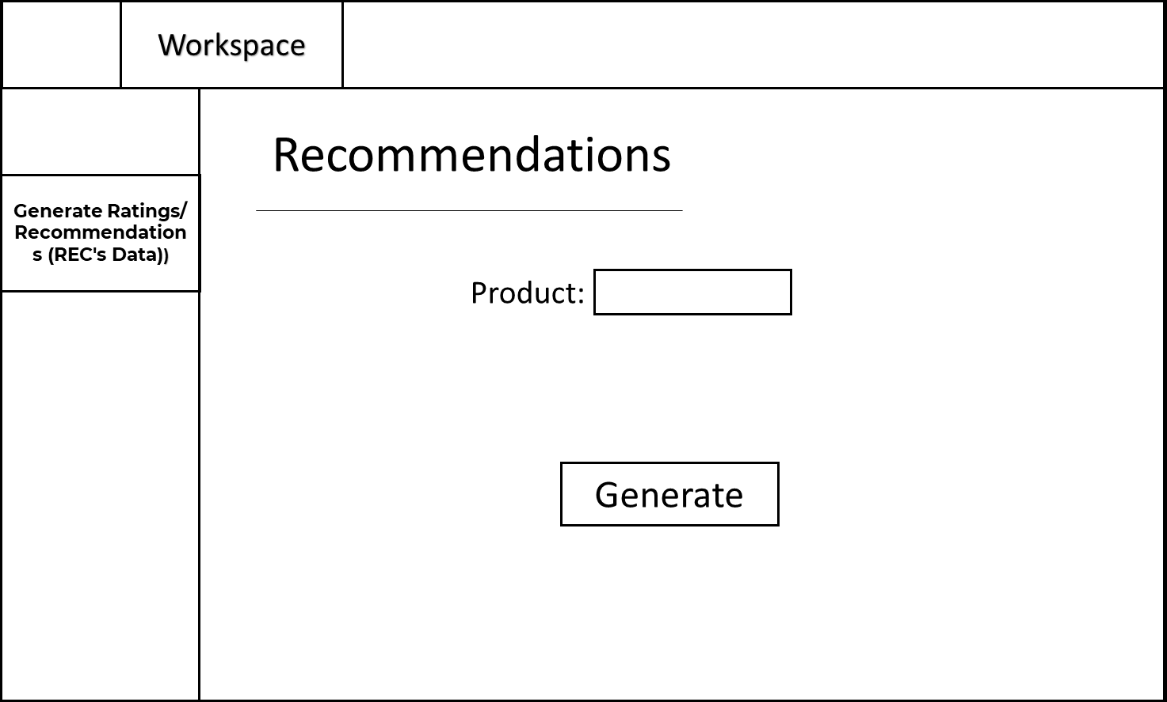

**U27:**

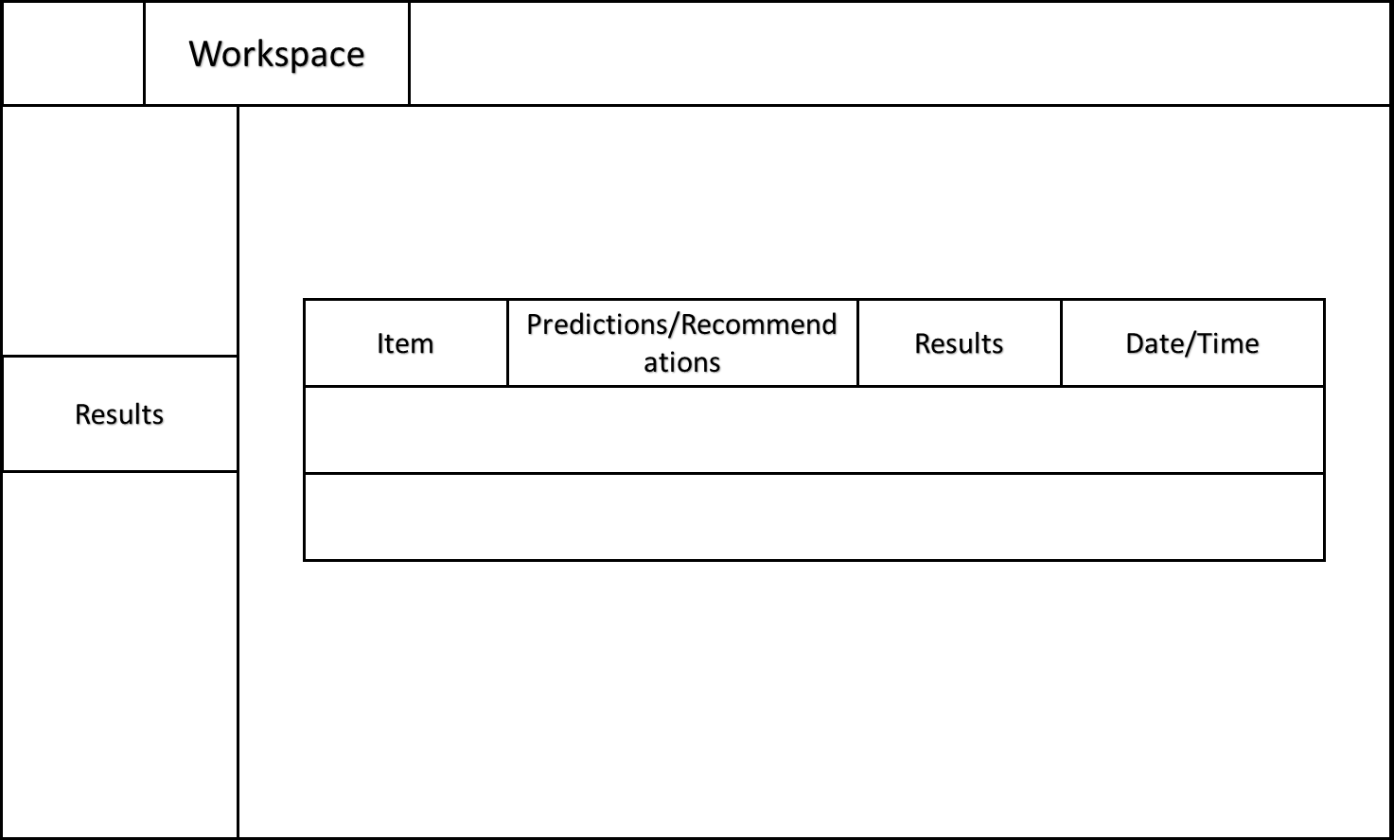

## Design Specification

### Architecture Design

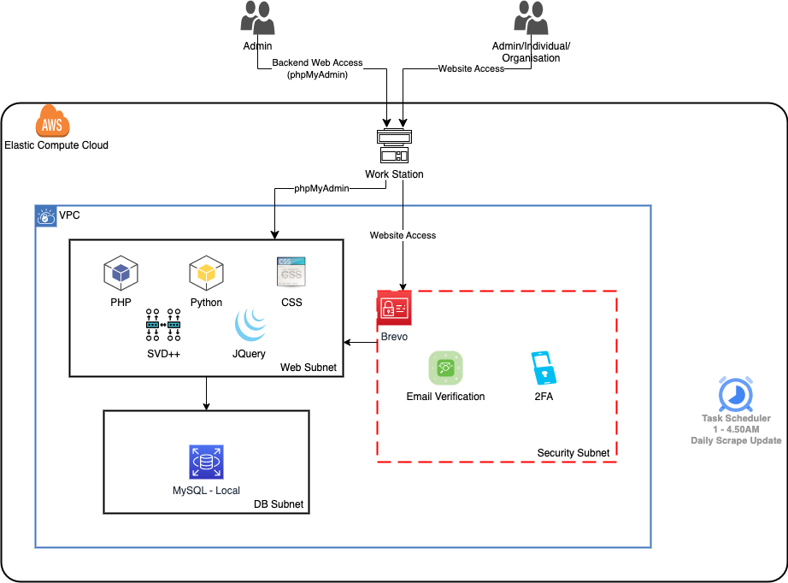

### Database Design

We have chosen MySQL as our main database for storing user data. Below is our Entity Relation Diagram.

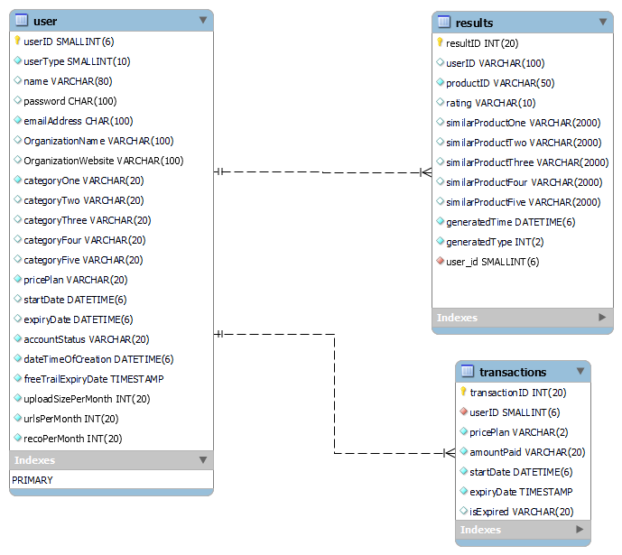

In our database design, we have a total of 3 tables. user table which stores all the user information, results table which stores all of the results that were generated and lastly the transactions table where all the transactions are stored.

The tables are in a relationship of 1 user to many results and 1 user to many transactions.

The primary keys are userID for user table, resultID for results table and transactionID for transactions table. Foreign key for the results table is user_id which is linked to userID in the user table. Foreign key for the transactions table is userID which is linked to userID in the user table.

### Software Design

The creation of the product is heavily based on the integration between PHP, CSS, JavaScript, Python and MySQL.

PHP was chosen for the frontend as it was extremely scalable, helps create dynamic web pages and its learning curve was not steep. CSS is a given as it was needed to customize the web page, and MySQL is one of the most popular database software. Python is one of the most popular web crawling or web scraping languages, and it also supports the prediction model that we are planning to use. JQuery, a framework of JavaScript works well with PHP to help integrate with Python. It also enabled asynchronous calls, meaning that we can run multiple Python scripts from PHP via JQuery without it lagging as much.

Initially, the team was thinking about using HTML and Python, but once we figured out that there was an open source cross-platform program out there known as XAMPP, which offered solutions to displaying PHP, as well as management of MySQL, it made us go that direction instead.

Elaborating further on the web crawling part, we utilized a web crawling framework written in Python, known as Scrapy. Scrapy was a great choice due how scalable it was, and its ability in being able to handle big data at great speed. There was a lot of trial and error involved, and most of these errors were mostly getting blocked by the website that we wanted to crawl, which in this case, was Amazon, or rather Amazon.com.au. To overcome that, we implemented a random proxy selector for each scrape which will take a random IP Address from valid_proxylist.txt, which contains all the valid proxies that we have found. And this indeed did help us to avoid getting blocked by Amazon.com.au. Another consideration we took was finally deciding not to scrape Amazon US, as they have very strict bot detections and force us to “sign-in” and serve us captcha even if we used a headless browser to log in.

How it works is that we have either a text or a csv input script that will extract the links from their original URL and will be checked via regex to get the domain and prodID; they will be added to separate domain_ls, prodID_ls. The crawler will combine the links back into amazon_reviews_url = f'https://{amazon_site}/product-reviews/{asin}/'. scrapy.Request is then called and then it will send the amazon_reviews_url into the parse_review function and pass the metadata of ‘asin’ and the domain url to be saved into the csv file later.

After that, the crawler extracts the ("div.product-variation-strip") and runs it through a for loop to get all the text from the span values. This will be used later to compare against the review format strip. We then added f'https://{url_amazon}' in front of the website url and extract the image url link and .replace("_AC_US60_", "_AC_US240_") if it is available in the url so that we could have a higher resolution picture. The program will then get the name of the product and extract the reviews from ("#cm_cr-review_list div.review"), where the reviews information will be extracted from a for loop. Furthermore, the crawler will get the user links from a review, check against product-variation-strip and if it is the same, scrape the info and user_link being available, and if product variation strip is None and user_link being available, we will scrape the data which consists of userID, prodID, rating, domain, image_url and prodname. Lastly, the crawler will check whether there is any next page url that we are able to scrape. If there is “/ap/signin”, we will set the next_page_short_url as none. If both next_page_short_url and user_link is not None, the crawler will do scrapy.Request on parse_review function to extract the previous information again.

For the category scraping, we use links that are from the subcategories of the category that we chose, which are computers, electronics, pets, toys and videogames. We will make use of a modify_settings script to modify the settings.py of scrapy. This is to ensure the host and referrer in the DEFAULT_REQUEST_HEADERS are similar to the request headers that any web browser uses. We will use scrapy to extract the product links from those subcategories that we found that allow us to extract links from, with a maximum limit of 100, However, as the pages are loaded in either 16 or 24 links, they will exceed limit, so the maximum number of links scraped will be at 120. There will be a delete script to do some data cleaning so that we will not have an overlapping of data. We will run a specialcharfilter.py to remove unwanted special characters from the prodname column, as it is difficult for php to display unwanted special characters. We thought about the website running in the background, so we decided to scrape these into a processing folder after that we will merge the data together with the original data without duplicates.

Svdpp is the prediction model we are using, and it runs using Python as well. It takes into account implicit ratings, and is similar to singular value decomposition (SVD) in terms of usage of stochastic gradient descent (SGD). The program utilizes the regularized squared error objective to train the parameters through SGD. There will be more info on how the program works in detail below.

Moving on from the web crawling and prediction model to the website implementation, first of all, during the development of various aspects of the website, PHP and CSS are the primary languages utilized for the majority of the website’s components. Some Javascript was also used to help facilitate dynamic requests, like the changing of screen upon clicking a button without the need to make a server request. Other than those, every design user can view, be in the login, sign up page, home or main page, they are all built using PHP and CSS.

The main idea here is to build a functional website that looks visually appealing while carrying out its core functions at a good to high level. We understood the requirements of our product and identified the key functionalities that we had to implement.

PHP worked hand in hand with MySQL to get user information to display on screen. For instance, for management of users, the admin user will get to view all the users which have signed up on the website, which allows for easier management. Things like the creating, editing, deleting of users are also enabled with the assistance of MySQL. And all these are actually part of the core functionalities of our product. Taking that into consideration, all the core functionalities are actually grouped under a class in PHP called ‘User’. In this case, there would be an edit user, create user, get user and delete user function. This benefits the programming process as we can just call the function if we need it again.

Once a user has signed up, logged in, they will be able to access the workspace, which is the place where users can add files, crawl information, generate recommendations and ratings prediction. To be able to get the results after putting the user and product information, the PHP would have to use a shell command to run the Python script, before gathering the information and then displaying as results to the user. This Python includes both the crawling script as well as the prediction model script.

Initially, the website was lagging every time we tried to execute the shell command. After some research, it was discovered that this happens because the shell command was executing on the same php page that the user is currently on. With this revelation in mind, the team decided that JQuery, which is a Javascript framework, and AJAX, which stands for Asynchronous JavaScript and XML, would help to minimize this issue. And as such that is implemented in such a that when user clicks generate, the information will be saved as JQuery variables, and JQuery uses AJAX to send this information to another PHP script which will execute the python shell command in the background without interfering with what’s happening in the current page. Once the PHP script executes whatever that’s sent over from JQuery, it sends back the information and JQuery will display the information to the user.

When users see this information, they will only be able to see the frontend portion of it, which will be the product names and images. They won’t even catch any glimpse of anything that runs in the backend. After all, we prioritize user experience, which includes easy-to-use services, alongside good to great visuals.

**SVDpp_input_csv program:**

All the checking will be encompassed under the start() function, until we pass variables into svdppcv3_gs function.

We will start by calling the python script with a directory of the csv(s) as the first argument. If length of sys.argument is more than 3, and if the second argument is “product”, it will assign the 3rd variable as prodID. If the length of the argument is more than 5, and if the fourth argument is “user”, it will assign the fifth variable as userID. If the userID is less than 13, it will output to tell the user to “User ID usage incorrect, please use another user ID” and exit the program. If length of argument is less than 6, it will assign the fourth variable to arg_no_of_reco, required number to display for similar recommendation and set arg_userID = ‘’. If the prodID length is not between 7 and 12, the program will say Product ID usage incorrect, please use another product ID, and exit the program.

Skip SVDpp_input_csv_5 program portion, go to Continue from here.

**SVDpp_input_csv_5 program:**

There will start by calling the python script with the directories of the csv(s) as the five arguments being passed. If length of sys.argument is more than 7, and if the sixth argument is “product”, it will assign the 7th variable as prodID. If the length of the argument is more than 9, and if the eighth argument is “user”, it will assign the ninth variable as userID and arg_no_of_reco = 0. If the userID is less than 13, it will output to tell the user to “User ID usage incorrect, please use another user ID” and exit the program. If length of argument is less than 10, it will assign the eighth variable to no_of_reco, required number to display for similar recommendation and set arg_userID = ‘’. If the prodID length is not between 7 and 12, the program will say Product ID usage incorrect, please use another product ID, and exit the program.

Continue from here:

The program will find file(s) ending with .csv in the directory argument, and append it to a list called csv_files. Next, it will access the data in those .csv file(s), if it is not empty, and store the data in merged_df.

We will use df as the main calling point rather than merged_df, “df = merged_df”.

Extract_user_id(href) function will be used on userID by using regex. Using the commands, if re.search(r'amzn1\.account\.(\w+)', href), has a variable, they will return re.search(r'amzn1\.account\.(\w+)', href).group(1).

df.dropna() will be used to drop all the null values.

df.drop_duplicates() will be used to remove duplicates.

We will check for the label headers for the first 3 column data, if the first column of the dataframe is not equal to 'userID' and the second column is not equals to 'prodID' and third column is not equals to 'rating'. We will use df.rename(columns=rename_ID), rename_ID function will check on the length >13, and return ‘userID’, it will check whether the length is between 7 to 12 and return ‘prodID’, it will check whether the x == ‘5.0’ or x=='4.0' or x=='3.0' or x=='2.0' or x=='1.0' and return ‘rating’. It will just return x, as it does not fulfil these criterias.

Get the df_shape, and if the df_shape[1] is more than 3, it will slice the df, to only have the first 3 columns.

if (df_shape[0]>10000) then we will sample it to 10000, df = df.sample(10000), else if (df_shape[0]>1000) then we will sample it to 1000, df = df.sample(1000)

Set reader to the default settings.

Pass df, reader, arg_userID, arg_prodID, arg_no_of_reco into svdppcv3_gs function.

In svdppcv3_gs, we will use Dataset.load_from_df and extract 'userID', 'prodID', 'rating' from df, and pass the reader into it, and equate it to data.

We will use build_full_trainset on data, and equate it to train_set.

We will use the train_set and build_testset on it to check the RMSE values and call it data_testset.

We create a basic svdpp() model that is called svdppalgo.

We will use svdppalgo to fit the train_set.

We use svdppalgo.test(data_testset) and call it test_Pred,

Using test_Pred on accuracy.rmse value to compute an RMSE value, and name it rmseVal_ori for the basic svdpp.

We will go on to use param_grid to tune the gridsearchCV.

We will use this param_grid based on previous runtime speed and RMSE outputs for the tuned values.

# hyperparameters

param_grid = {"n_factors": [10, 15],

"n_epochs": [30, 60],

"lr_all": [0.002, 0.004],

"reg_all": [0.04, 0.07]

}

We will use gridsearch at cv=3, n_jobs=-1 will use all cores in the system and put the param_grid and SVDpp in the GridSearchCV

gs_cv3 = GridSearchCV(SVDpp, param_grid, measures=["rmse", "mae"], cv=3, n_jobs=-1)

We will fit the data into the gs_cv3.

We will use best_estimator for rmse to get the lowest value out of the param grid that was in the gridsearch, svd_pp_cv3 = gs_cv3.best_estimator["rmse"]

We will fit the train_set into svd_pp_cv3.

We use svd_pp_cv3.test(data_testset), to compute an accuracy.rmse value, and name it bestpred_cv3 for the tuned svdpp.

Using bestpred_cv3 on accuracy.rmse to compute an RMSE value, and name it as rmseVal_cv.

If rmseVal_cv is more than rmseVal_ori, we will use the original base SVD++ parameters and run the prediction.

If the length of sys.argv is more than 5, we will print out the RMSE value for rmseVal_ori.

And run the svdppalgo.predict on uid=arg_userID, iid=arg_prodID, and r_ui = None with .est and call it norm_pred.

We will print out the rating prediction (f"Rating prediction: {round(norm_pred)}")

If the length of sys.argv is less than 6, we will pass arg_prodID, df, train_set, svdppalgo, int(no_of_reco) into similar_products function

In similar_products, we will get the list of all item IDs in the dataset.

Run it through the algo to get the predicted ratings for each item for the userID = 0.

Sort the predictions by rating and extract the top n recommended item IDs and exclude the prodID that is being recommended on.

Get the names of the recommended items and drop duplicates.

Create a list of dictionaries containing the recommended item IDs and names

Return the list to topReco_prod

Print out the top recommended items from topReco_prod.

start() at the end to start the program.

## Testing Documentation

### Test Plan

#### Introduction

This document is a test plan whereby it is used to communicate the test approach to team members. It includes the objectives, scope, schedule, risks, and approach. This document will clearly identify what the test deliverables will be and what is deemed in and out of scope.

#### 

#### Objectives

The test team is responsible for testing the website service and ensuring it meets the requirements and is of high quality. The test team will be acting as organization, individuals as well as the admin in this project.

The team will create and conduct test cases on every functionality of the website service. Must have functionality is considered more important than the delivery date in this project.

#### 

#### Quality Assurance Team Members

| **Name** | **Role** |
| --- | --- |
| Loo Joon Wee | QA Team Lead, QA Analyst, QA Tester |
| Muhamad Amir Akmal BMS | QA Analyst, QA Tester |

### 

#### Scope

Testing for all ‘must have’ requirements are set as priority. These and any other requirements that get included must all be tested. At each test sprint, the tester must:

1. Create test cases that caters to individual functionality with as detailed steps as possible.
2. Conduct the test according to the test case’s steps.
3. Record down the results and enter appropriate comments.
4. Document test report
5. Ensure requirements are met.

#### Functional Testing:

* Verify that all user stories and requirements are met.
* Test all functional requirements to ensure that they meet the expected behavior and functionality.
* Verify that the software is compatible and functional in all intended environments, platforms, and browsers.
* Verify that the software handles errors and exceptions correctly.
* Verify that the software performs the required outcome after integration with third-party systems, databases, and services.

#### Non-Functional Testing:

* Conduct usability testing to ensure that the website service is easy to use and understand.
* Conduct security testing to ensure that the website service is secure from unauthorized access or users with unauthentic profile information (Non-existent organization or email of individual)
* Conduct compatibility testing to ensure that the website service works correctly with all intended operating systems and hardware.

#### Regression Testing:

* To ensure that previously tested functionalities continue to function correctly after changes, improvements or debugging have been made to the website and software.

#### System Testing:

* To ensure that the website service works as a whole after all different modules and functions are being integrated together.
* To ensure that the website service as a whole meets all the specified requirements and performs as expected.

#### Acceptance Testing:

* To ensure that the website service meets the requirements of the client and end-user.
* To assure that the service is ready for publish.

#### Deliverables:

* Test plan outlining scope, testing approach, risk assessment, and schedule
* Test cases
* Test results and reports

#### Roles and Responsibilities:

* The quality assurance team is responsible for developing and executing test cases, identifying, and reporting bugs, as well as providing updates.
* The development team is responsible for fixing bugs, addressing and solving issues identified during testing.
* The product owner is responsible for verifying that the website service meets all acceptance criteria.

#### Assumptions / Risks

**Assumptions**

This section lists assumptions that are made specific to this project.

1. Functions that meant to be tested, are implemented, and published on the website.
2. All the content on the website and test cases are in English.
3. Testers and users understand English.
4. Website and services accessible to any OS platform and browsers.
5. Testers and users have access to internet.
6. Test data will be available and accurate.
7. The software will be stable and free of major bugs.

## 

**Risks**

The following risks have been identified and the appropriate action identified to mitigate their impact on the project. The impact of the risk is based on how the project would be affected if the risk was triggered. The consequence is what event would cause the risk to become an issue to be dealt with.

| **No** | **Risk** | **Impact** | **Consequence** | **Mitigation Plan** |
| --- | --- | --- | --- | --- |
| 1 | Delay in the delivery of functional software features | Medium | Affect testing schedule | Skip to next available user story functionality and conduct respective tests on it and return to the planned function testing when the development team is ready. |
| 2 | The software may have critical bugs that requires long debugging duration | Medium | Affect testing schedule | Same as previous mitigation plan, move on to subsequent functional testing first or documentation updates while waiting for development team. |
| 3 | Team members may face unexpected personal issues that delays their work production | High | Affect testing schedule and development schedule | Other team members help to cover up the required work production while waiting for the team member to be back. So, the whole team doesn’t fall behind too much. |
| 4 | Third party integrations may not work as expected or functionalities might not work as expected | High | Affect testing schedule and development schedule | If confirmed on third party integrations being unable to work as planned, for example hosting platforms, immediately switch to next better option that was researched in the documentations. |

#### 

#### 

#### 

#### 

#### 

#### 

#### 

#### 

#### 

#### 

#### 

#### 

#### 

#### 

#### Test Approach

* Test often throughout the development cycle to ensure that issues are identified and addressed as early as possible.
* Test in parallel with development to ensure that issues are identified and addressed in a timely manner.
* Focus on critical functionality first, followed by testing of remaining functionalities or good to have functionalities.

**Manual testing**

Automated tests are part of the development process, but no automated functional tests are planned for our projects, we will only be conducting manual testing.

Our quality assurance team will be manually testing all the test cases, record down the results and feedback accordingly.

## 

**Metrics to measure usability testing:**

**To define measurement of whether usability testing pass/fail:**

* Success Rate: Percentage of testers and users being able to complete certain task without assistance or guidance from developer team
* Efficiency Rate: Percentage of testers and users that agrees that they are able to complete task smoothly without having to hesitate or trial and error around the navigation of the whole service
* User Experience: Level of difficulty to navigate through the website, level of difficulty to adapt and understand the usage of the software, level of satisfaction after using the software, level of engagement and interest the users have with the software

### 

### 

### 

### 

### 

### 

### 

### 

### 

#### Test Environment

The service will be integrated in the website, hosting on AWS platform. So, the testing will be done through website, with the presence of internet. However, early testing will be conducted through local host, as the hosting on AWS will be integrated at a later stage.

After hosting on AWS platform, we will be running integration testing, regression testing, system testing, acceptance testing again. It will be conducted using desktop/laptop, with the presence of internet, on both windows and IOS

**Testing website link: (Either of it)**

* bit.ly/-RECS
* https://ec2-52-64-251-102.ap-southeast-2.compute.amazonaws.com/dashboard/fyp/main.php

**Hardware and software requirements:**

* Desktop/Laptop (MacOS, Windows)
* Browsers (Google Chrome, Internet Explorer, Firefox, Safari)

**Dependencies:**

* MySQL database
* Connected working internet access

**Preconditions:**

* Ensure the hardware, software and dependencies are all installed and present

#### Timeline

**Test Schedule**

* **Sprint 6:**
  + **Week 2:**
    - Create test plan
    - Create test cases for user stories on all aspects of account management for all types of users
    - Begin parts of functional testing for user stories on account management
    - Begin regression testing on previously tested user stories
* **Sprint 7:**
  + **Week 1:**
    - Continue and finish up functional testing on remaining user stories on account management
    - Continue and finish up regression testing on previously tested user stories
    - Conduct and finish integration testing for previous tested user stories that are integrated together
    - Create test cases for user stories on security features aspects, as well as rating and prediction function aspects of all users
    - Conduct and finish functional testing for user stories on above mentioned aspects
    - Conduct and finish regression testing on previously above tested user stories
    - Conduct and finish integration testing for previous tested user stories
  + **Week 2:**
    - Create test cases on user stories of recommendation and web scraping based on category
    - Conduct and finish functional testing for the above mentioned user stories
    - Conduct and finish integration testing of certain above mentioned user stories
    - Conduct and finish regression testing on previously tested user stories and ensure every user stories tested and integrated so far are working together as a whole
    - Create test cases on user stories of security functions
    - Begin functional testing of security function test cases
    - Begin integration testing of above tested security test cases
* **Sprint 8:**
  + **Week 1:**
    - Continue and finish functional testing of security function test cases
    - Continue and finish integration testing on above test cases
    - Conduct and finish final debugging, implementations, build testing and polishing
    - Conduct final regression testing for all above tested user stories
    - Conduct system testing as a whole to ensure the software is ready for publishment
    - Conduct acceptance testing to ensure the software meets the criteria

#### Deliverables

| **Deliverable** | **By** |
| --- | --- |
| Test Plan | Joon Wee |
| Test Cases | Joon Wee, Amir |
| Test Results | Joon Wee, Amir |
| Test Status report | Joon Wee |

### Test Cases

*In-depth detailed test cases are attached in the QA folder, under Test Cases

Account Management:

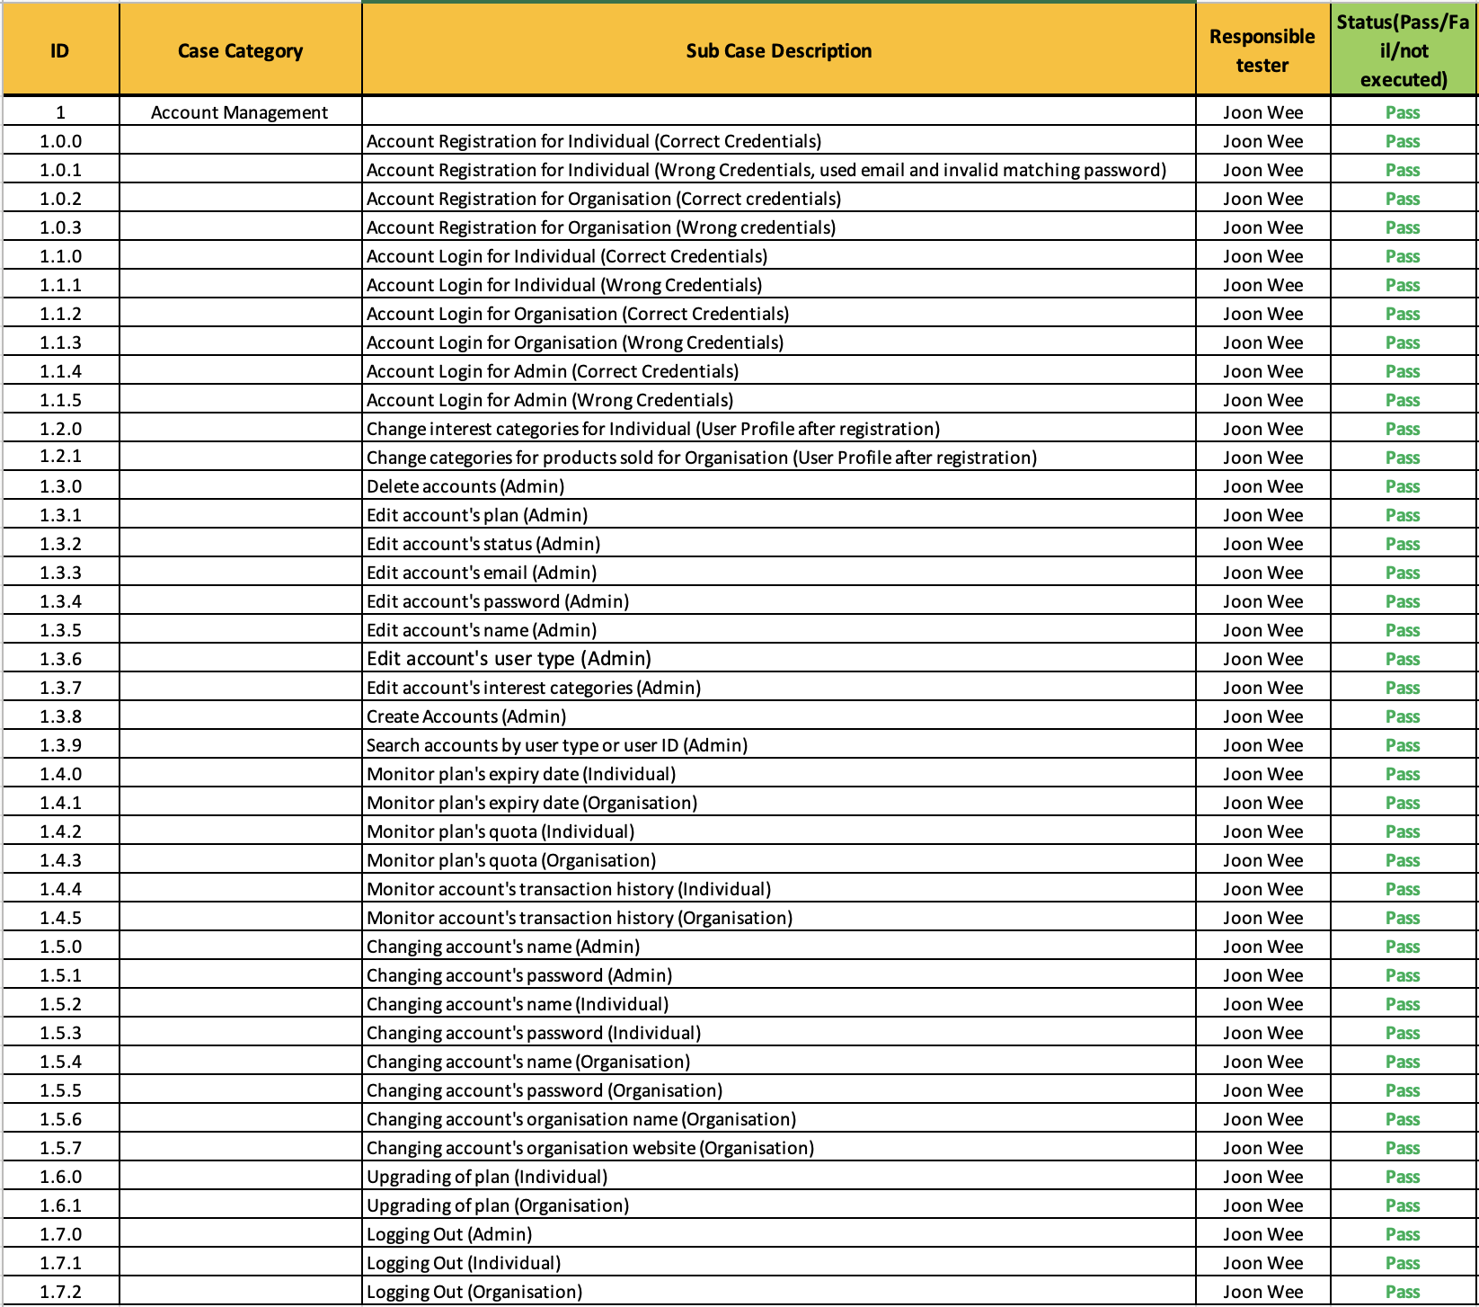

Security:

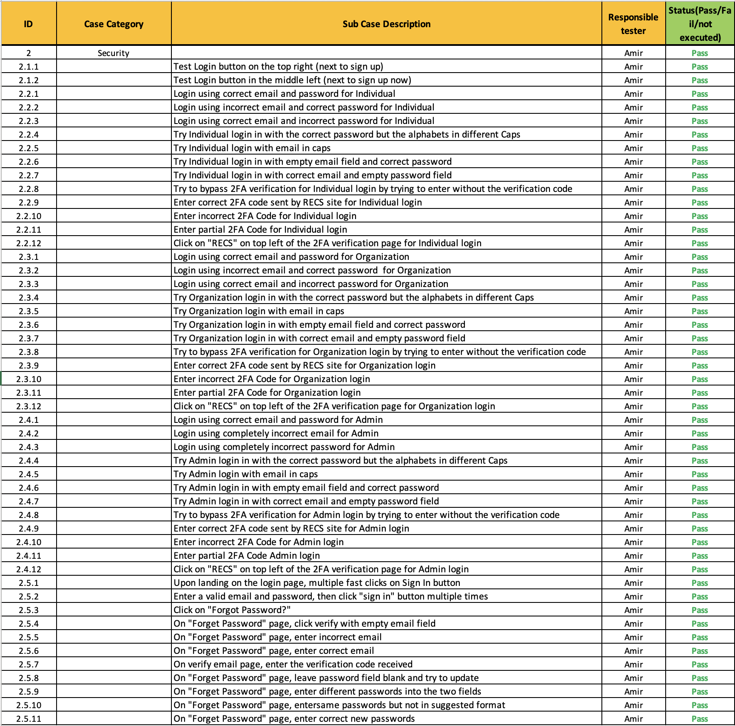

Trial Feature:

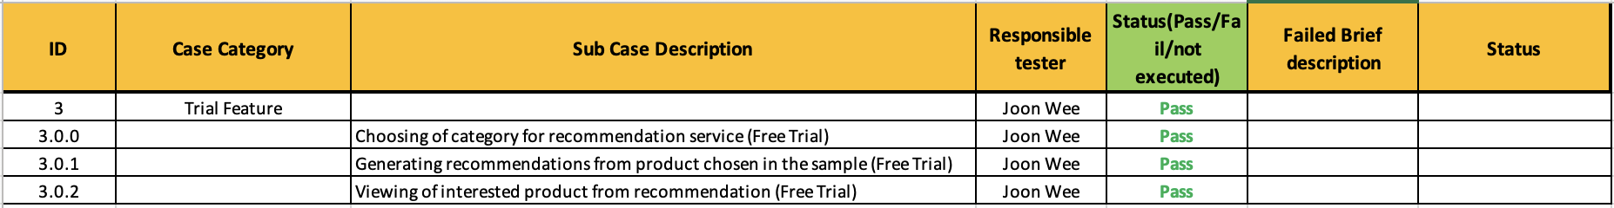

Website Introduction:

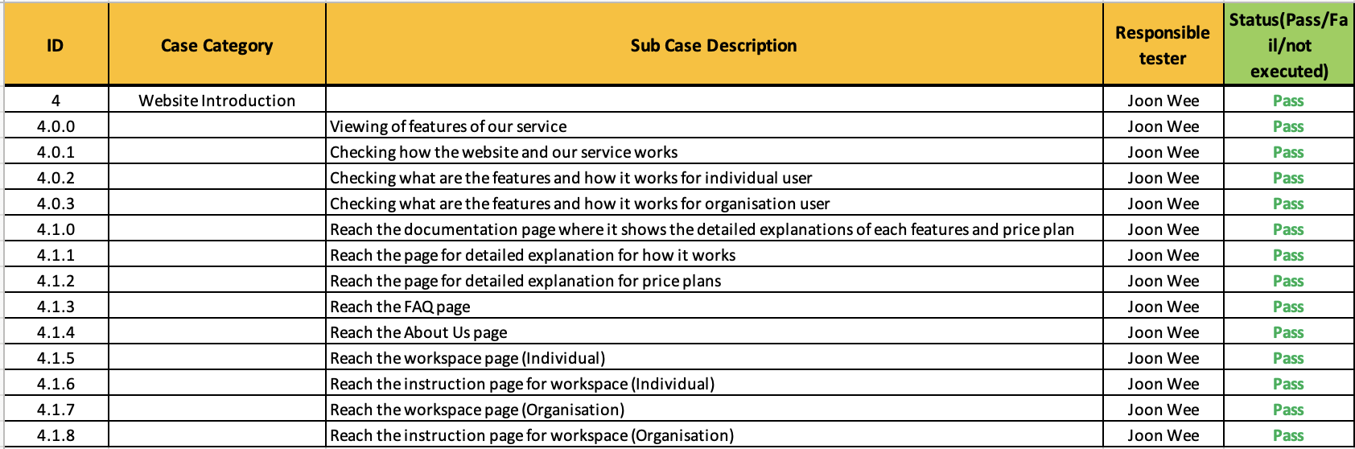

Web scraping:

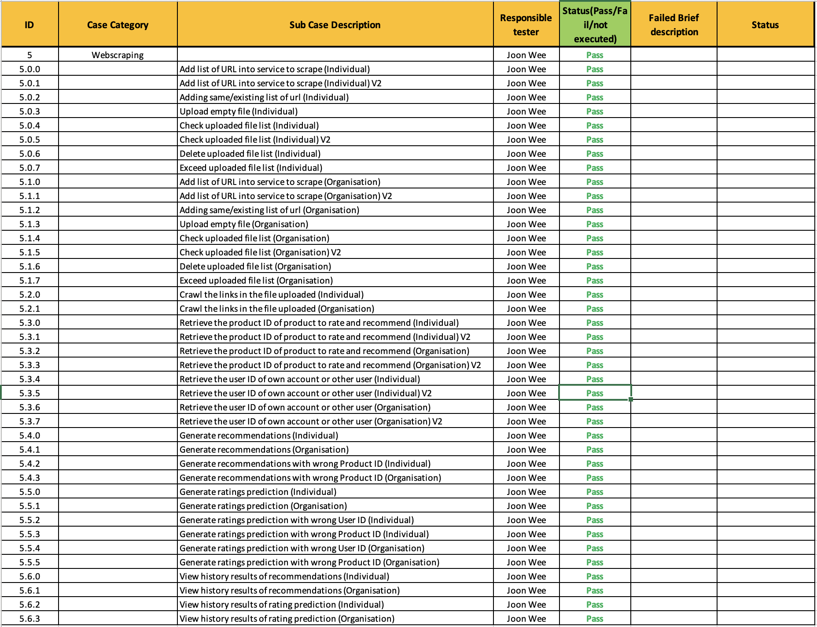

Data Set:

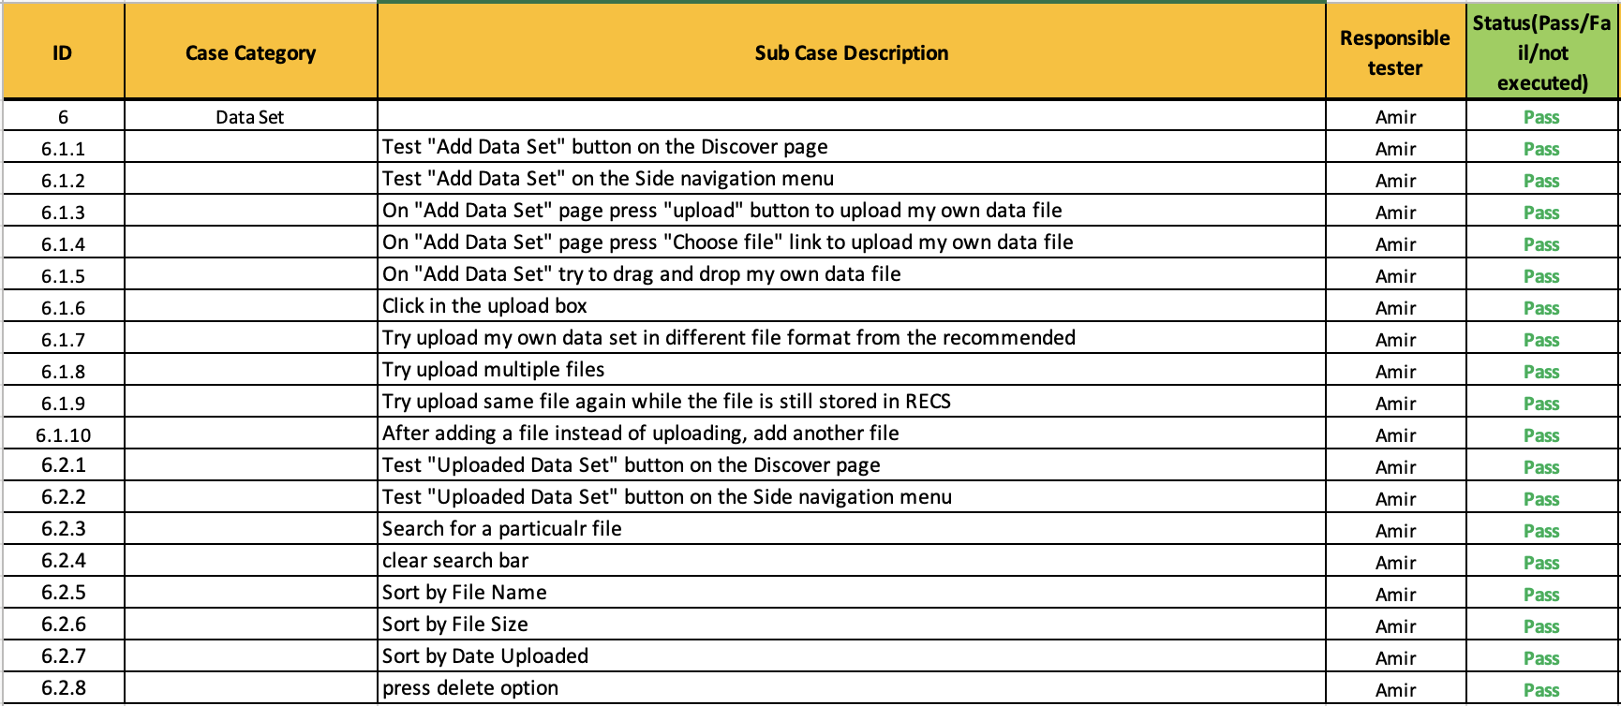

Ratings Prediction:

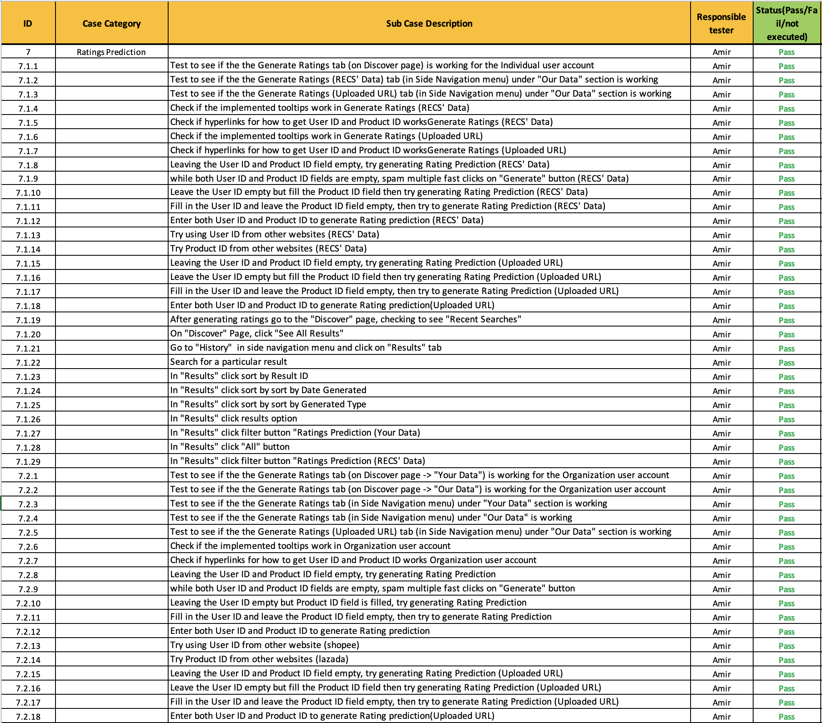

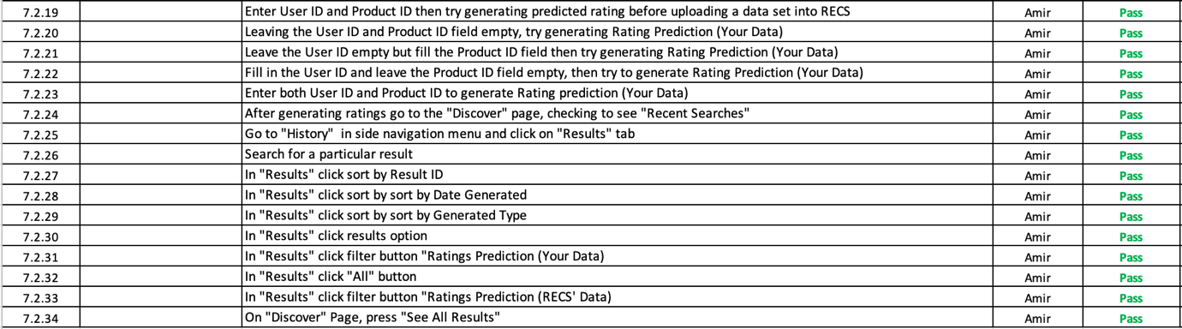

Recommendations:

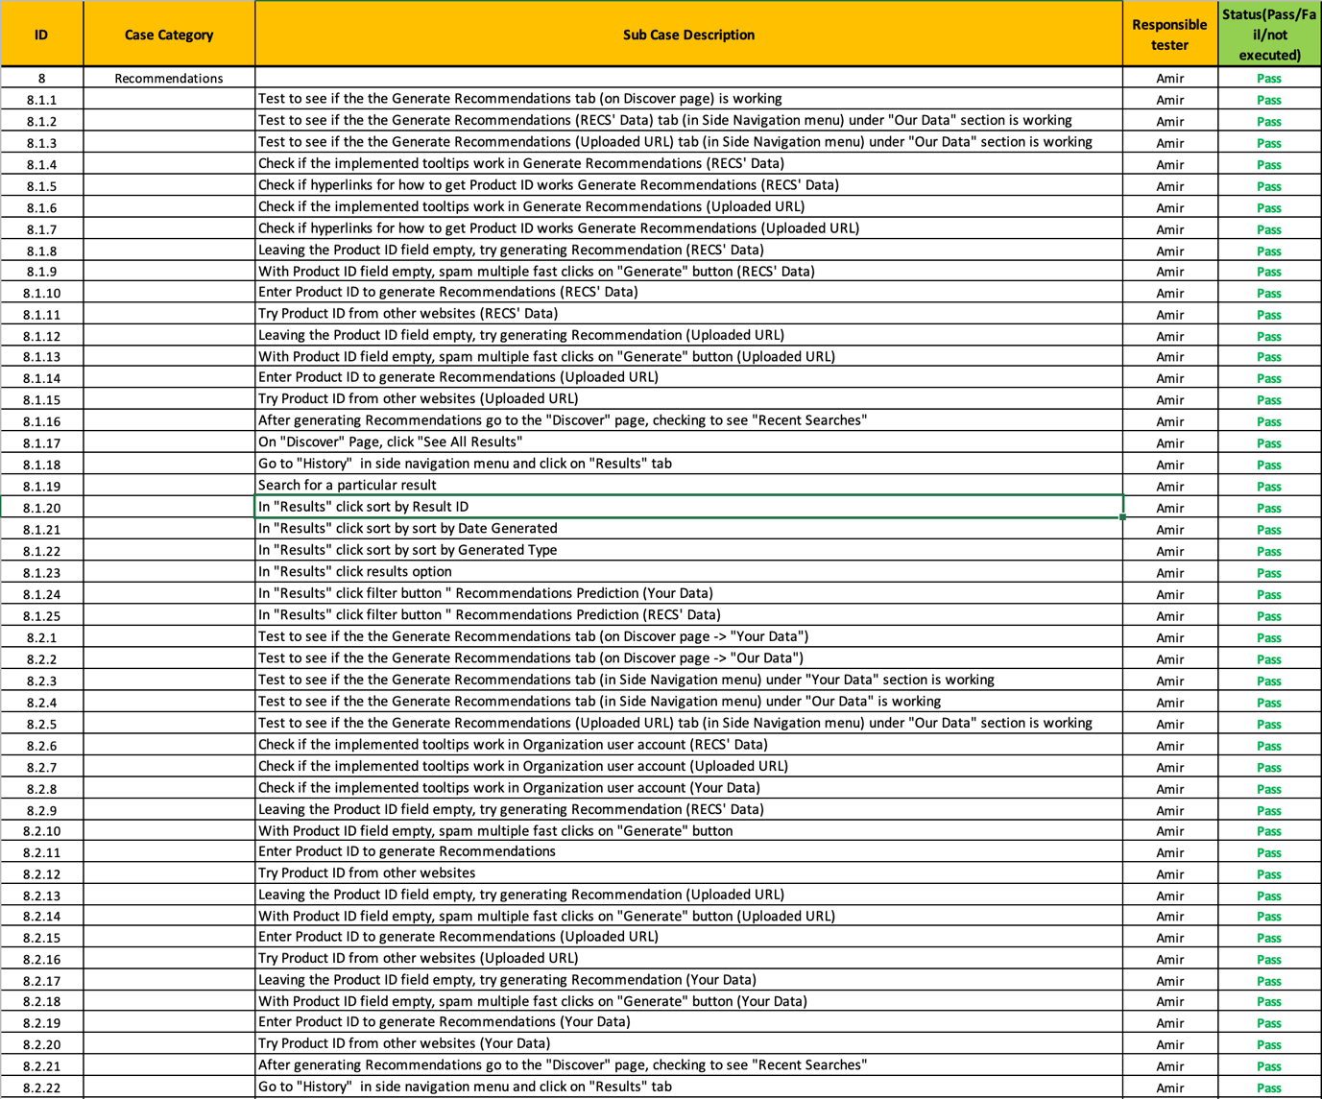

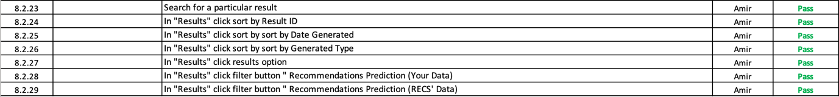

### Test Status Report

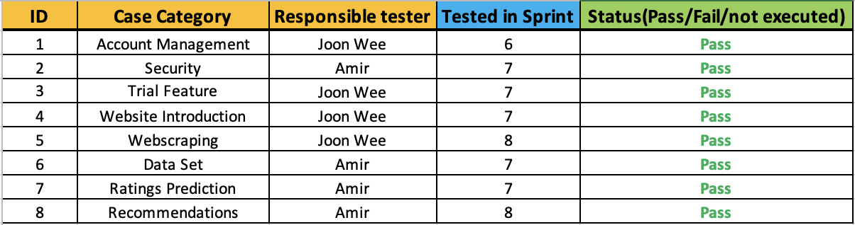

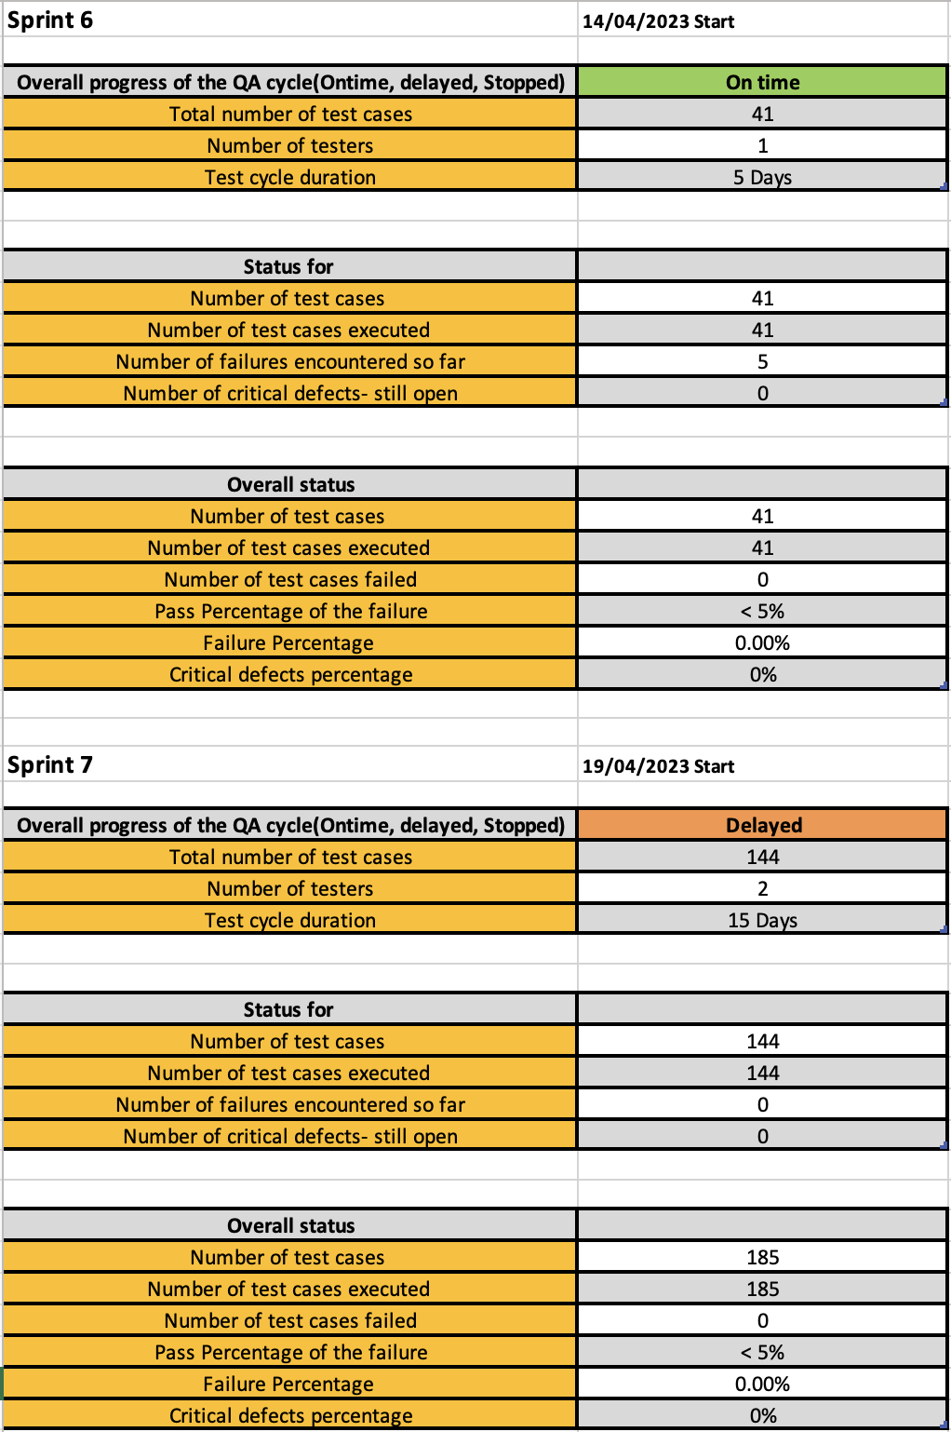

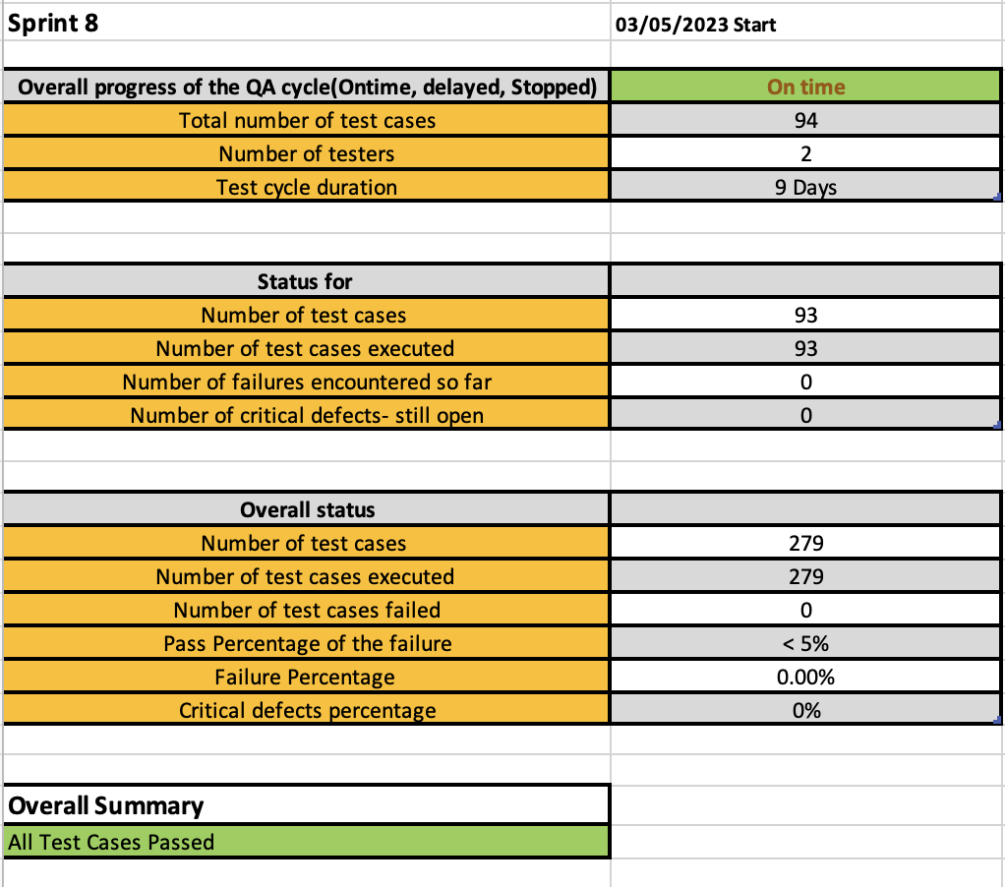

## 

## Gantt Chart (Work Breakdown Structure)

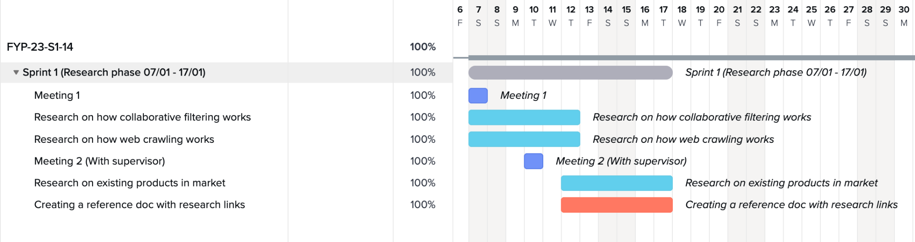

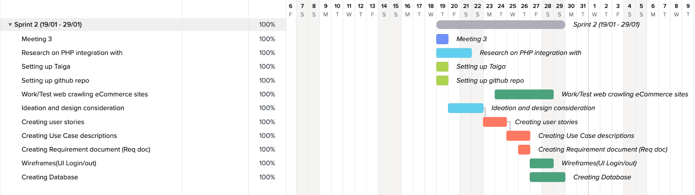

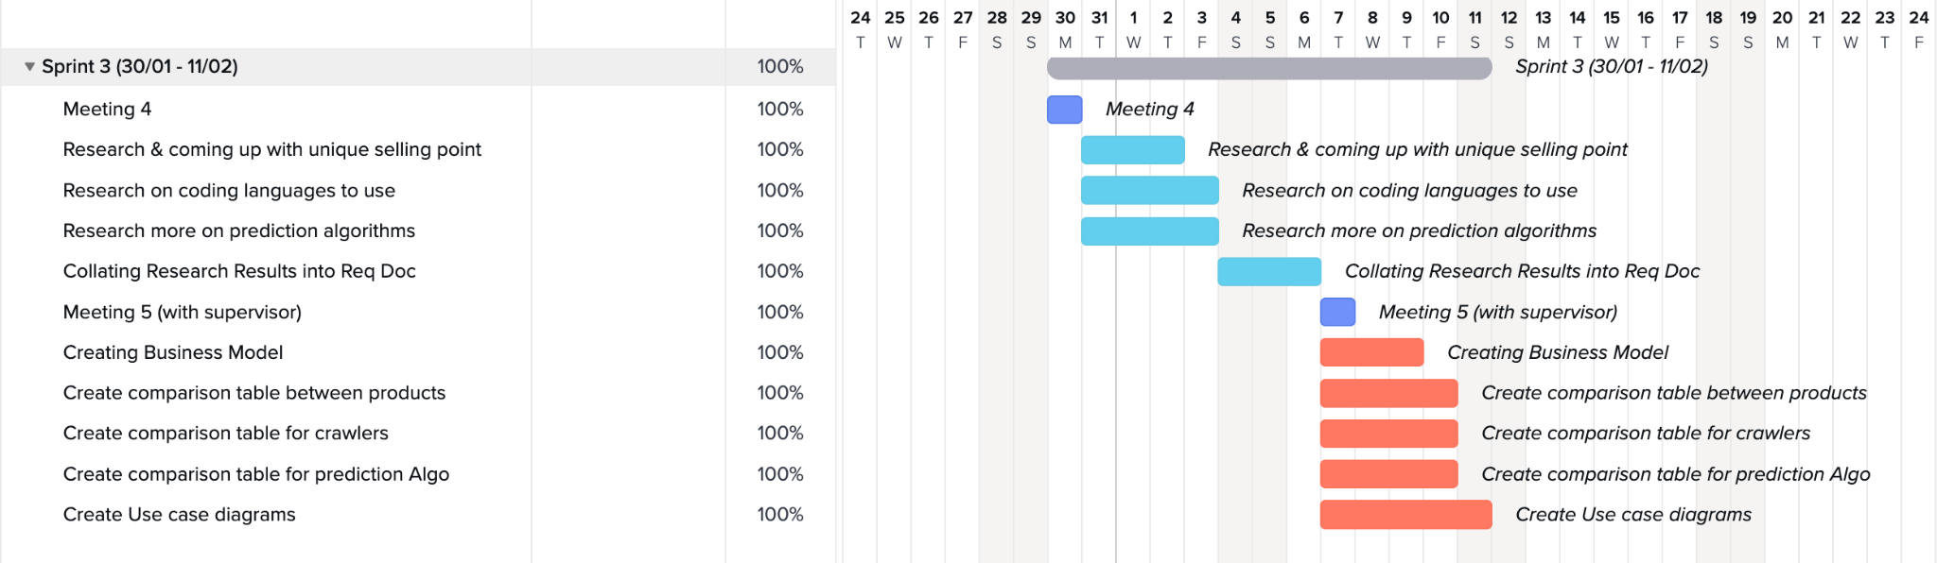

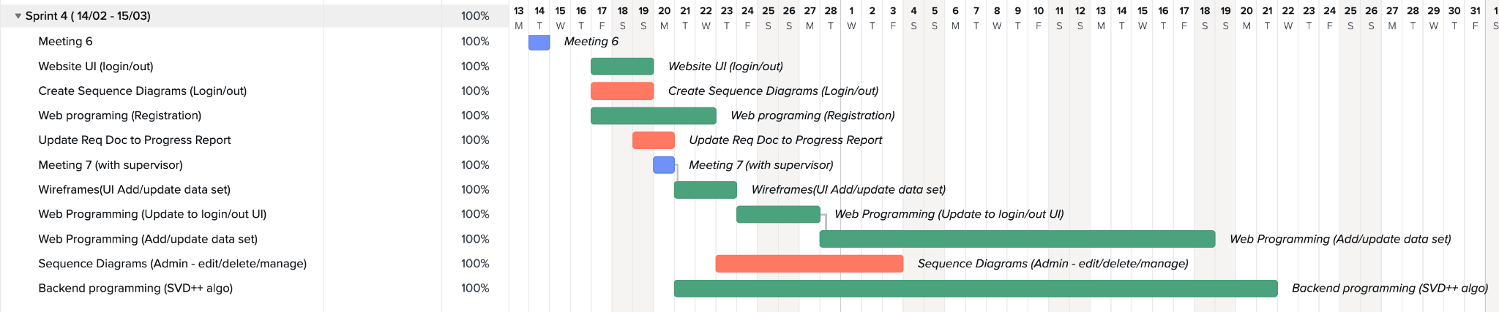

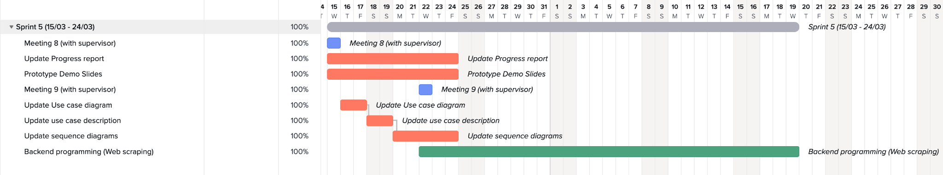

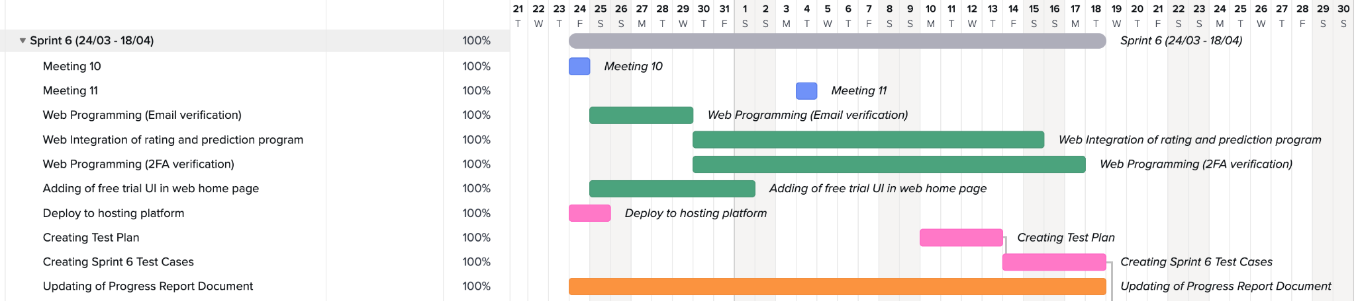

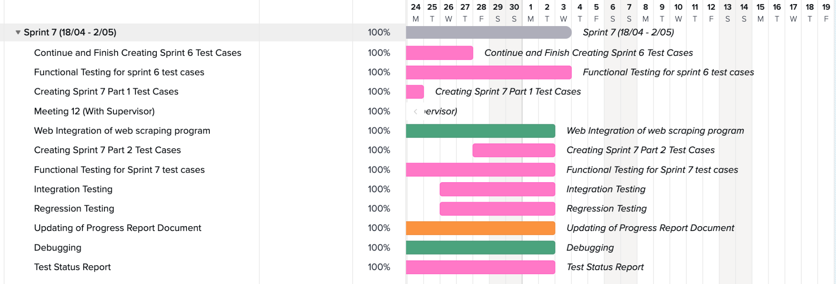

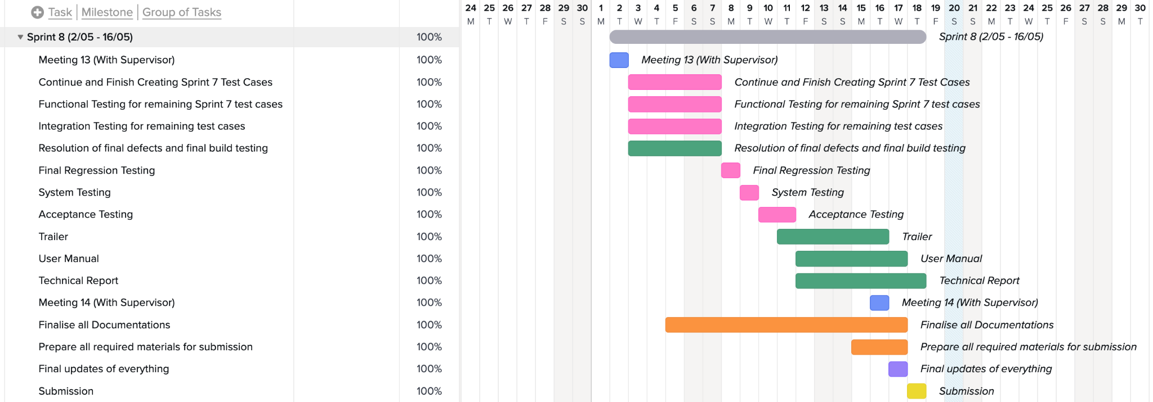

## Meeting Minutes

### Meeting minute 1

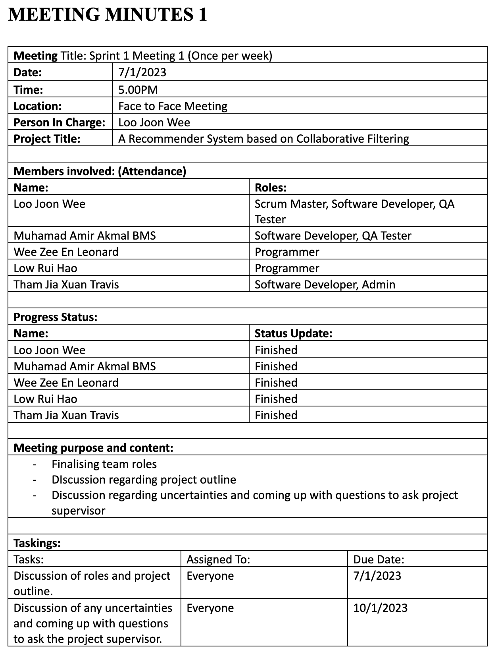

### Meeting minute 2

### 

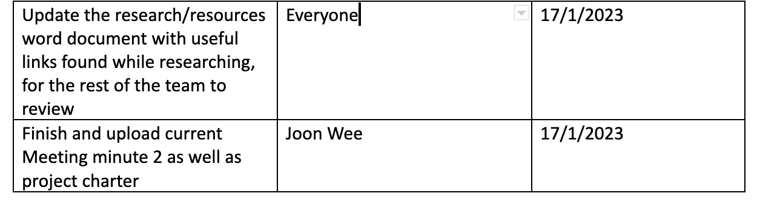

### 

### Meeting minute 3

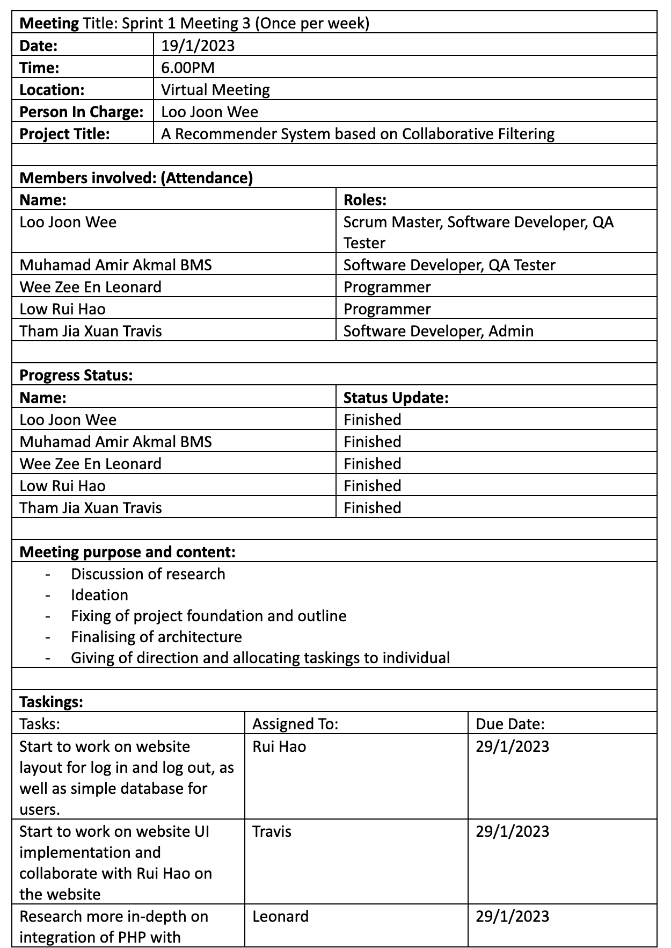

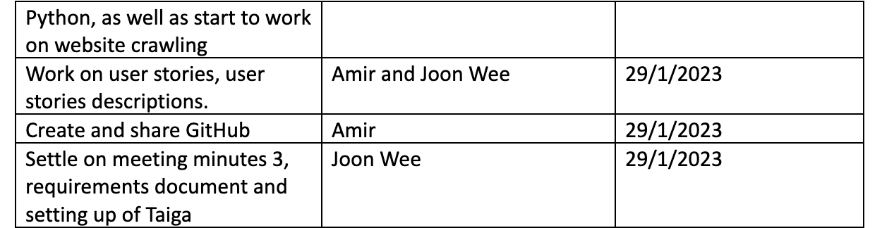

### Meeting minute 4

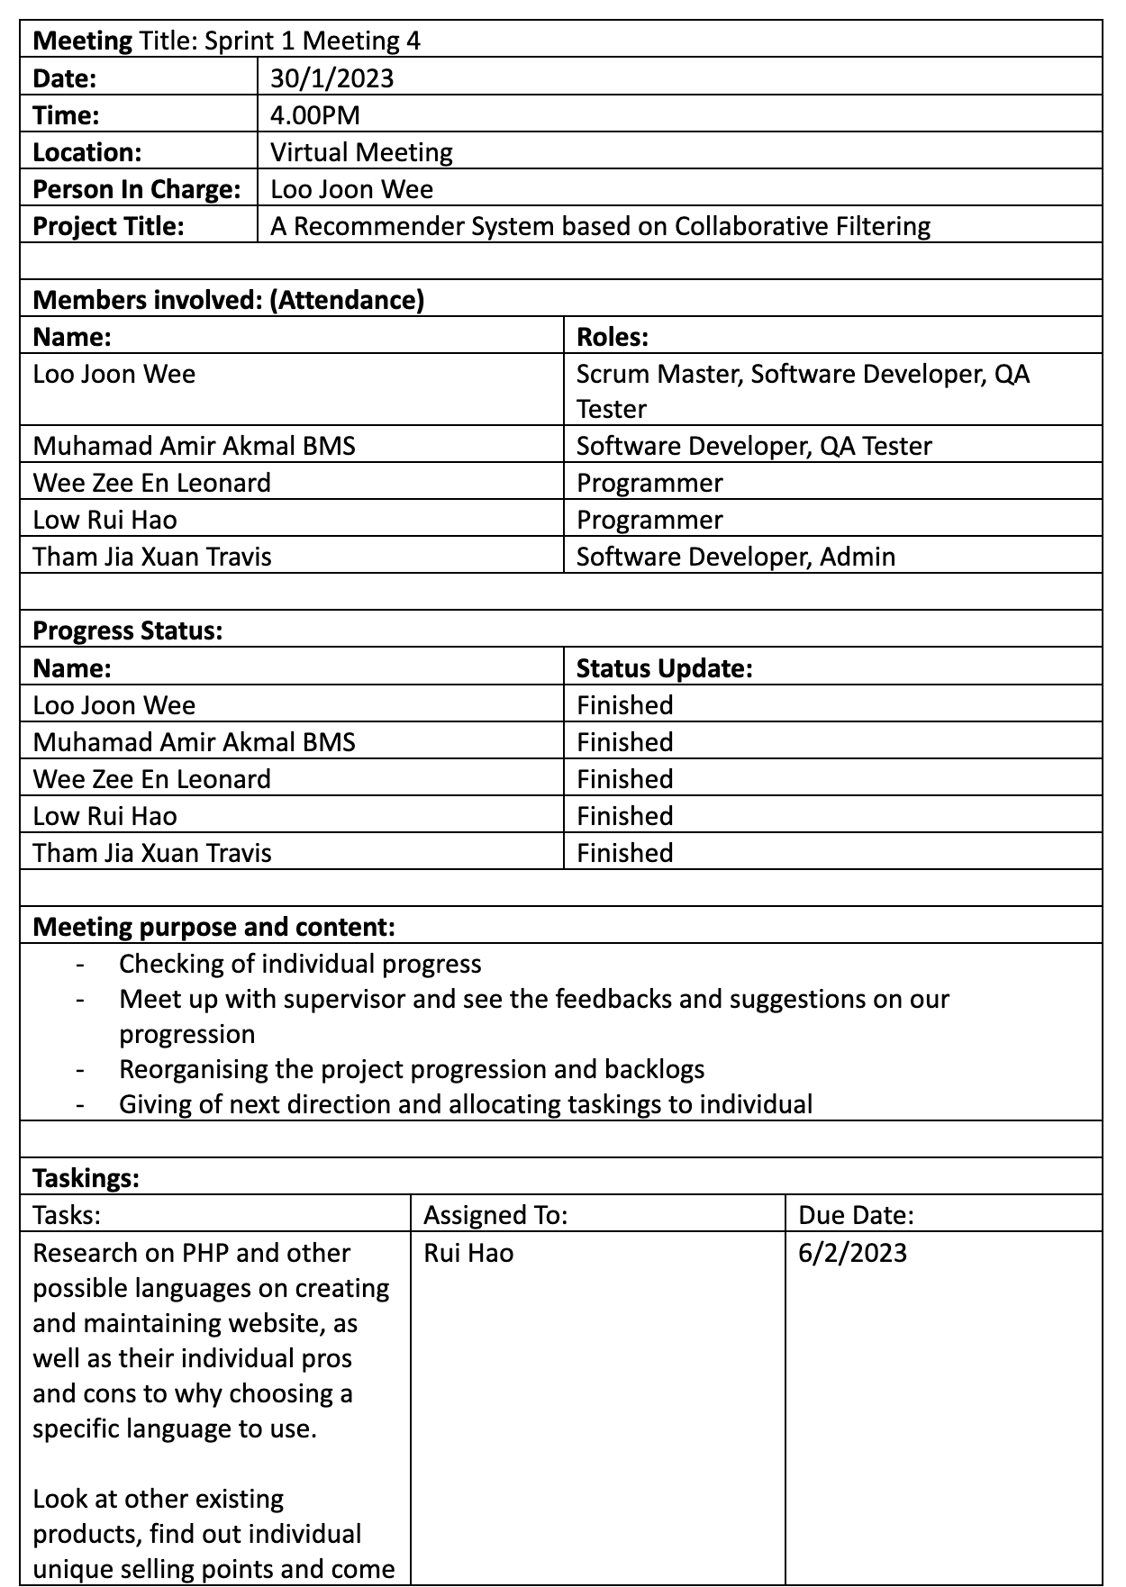

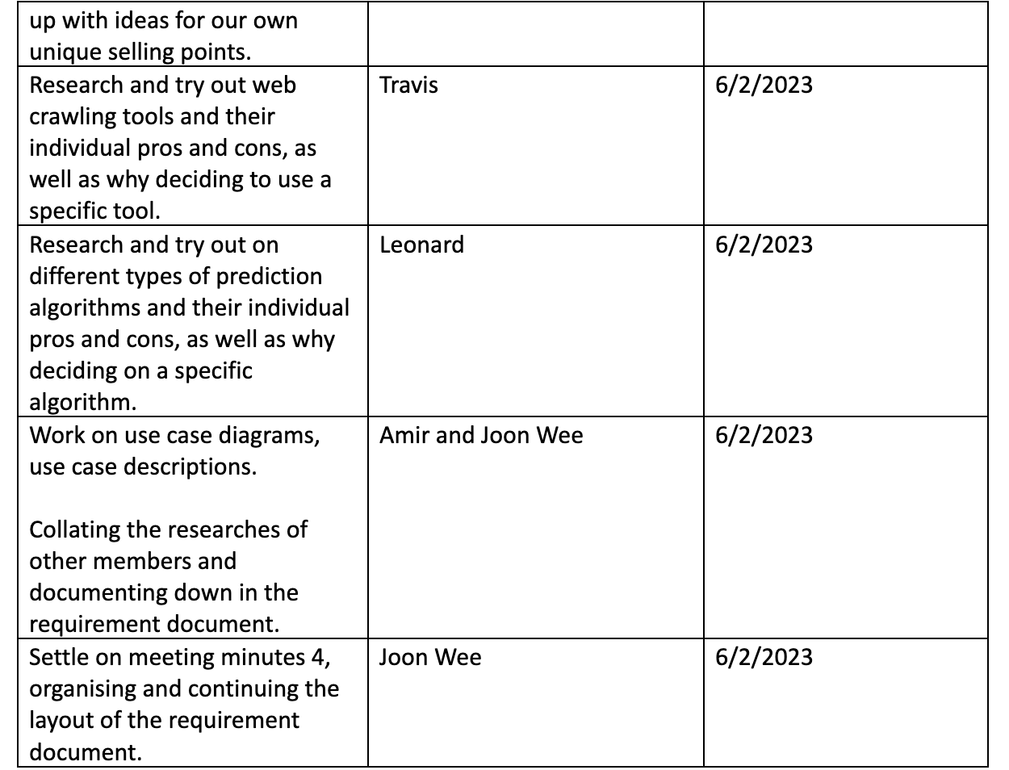

### Meeting minute 5

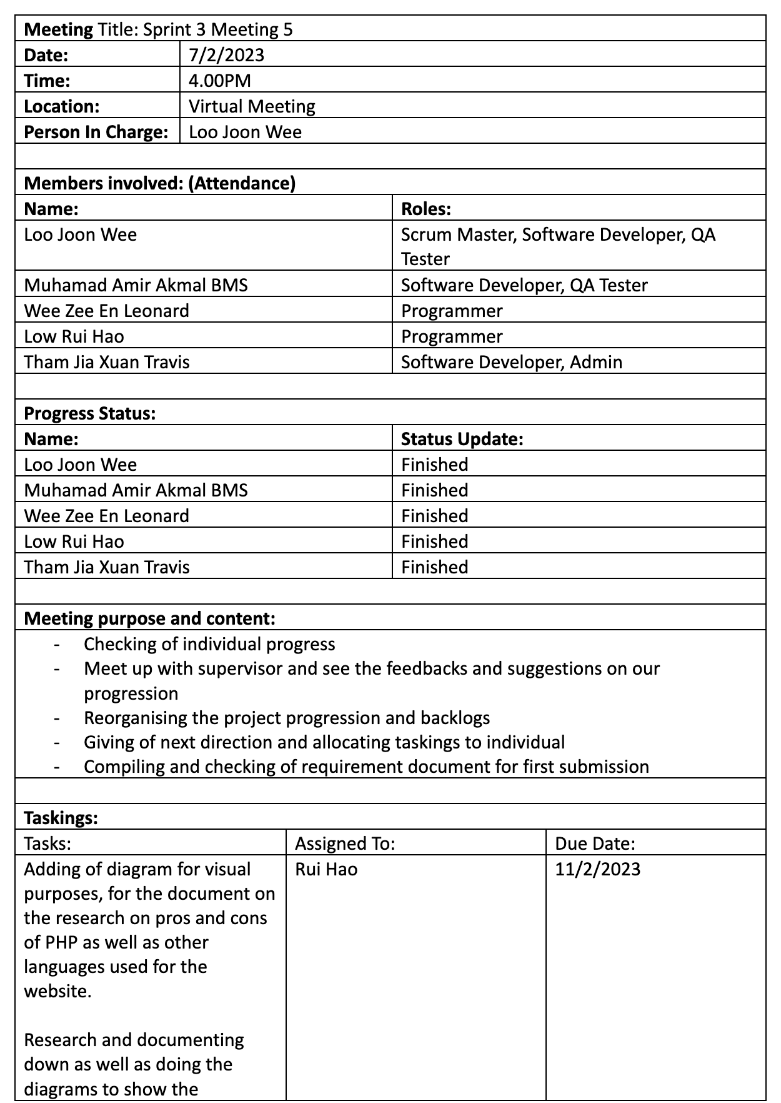

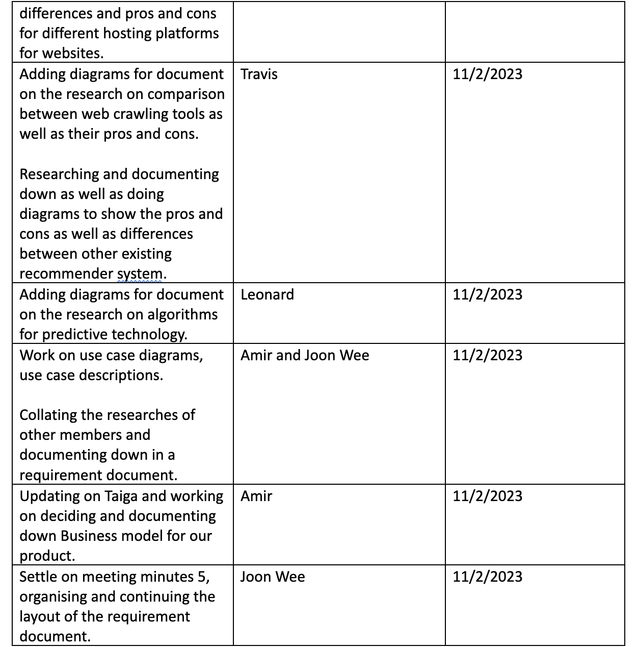

### 

### Meeting minute 6

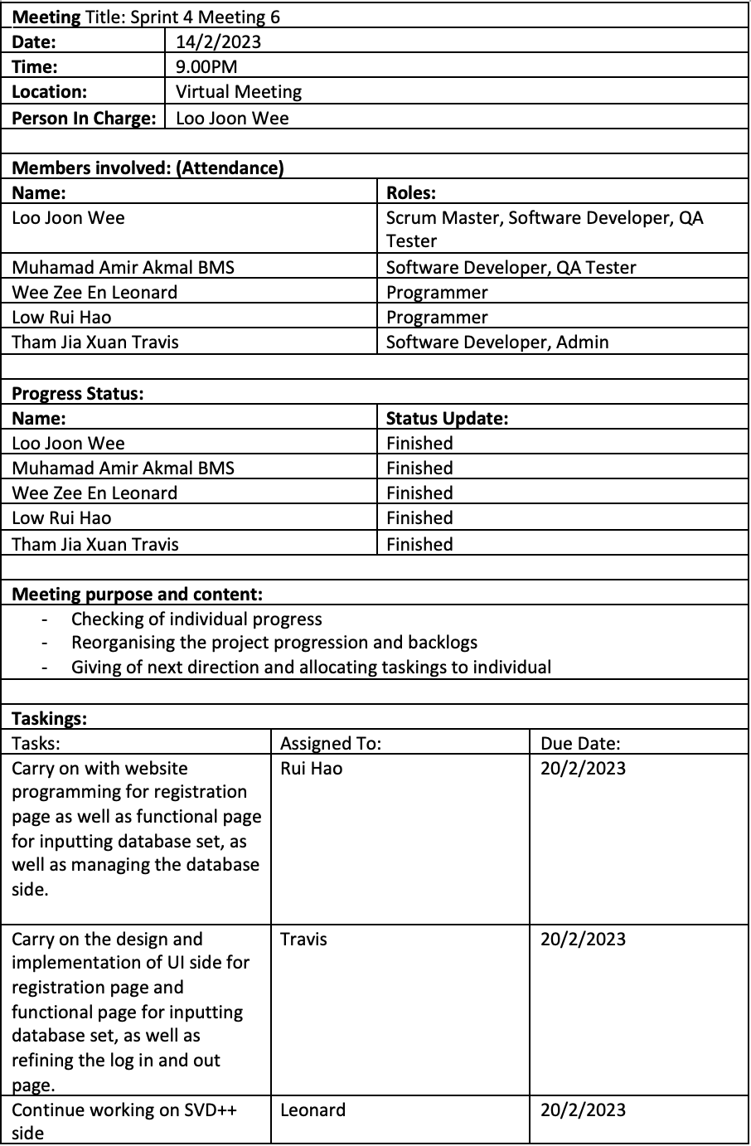

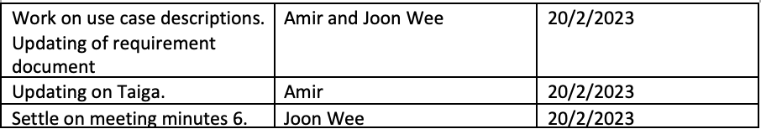

### 

### Meeting minute 7

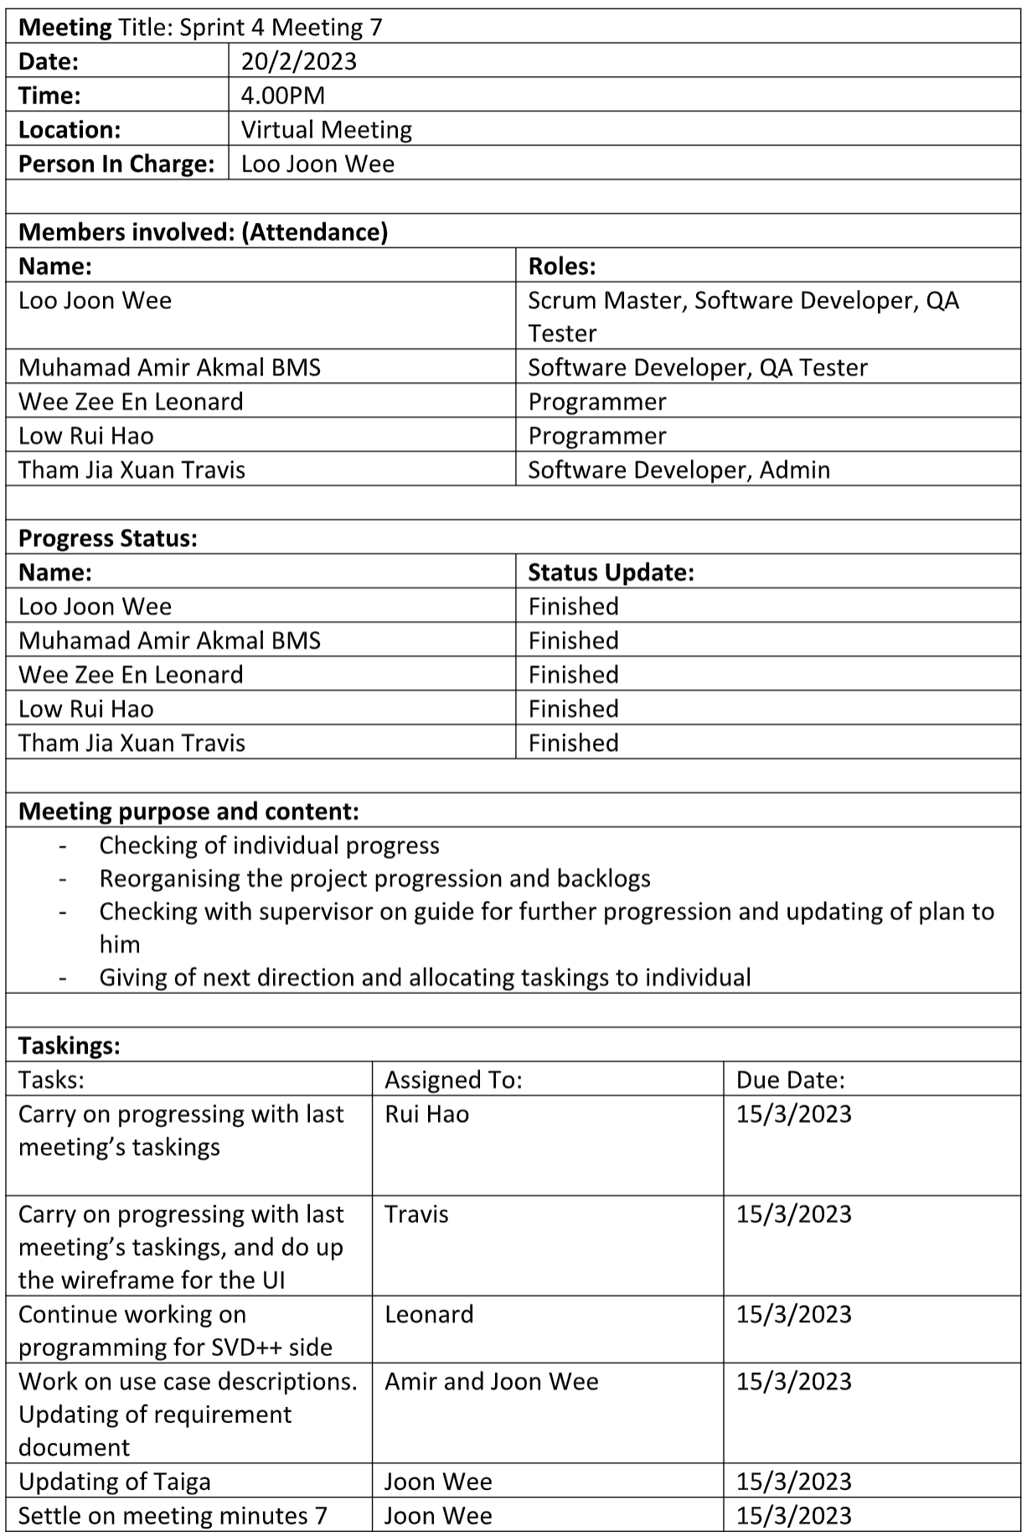

### 

### Meeting minute 8

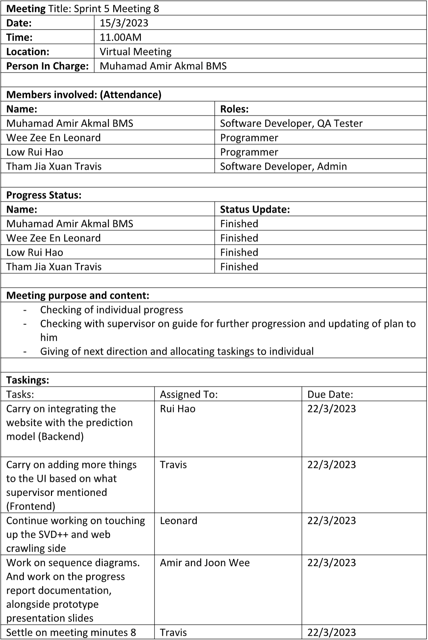

### 

### Meeting minute 9

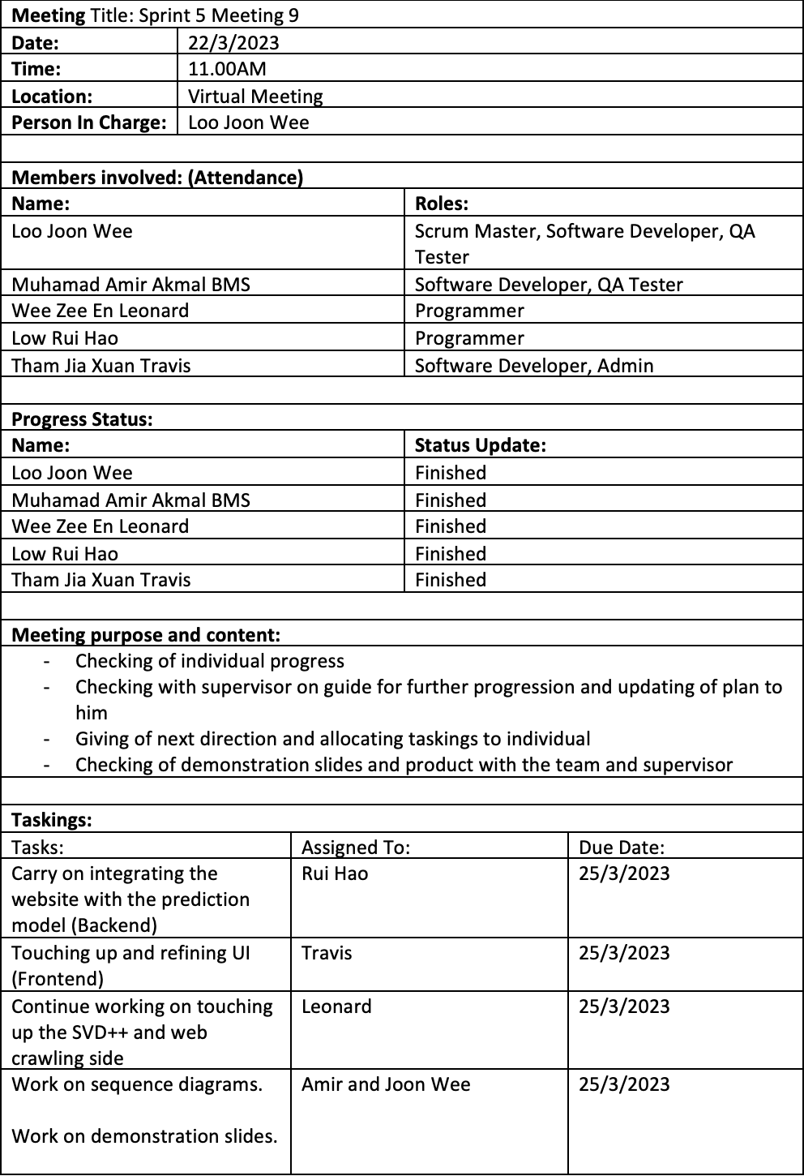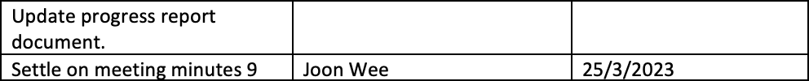

### Meeting minute 10

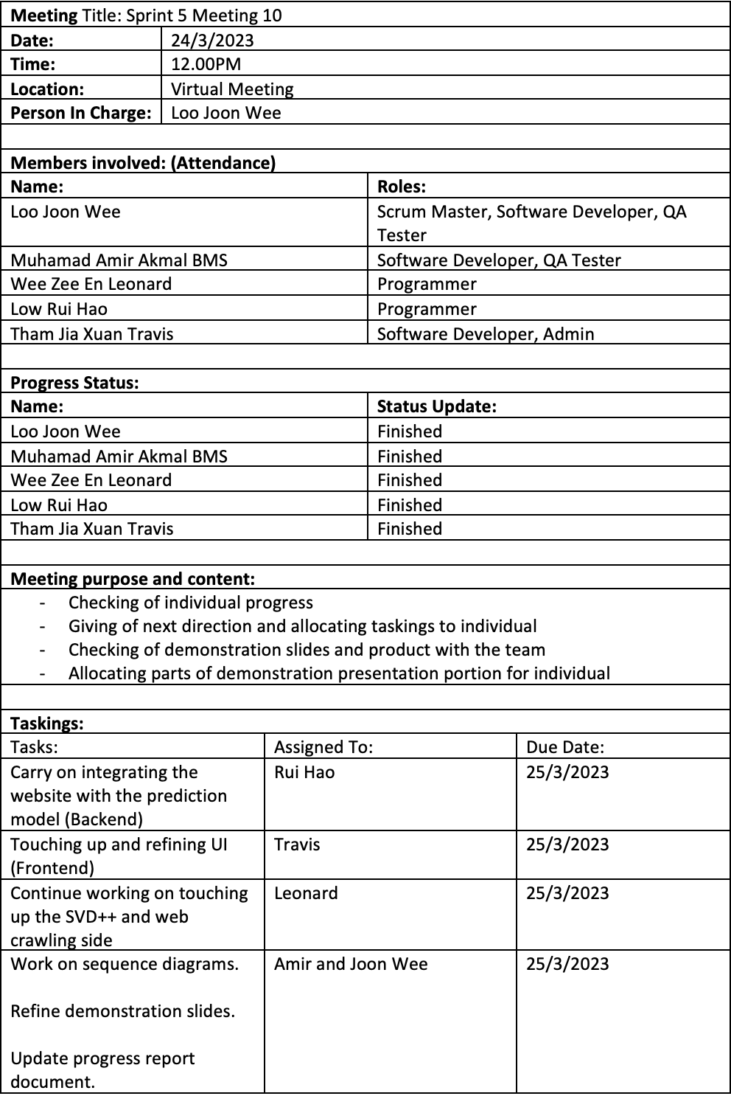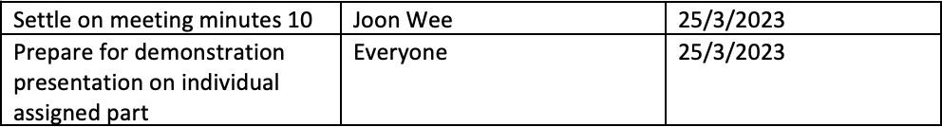

### Meeting minute 11

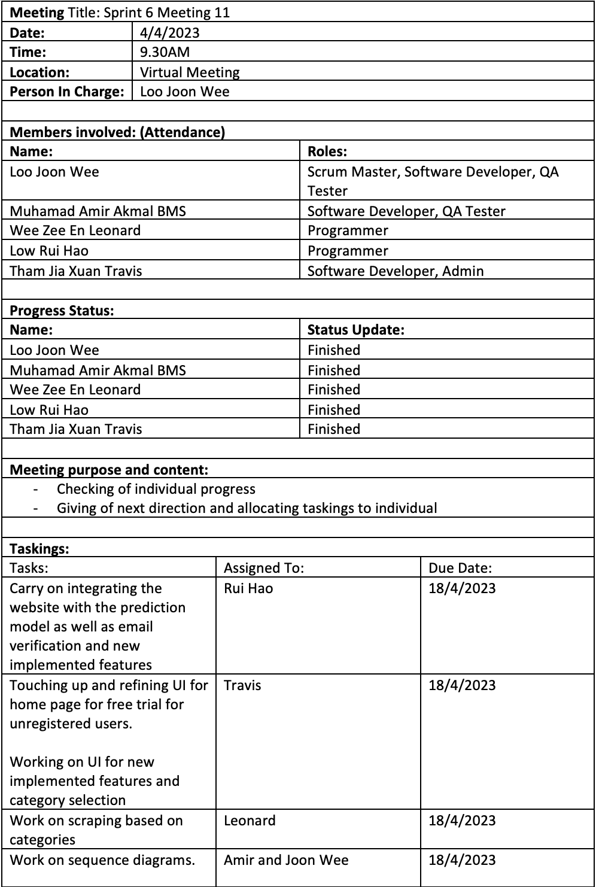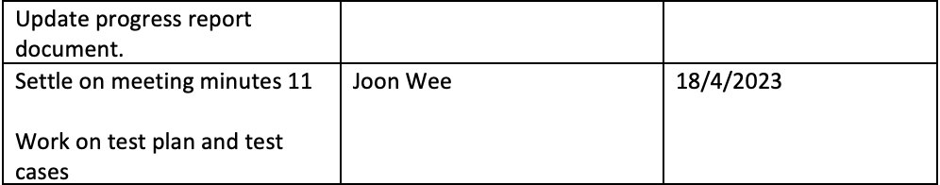

### Meeting minute 12

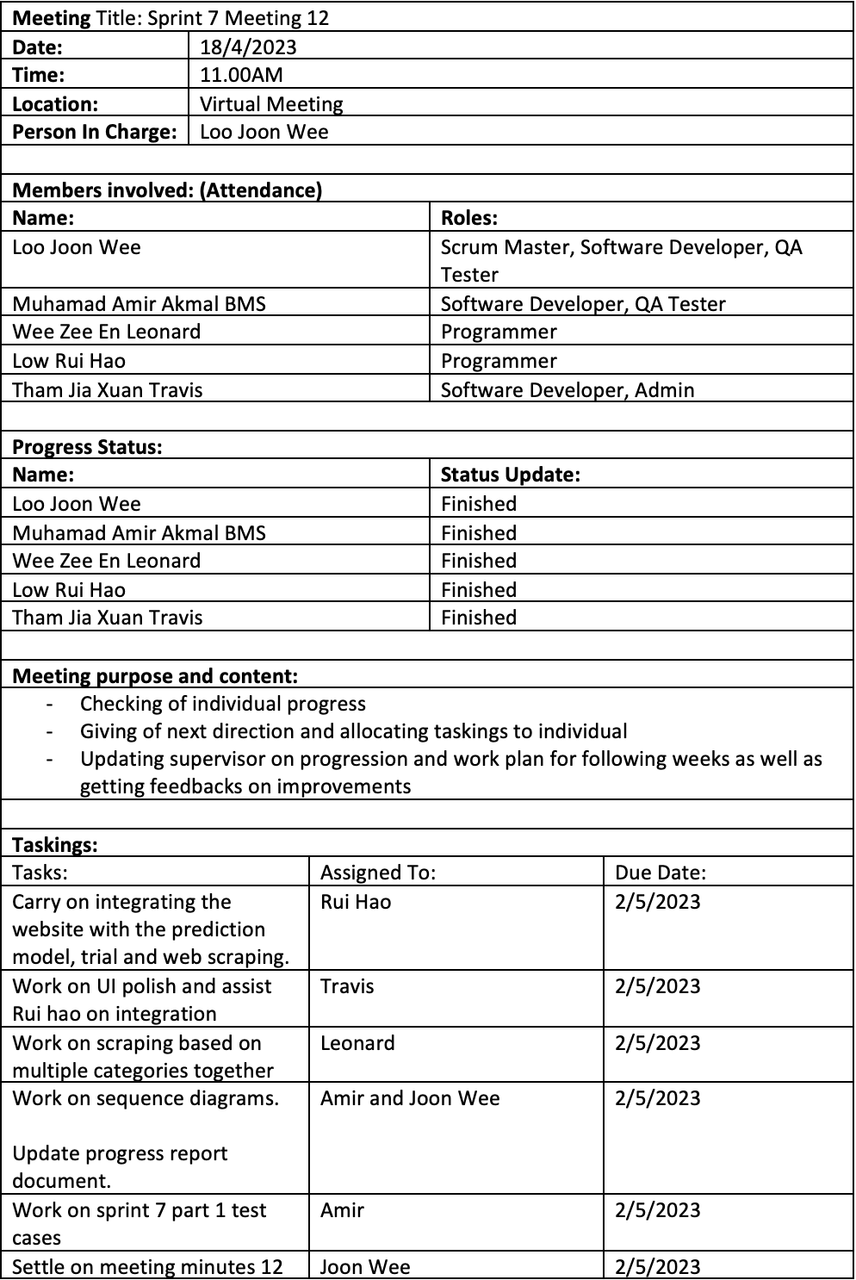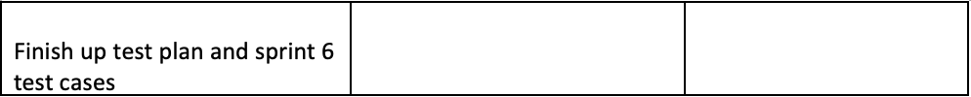

### Meeting minute 13

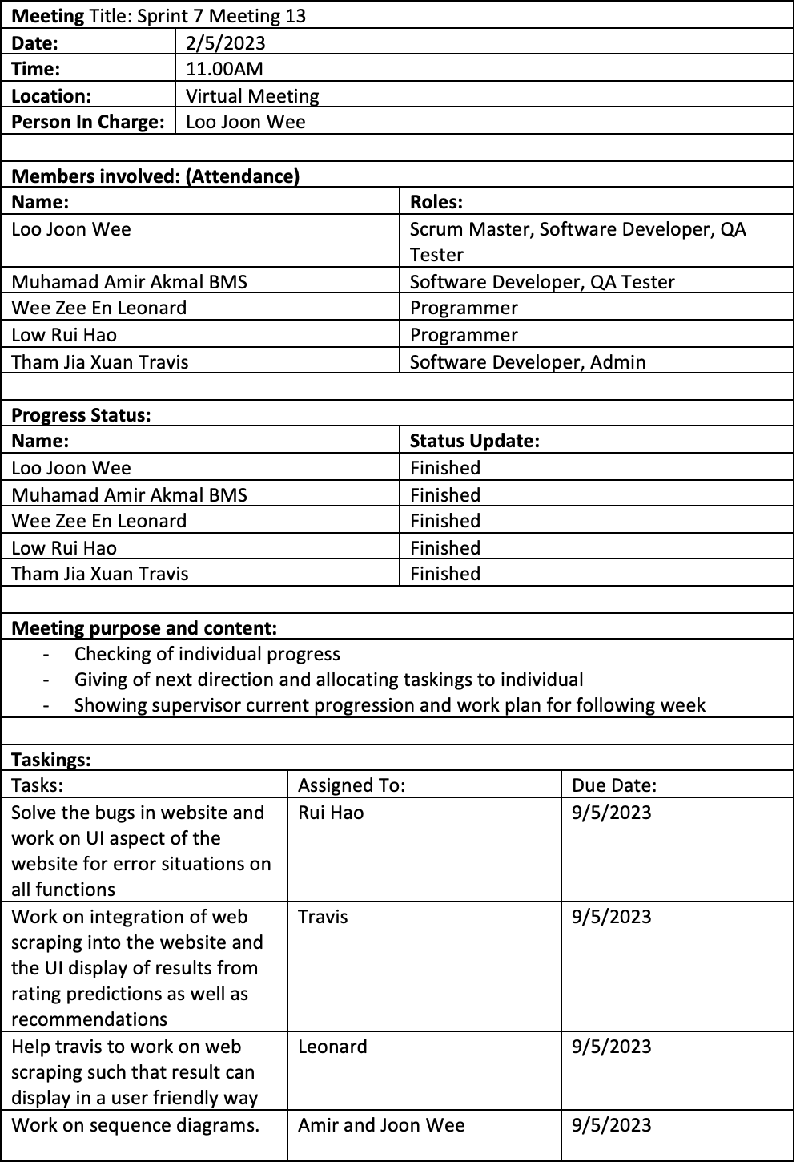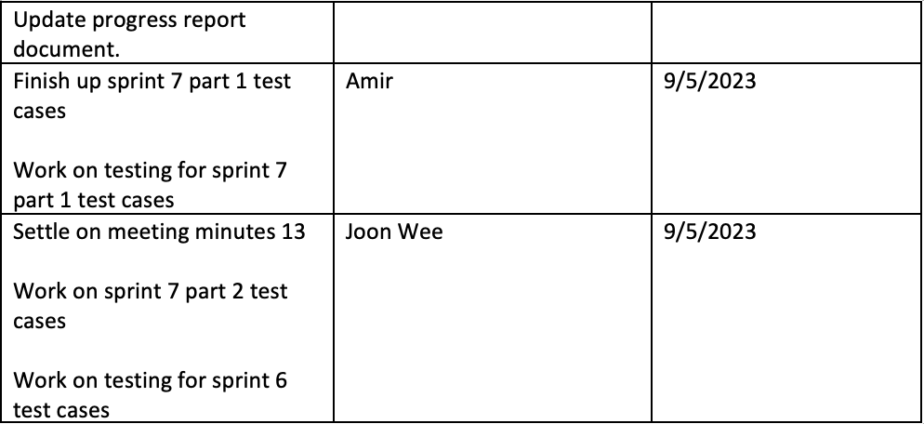

### Meeting minute 14

